# 1) What is Spring?

|  |
| --- |
| org.springframework |
|

It is a lightweight, [inversion of control](https://en.wikipedia.org/wiki/Inversion_of_control) [container](https://en.wikipedia.org/wiki/Servlet_container) ,loosely coupled and integrated framework for developing enterprise applications in java.

Spring framework was initially written by Rod Johnson and was first released under the Apache 2.0 license in June 2003.

Spring framework is said to be a non-invasive means it doesn’t force a programmer to extend or implement their class from any predefined class or interface given by Spring API, in struts we used to extend Action Class right that’s why struts is said to be invasive

In case of struts framework, it will forces the programmer that, the programmer class must extend from the base class provided by struts API

# 2) What are the advantages of spring framework?

1. Predefined Templates
2. Loose Coupling
3. Easy to test
4. Lightweight
5. Fast Development
6. Powerful Abstraction
7. Declarative support

#### 1) Predefined Templates

Spring framework provides templates for JDBC, Hibernate, JPA etc. technologies. So there is no need to write too much code. It hides the basic steps of these technologies.

Let's take the example of JdbcTemplate, you don't need to write the code for exception handling, creating connection, creating statement, committing transaction, closing connection etc. You need to write the code of executing query only. Thus, it save a lot of JDBC code.

#### 2) Loose Coupling

The Spring applications are loosely coupled because of dependency injection.

#### 3) Easy to test

The Dependency Injection makes easier to test the application. The EJB or Struts application require server to run the application but Spring framework doesn't require server.

#### 4) Lightweight

Spring framework is lightweight because of its POJO implementation. The Spring Framework doesn't force the programmer to inherit any class or implement any interface. That is why it is said non-invasive.

#### 5) Fast Development

The Dependency Injection feature of Spring Framework and it support to various frameworks makes the easy development of JavaEE application.

#### 6) Powerful abstraction

It provides powerful abstraction to JavaEE specifications such as JMS, JDBC, JPA and JTA.

#### 7) Declarative support

It provides declarative support for caching, validation, transactions and formatting.

# 3) What are the benefits of Spring Framework?

Following are the benefits of Spring framework:

* Extensive usage of Components
* Reusability
* Decoupling
* Reduces coding effort by using pattern implementations such as singleton, factory, service locator etc.
* Removal of leaking connections
* Declarative transaction management
* Easy to integrate with third party tools and technologies.

# 4)What are the differences between EJB and Spring ?

   Spring and EJB feature comparison.TransactionManagement, Declarative transaction support, Persistence, Declarative security, Distributed computing.

|  |  |  |
| --- | --- | --- |
| **Feature** | **EJB** | **Spring** |
| Transaction management | * Must use a JTA transaction manager. * Supports transactions that span remote method calls. | * Supports multiple transaction environments through its PlatformTransactionManager interface, including JTA, Hibernate, JDO, and JDBC. * Does not natively support distributed transactions—it must be used with a JTA transaction manager. |
| Declarative transaction support | * Can define transactions declaratively through the deployment descriptor. * Can define transaction behavior per method or per class by using the wildcard character \*. * Cannot declaratively define rollback behavior—this must be done programmatically. | * Can define transactions declaratively through the Spring configuration file or through class metadata. * Can define which methods to apply transaction behavior explicitly or by using regular expressions. * Can declaratively define rollback behavior per method and per exception type. |
| Persistence | Supports programmatic bean-managed persistence and declarative container managed persistence. | Provides a framework for integrating with several persistence technologies, including JDBC, Hibernate, JDO, and iBATIS. |
| Declarative security | * Supports declarative security through users and roles. The management and implementation of users and roles is container specific. * Declarative security is configured in the deployment descriptor. | * No security implementation out-of-the box. * Acegi, an open source security framework built on top of Spring, provides declarative security through the Spring configuration file or class metadata. |
| Distributed computing | Provides container-managed remote method calls. | Provides proxying for remote calls via RMI, JAX-RPC, and web services. |

Spring 4 features:

# 5) Here are the some important improvements in Spring 4.x

* Removed Deprecated Packages and Methods, [check out the API Differences Report](http://docs.spring.io/spring-framework/docs/3.2.4.RELEASE_to_4.0.0.RELEASE/)
* Java 8 Support[
* JSR-335 [Lambda expressions](https://javabeat.net/2012/05/a-sneak-peak-at-the-lambda-expressions-in-java-8/)
* JSR-310 Date-Time value types for Spring data binding and formatting.
* Java EE 6 and 7 or above is now considered the baseline for Spring Framework 4

Java EE 7 Enterprise Concurrency support.

* Groovy Bean Definition DSL, [read more about this API](http://docs.spring.io/spring/docs/current/javadoc-api/org/springframework/beans/factory/groovy/GroovyBeanDefinitionReader.html).
* Core Container Improvements
* General Web Improvements

WebSocket, SockJS, and STOMP Messaging[ STOMP (Simple (or Streaming) Text-Oriented Messaging Protocol) is a simple text-oriented protocol, similar to HTTP].

* [JSR-343](http://jcp.org/en/jsr/detail?id=343) JMS 2.0. latest version
* [JSR-338](http://jcp.org/en/jsr/detail?id=338) JPA 2.1. latest version
* Testing Improvements

**And Spring 3.x which introduced lot of new features like:**

* Spring MVC Test Framework
* Asynchronous MVC processing on Servlet 3.0
* custom @Bean definition annotations in @Configuration classes
* @Autowired and @Value to be used as meta-annotations
* Concurrency refinements across the framework
* loading WebApplicationContexts in the TestContext framework
* JCache 0.5 (JSR-107)

**1. Removed Deprecated Packages and Methods**

All deprecated packages, and many deprecated classes and methods have been removed with version 4.0. If you are upgrading from a previous release of Spring, you should ensure that you have fixed any deprecated calls that you were making to outdated APIs. This should be the challenging point for those who want to migrate their old spring applications to the new version. As a caution, if you are running the old spring application, then first thing to get rid of your deprecated APIs before migrating to the latest version.

For a complete set of changes, [check out the API Differences Report](http://docs.spring.io/spring-framework/docs/3.2.4.RELEASE_to_4.0.0.RELEASE/).

**2. Java 8 Support**

Spring Framework 4.0 provides support for several Java 8 features. You can make use of lambda expressions and method references with Spring’s callback interfaces. There is first-class support for java.time (JSR-310), and several existing annotations have been retrofitted as @Repeatable. You can also use Java 8’s parameter name discovery (based on the -parameters compiler flag) as an alternative to compiling your code with debug information enabled.

**Some of the Java SE 8 features to be supported include:**

* JSR-335 Lambda expressions.
* JSR-310 Date-Time value types for Spring data binding and formatting.
* Support for the new 1.8 byte code format (required to support Lambda expressions).

Spring 4.0 has increased the minimum recommendation to Java 6.0. Also it states that any new project recommended to use the Java 7.0 for their projects with Spring 4.0. It still supports the lower version Java 6 and 7 without any problem.

**3. Java EE 6 and 7**

Java EE version 6 or above is now considered the baseline for Spring Framework 4, with the JPA 2.0 and Servlet 3.0 specifications being of particular relevance. It is possible to run your application in Servlet 2.5, but it is recommended to use Servlet 3.0 environment.

**4. Groovy Bean Definition DSL**

With Spring Framework 4.0 it is now possible to define external bean configuration using a Groovy DSL. [Read more about this API](http://docs.spring.io/spring/docs/current/javadoc-api/org/springframework/beans/factory/groovy/GroovyBeanDefinitionReader.html).

**5. Core Container Improvements**

There have been several general improvements to the core container:

* Spring now treats [generic types as a form ofqualifier](http://docs.spring.io/spring/docs/4.0.0.RELEASE/spring-framework-reference/htmlsingle/#beans-generics-as-qualifiers) when injecting Beans. For example, if you are using a Spring Data Repository you can now easily inject a specific implementation: @Autowired Repository<Customer> customerRepository.
* If you use Spring’s meta-annotation support, you can now develop custom annotations that [expose specific attributes from the source annotation](http://docs.spring.io/spring/docs/4.0.0.RELEASE/spring-framework-reference/htmlsingle/#beans-meta-annotations).
* Beans can now be Ordered when they are [autowired intolists and arrays](http://docs.spring.io/spring/docs/4.0.0.RELEASE/spring-framework-reference/htmlsingle/" \l "beans-autowired-annotation" \t "_blank). Both the @Ordered annotation and Ordered interface are supported.
* The @Lazy annotation can now be used on injection points, as well as @Bean definitions.
* The [@Description annotation has been added](http://docs.spring.io/spring/docs/4.0.0.RELEASE/spring-framework-reference/htmlsingle/#beans-java-bean-description) for developers using Java-based configuration.
* A generalized model for [conditionally filtering beans](http://docs.spring.io/spring/docs/4.0.0.RELEASE/spring-framework-reference/htmlsingle/#beans-java-conditional) has been added via the @Conditional annotation. This is similar to @Profile but allows for user-defined strategies to be developed.
* [CGLIB-based proxy classes](http://docs.spring.io/spring/docs/4.0.0.RELEASE/spring-framework-reference/htmlsingle/#aop-pfb-proxy-types) no longer require a default constructor. Support is provided via the [objenesis](http://code.google.com/p/objenesis/" \t "_blank) library which is repackaged *inline* and distributed as part of the Spring Framework. With this strategy, no constructor at all is being invoked for proxy instances anymore.
* There is managed time zone support across the framework now, e.g. on LocaleContext.

**6. General Web Improvements**

Deployment to Servlet 2.5 servers remains an option, but Spring Framework 4.0 is now focused primarily on Servlet 3.0+ environments. If you are using the Spring MVC Test Framework you will need to ensure that a Servlet 3.0 compatible JAR is in your test classpath.

In addition to the WebSocket support mentioned later, the following general improvements have been made to Spring’s Web modules:

* You can use the new ***@RestController*** annotation with Spring MVC applications, removing the need to add ***@ResponseBody*** to each of your ***@RequestMapping*** methods.
* The ***AsyncRestTemplate***class has been added, allowing non-blocking asynchronous support when developing REST clients.
* Spring now offers comprehensive timezone support when developing Spring MVC applications.

**7. WebSocket, SockJS, and STOMP Messaging**

A new spring-websocket module provides comprehensive support for WebSocket-based, two-way communication between client and server in web applications. It is compatible with JSR-356, the Java WebSocket API, and in addition provides SockJS-based fallback options (i.e. WebSocket emulation) for use in browsers that don’t yet support the WebSocket protocol (e.g. Internet Explorer < 10).

A new spring-messaging module adds support for STOMP as the ***WebSocket***sub-protocol to use in applications along with an annotation programming model for routing and processing STOMP messages from ***WebSocket***clients. As a result an ***@Controller*** can now contain both ***@RequestMapping*** and ***@MessageMapping*** methods for handling HTTP requests and messages from WebSocket-connected clients. The new spring-messaging module also contains key abstractions from the Spring Integration project such as ***Message, MessageChannel, MessageHandler***, and others to serve as a foundation for messaging-based applications.

**8. Testing Improvements**

In addition to pruning of deprecated code within the spring-test module, Spring Framework 4.0 introduces several new features for use in unit and integration testing.

* Almost all annotations in the spring-test module (e.g., *@ContextConfiguration, @WebAppConfiguration, @ContextHierarchy, @ActiveProfiles, etc.*) can now be used as meta-annotations to create custom composed annotations and reduce configuration duplication across a test suite.
* Active bean definition profiles can now be resolved programmatically, simply by implementing a custom ***ActiveProfilesResolver***and registering it via the resolver attribute of *@ActiveProfiles*.
* A new ***SocketUtils***class has been introduced in the spring-core module which enables you to scan for free TCP and UDP server ports on localhost. This functionality is not specific to testing but can prove very useful when writing integration tests that require the use of sockets, for example tests that start an in-memory SMTP server, FTP server, Servlet container, etc.
* As of Spring 4.0, the set of mocks in the *org.springframework.mock.web* package is now based on the Servlet 3.0 API. Furthermore, several of the Servlet API mocks (e.g., **MockHttpServletRequest**, **MockServletContext**, etc.) have been updated with minor enhancements and improved configurability.

# 6) Spring versions List

Minimum requirements

* JDK 8+ for Spring Framework 5.x
* JDK 6+ for Spring Framework 4.x
* JDK 5+ for Spring Framework 3.x

|  |  |  |
| --- | --- | --- |
| Unreleased | [5.1 RC1](https://jira.spring.io/browse/SPR/fixforversion/16630) | 08/May/18 |
| Unreleased | [5.0.5](https://jira.spring.io/browse/SPR/fixforversion/16634) | 03/Apr/18 |
| Unreleased | [5.0.4](https://jira.spring.io/browse/SPR/fixforversion/16629) | 26/Feb/18 |
| Released) | [5.0.3](https://jira.spring.io/browse/SPR/fixforversion/16496) | 23/Jan/18 |

# 7)Spring Modules, What Are Spring Modules

Actually in spring 1.x, the framework has divided into 7 well defined modules.  But in 2.x framework is divided into 6 modules only..

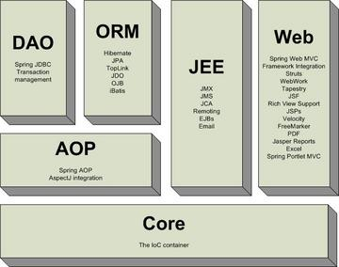

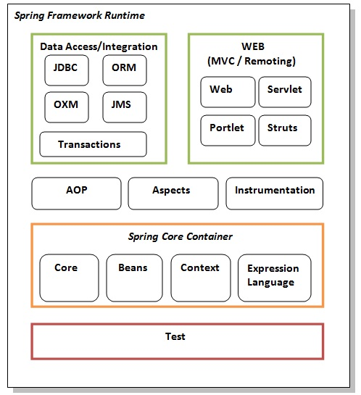

**Test**

This layer provides support of testing with JUnit and TestNG.

**Spring Core Container**

The Spring Core container contains core, beans, context and expression language (EL) modules.

**Core and Beans**

These modules provide IOC and Dependency Injection features.

**Context**

This module supports internationalization (I18N), EJB, JMS, Basic Remoting.

**Expression Language**

It is an extension to the EL defined in JSP. It provides support to setting and getting property values, method invocation, accessing collections and indexers, named variables, logical and arithmetic operators, retrieval of objects by name etc.

**AOP, Aspects and Instrumentation**

These modules support aspect oriented programming implementation where you can use Advices, Pointcuts etc. to decouple the code.

The aspects module provides support to integration with AspectJ.

The instrumentation module provides support to class instrumentation and classloader implementations.

**Data Access / Integration**

This group comprises of JDBC, ORM, OXM, JMS and Transaction modules. These modules basically provide support to interact with the database.

**Web**

This group comprises of Web, Web-Servlet, Web-Struts and Web-Portlet. These modules provide support to create web application.

# 8) spring package overview

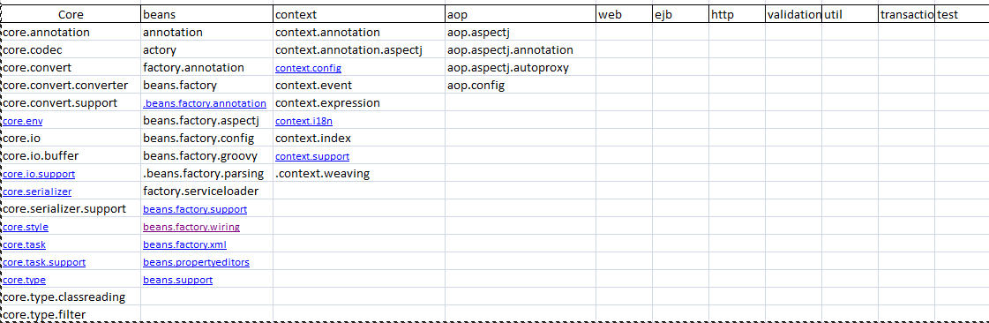

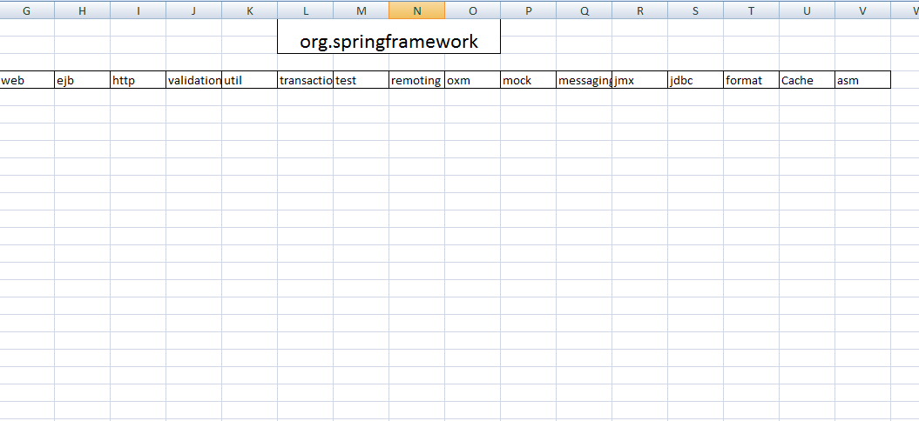

# 9)List of Core/common GoF / J2EE Design Patterns which are internally used by Spring / based upon:

1. **MVC** - The advantage with Spring MVC is that your controllers are POJOs as opposed to being servlets. This makes for easier testing of controllers. One thing to note is that the controller is only required to return a logical view name, and the view selection is left to a separate ViewResolver. This makes it easier to reuse controllers for different view technologies.

2. **Front controller** - Spring provides "DispatcherServlet" to ensure an incoming request gets dispatched to your controllers.

3. **View Helper** - Spring has a number of custom JSP tags, and velocity macros, to assist in separating code from presentation in views.

4. **Singleton** - Beans defined in spring config files are singletons by default.

5. **Prototype** - Instance type can be prototype.

6. **Factory** - Used for loading beans through BeanFactory and Application context.

7. **Builder** - Spring provides programmatic means of constructing BeanDefinitions using the builder pattern through Class "BeanDefinitionBuilder".

8. **Template** - Used extensively to deal with boilerplate repeated code (such as closing connections cleanly, etc..). For example JdbcTemplate.

9. **Proxy** - Used in AOP & Remoting.

10. **DI/IOC** - It is central to the whole BeanFactory/ApplicationContext stuff.

# 10)Overview of Spring Bean Life Cycle

Spring Beans are Instantiated / Managed by [**Spring IoC Container**](http://javabeginnerstutorial.com/spring-framework-tutorial/spring-ioc-container-overview/).  These beans can be created by providing bean specific *configuration metadata* to container. Configuration Metadata can be provided in any of below formats.

1. *XML*
2. *Annotation*
3. *Java Code*

Spring framework provides following **4 ways for controlling life cycle events** of bean:

1. **InitializingBean and DisposableBean callback interfaces**
2. **Other Bean Name, bean factory and Application Context  Aware interfaces for specific behavior**
3. **custom init() and destroy() methods in bean configuration file**
4. **@PostConstruct and @PreDestroy annotations**

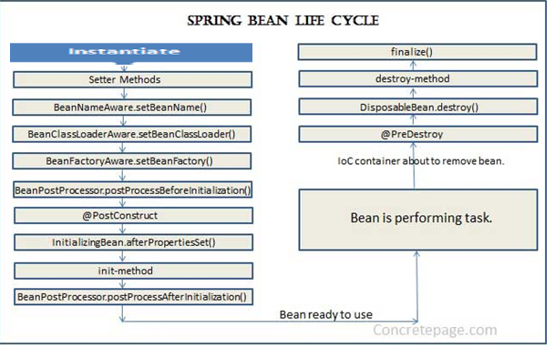

Standard bean lifecycle interfaces & there standard order of execution are given below.

  1 IoC container will look for the configuration metadata of given Bean.  
  2 Once find, container will create the instance of Bean(Using reflection API).  
  3 After instance creation dependency will be injected(DI).

4 setBeanName method of **BeanNameAware I**nterface. It sets the name of the bean in the bean factory that created this bean.

5 setBeanFactory  method of **BeanFactoryAware**Interface. Callback that supplies the owning factory to a bean instance

6 setApplicationContext method of **ApplicationContextAware**Interface. Set the ApplicationContext that this object runs in.

7 IoC container calls BeanPostProcessor.postProcessBeforeInitialization on the bean. Using this method a wrapper can be applied on original bean..before any bean initialization callbacks.

8 Now the method annotated with @PostConstruct is called.

9 After @PostConstruct, the method InitializingBean.afterPropertiesSet() is called.

10 Now the method specified by init-method attribute of bean in XML configuration is called.

11 postProcessAfterInitialization methods of BeanPostProcessors. Apply this BeanPostProcessor to the given new bean instance after any bean initialization callbacks

12 Now the bean instance is ready to be used. Perform the task using the bean.

13 Now when the ApplicationContext shuts down such as by using registerShutdownHook() then the method annotated with @PreDestroy is called.

14 After that DisposableBean.destroy() method is called on the bean.

15 Now the method specified by destroy-method attribute of bean in XML configuration is called.

16 Before garbage collection, finalize() method of Object is called.

Detailed explanation

1. By implementing InitializingBean and DisposableBean interfaces – Both these interfaces declare a single method where we can initialize/close resources in the bean. For post-initialization, we can implement InitializingBean interface and provide implementation of afterPropertiesSet()method. For pre-destroy, we can implement DisposableBean interface and provide implementation of destroy() method. These methods are the callback methods and similar to servlet listener implementations.

This approach is simple to use but it’s not recommended because it will create tight coupling with the Spring framework in our bean implementations.

1. Providing init-method and destroy-method attribute values for the bean in the spring bean configuration file. This is the recommended approach because of no direct dependency to spring framework and we can create our own methods.

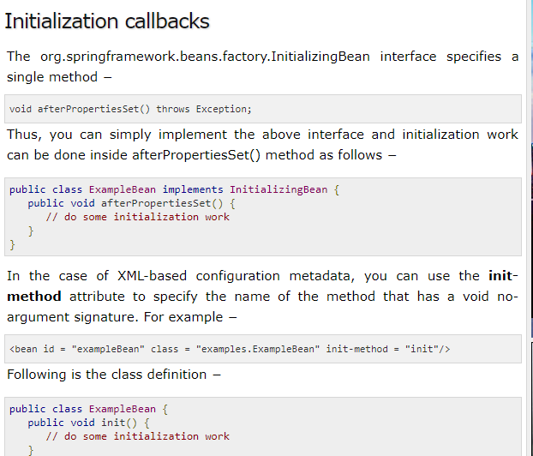

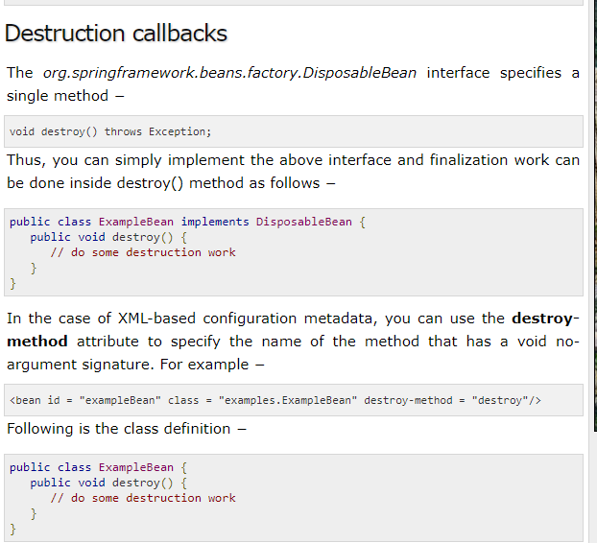

**Spring Bean Life Cycle – @PostConstruct, @PreDestroy Annotations**

Spring 2.5 onwards we can use annotations to specify life cycle methods using @PostConstruct and @PreDestroy annotations.

Spring framework also support @PostConstruct and @PreDestroy annotations for defining post-init and pre-destroy methods. These annotations are part of javax.annotation package. However for these annotations to work, we need to configure our spring application to look for annotations. We can do this either by defining bean of type org.springframework.context.annotation.CommonAnnotationBeanPostProcessor or by context:annotation-config element in spring bean configuration file.

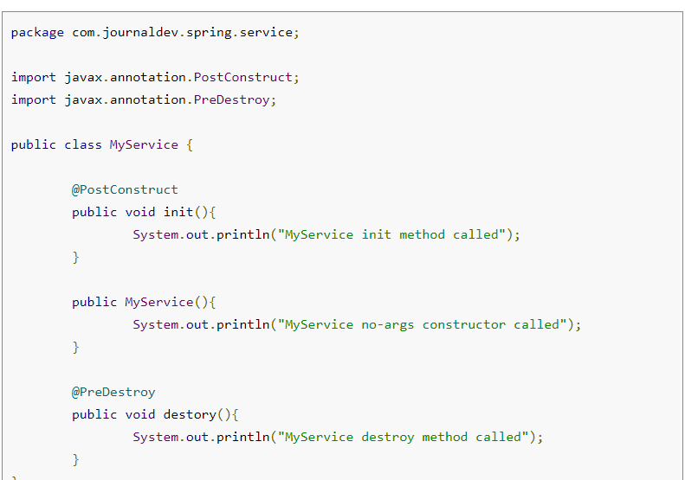

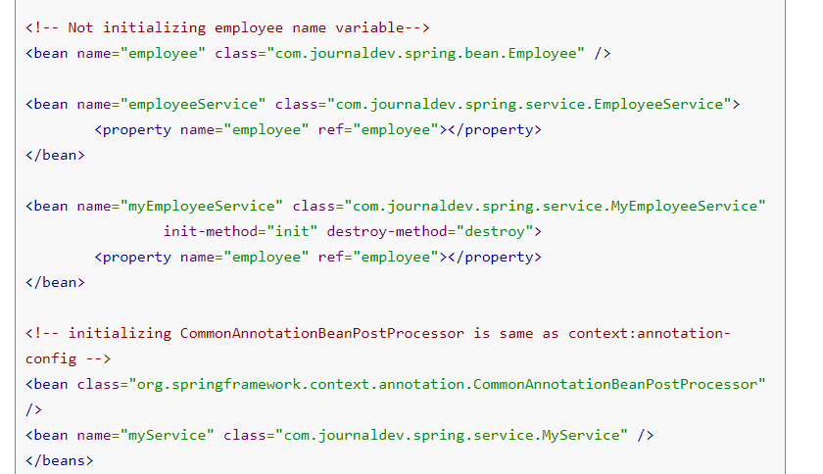

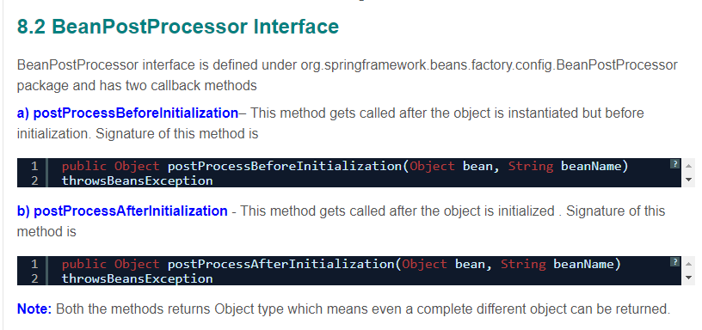

Example Code:

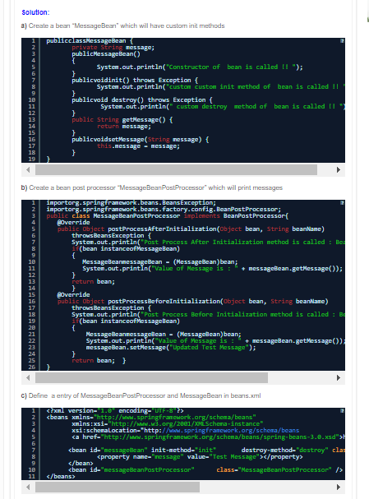

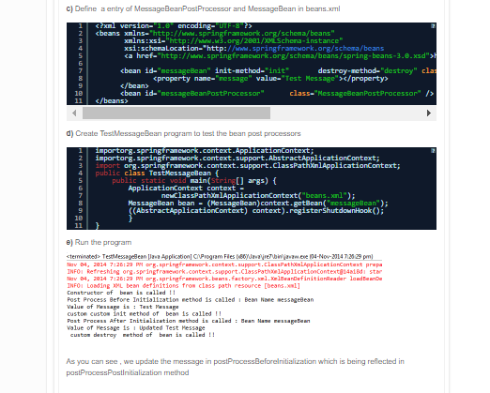

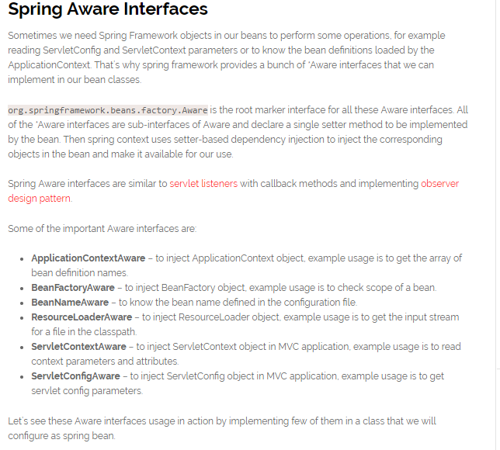

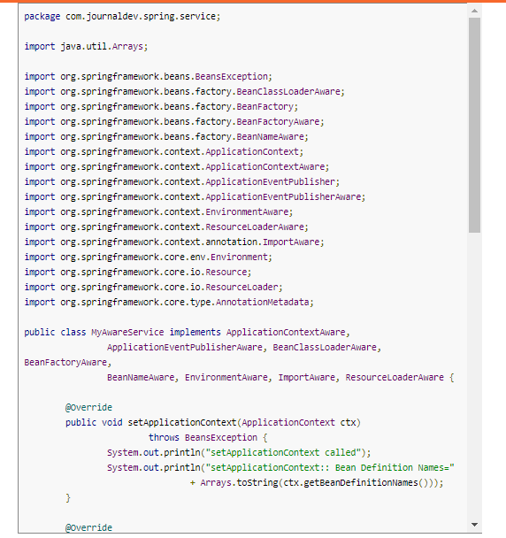

package com.journaldev.spring.service;

import java.util.Arrays;

import org.springframework.beans.BeansException;

import org.springframework.beans.factory.BeanClassLoaderAware;

import org.springframework.beans.factory.BeanFactory;

import org.springframework.beans.factory.BeanFactoryAware;

import org.springframework.beans.factory.BeanNameAware;

import org.springframework.context.ApplicationContext;

import org.springframework.context.ApplicationContextAware;

import org.springframework.context.ApplicationEventPublisher;

import org.springframework.context.ApplicationEventPublisherAware;

import org.springframework.context.EnvironmentAware;

import org.springframework.context.ResourceLoaderAware;

import org.springframework.context.annotation.ImportAware;

import org.springframework.core.env.Environment;

import org.springframework.core.io.Resource;

import org.springframework.core.io.ResourceLoader;

import org.springframework.core.type.AnnotationMetadata;

public class MyAwareService implements ApplicationContextAware,

ApplicationEventPublisherAware, BeanClassLoaderAware, BeanFactoryAware,

BeanNameAware, EnvironmentAware, ImportAware, ResourceLoaderAware {

@Override

public void setApplicationContext(ApplicationContext ctx)

throws BeansException {

System.out.println("setApplicationContext called");

System.out.println("setApplicationContext:: Bean Definition Names="

+ Arrays.toString(ctx.getBeanDefinitionNames()));

}

@Override

public void setBeanName(String beanName) {

System.out.println("setBeanName called");

System.out.println("setBeanName:: Bean Name defined in context="

+ beanName);

}

@Override

public void setBeanClassLoader(ClassLoader classLoader) {

System.out.println("setBeanClassLoader called");

System.out.println("setBeanClassLoader:: ClassLoader Name="

+ classLoader.getClass().getName());

}

@Override

public void setResourceLoader(ResourceLoader resourceLoader) {

System.out.println("setResourceLoader called");

Resource resource = resourceLoader.getResource("classpath:spring.xml");

System.out.println("setResourceLoader:: Resource File Name="

+ resource.getFilename());

}

@Override

public void setImportMetadata(AnnotationMetadata annotationMetadata) {

System.out.println("setImportMetadata called");

}

@Override

public void setEnvironment(Environment env) {

System.out.println("setEnvironment called");

}

@Override

public void setBeanFactory(BeanFactory beanFactory) throws BeansException {

System.out.println("setBeanFactory called");

System.out.println("setBeanFactory:: employee bean singleton="

+ beanFactory.isSingleton("employee"));

}

@Override

public void setApplicationEventPublisher(

ApplicationEventPublisher applicationEventPublisher) {

System.out.println("setApplicationEventPublisher called");

}

}

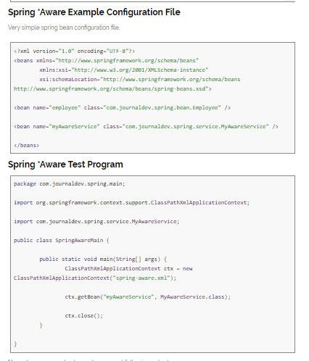

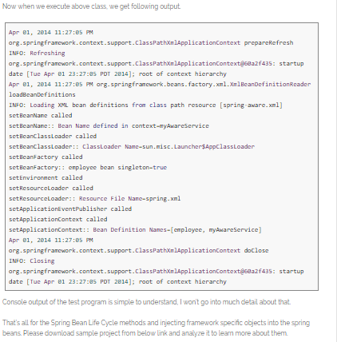

# 11) Sprin IoC Container

The main tasks performed by IoC container are:

* to instantiate the application class
* to configure the object
* to assemble the dependencies between the objects

There are two types of IoC containers. They are:

1. **BeanFactory [**org.springframework.beans.factory.BeanFactory]

Used for [Standalone applications]

1. **ApplicationContext[**org.springframework.context.ApplicationContext]

## Differences between BeanFactory and ApplicationContext

|  |  |
| --- | --- |
| **BeanFactory** | **ApplicationContext** |
| BeanFactory: (Lazy container because it creates the objects for the beans only when you explicitly call from the user/main class) | ApplicationContext: (Eager container because of creating the objects of all singleton beans while loading the spring.xml file itself) |
| Does not support the Annotation based dependency Injection. | Support Annotation based dependency Injection.-@Autowired, @PreDestroy |
| Doesn't Support I18N | Support I18N |
| it doesn't allow configure to multiple configuration files. ex: BeanFactory context=new XmlBeanFactory(new Resource("applicationContext.xml")); | it allow to configure multiple configuration files. ex: ApplicationContext context=new ClasspathXmlApplicationContext("applicationContext.xml"); |
| BeanFactory Container is basic container, it can only create objects and inject Dependencies But we can’t attach other services like security, transaction, messaging etc | to provide all the services we have to use ApplicationContext Container. |
| Beanfactory Container support only two scopes (singleton & prototype) of the beans | But ApplicationContext Container supports all the beans scope. |
|  |  |

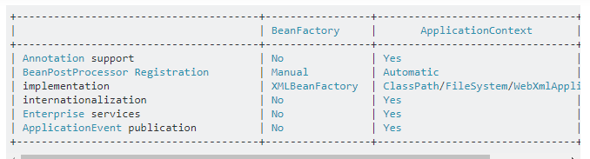

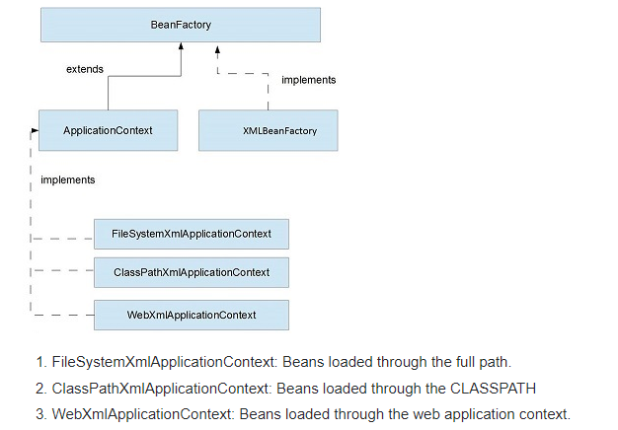

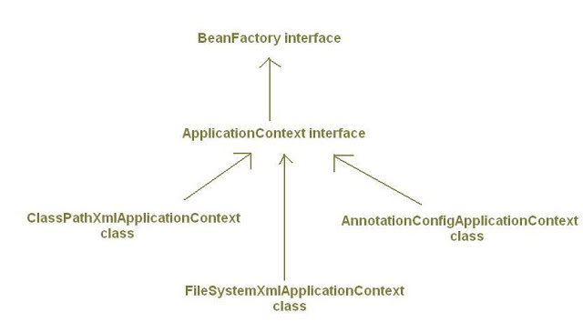

## SImplementations of ApplicationContext:

* There are many implementations of *ApplicationContext* interface. Important ones are:

## 1)  ClassPathXmlApplicationContext:

* It loads bean definitions from XML files located in the classpath.
* *Example1:*
* ApplicationContext context = new ClassPathXmlApplicationContext("myconfig.xml");
* *Example2:*  Loading configuration from multiple files under classpath.
* ApplicationContext context = new ClassPathXmlApplicationContext(
* newString[]{"servicesconfig.xml","daoconfig.xml"});

## 2) FileSystemXmlApplicationContext:

* It loads bean definitions from XML files in the file system.
* *Example:*
* ApplicationContext context = new FileSystemXmlApplicationContext("c:/myconfig.xml");

## 3)XmlWebApplicationContext:

* *XmlWebApplicationContext* is used to represent Spring Container for web applications.By defalut Spring creates object of *XmlWebApplicationContext* class to represent application context/spring container for web applications.
* It loads bean definitions from an XML file contained within a web application. By default it loads the configuration from file *"/WEB-INF/applicationContext.xml".*
* If we want to load bean definitions from more than one xml files we can specify their locations in  *contextConfigLocation*  parameter of *ContextLoaderListener* or *DispatcherServlet* in web.xml.[Read more about this here.](http://myjavadiary.blogspot.in/2012/08/webappicationcontext-and_5211.html)
* *XmlWebApplicationContext* is an implementation of *WebApplicationContext* interface which in turn extends *ApplicationContext*interface.
* [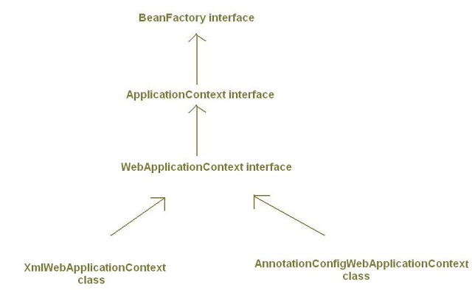](http://1.bp.blogspot.com/--Ejm4KKBCk8/UC-Sr9zanoI/AAAAAAAAAGY/57DP2Z13L1A/s1600/applicationcontext_8.JPG)

## 4)AnnotationConfigApplicationContext:

* *AnnotationConfigApplicationContext* class is used when we are using *Java-based configuration* for the bean definitions*instead of Xml files*.
* In above *ApplicationContext* implementations (*ClassPathXmlApplicationContext, FileSystemXmlApplicationContext*) we have supplied bean configuration from xml configuration files. *AnnotationConfigApplicationContext* class is used to create Spring container which takes bean definitions from java classes annotated with @Configuration, instead of xml files.
* It is introduced in Spring 3.0.
* *Example*:
* public static void main(String[]args){
* /\* Creating Spring IoC Container Without XML configuration file\*/
* ApplicationContext context= new AnnotationConfigApplicationContext(MyConfig.class);  
    
  MyBean beanObj = context.getBean(MyBean.class);  
    
  beanObj.someMethod();
* }
* In above code, *AnnotationConfigApplicationContext* is accepting*MyConfig* class as input. Here we are obtaining bean definitions from a java class named *MyConfig* annotated with @Configuration, instead of a Xml file. *MyConfig* class is described as:
* @Configuration
* public class MyConfig{
* @Bean
* public MyBean myBeanId(){
* return new MyBean();
* }
* }
* By giving @Configuration annotation we are treating *Myconfig* class as  <beans></beans>  tag of xml file.
* By giving @Bean annotation we are treating myBean() method as  <bean id="..." class="..."/>
* [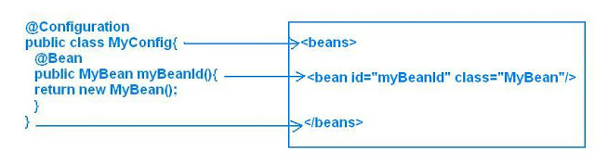](http://1.bp.blogspot.com/-_80gXx0KxOo/UC_BXzbWZ0I/AAAAAAAAAGw/ZYOgrNCDYg8/s1600/applicationcontext_9_1.JPG)
* Name of myBeanId() method will be treated as *bean id*.
* Both @Configuration and @Bean are also introduced in Spring 3.0.

## *5)*AnnotationConfigWebApplicationContext*:*

* Like *XmlWebApplicationContext* is web counterpart for the *ClassPathXmlApplicationContext* and *FileSystemXmlApplicationContext* and is used to create application context for web  applications, similarly, *AnnotationConfigWebApplicationContext* is web counterpart for *AnnotationConfigApplicationContext.*
* *AnnotationConfigWebApplicationContext* is used to create application context for web applications by using java clases as input for bean definitions instead of xml files.
* By default Spring use *XmlWebApplicationContext* (an implementation of *WebApplicationContext*) for creating spring container in web applications. But we can change this default value to *AnnotationConfigWebApplicationContext* by changing the value of *contextClass* parameter of *ContextLoaderListener* or *DispatcherServlet* in web.xml as shown below:
* *For ContextLoaderListener:*
* <web-app>
* <context-param>
* <param-name>**contextClass**</param-name>
* <param-value>
* org.springframework.web.context.support.**AnnotationConfigWebApplicationContext**
* </param-value>
* </context-param>
* <context-param>
* <param-name>contextConfigLocation</param-name>
* <!--MyConfig must be annotated with @Configuration-->
* <param-value> MyConfig</param-value>
* </context-param>
* <listener>
* <listener-class> org.springframework.web.context.ContextLoaderListener </listener-class>
* </listener>
* </web-app>
* *For* *DispatcherServlet:*
* <web-app>
* <servlet>
* <servlet-name>mydispatcher</servlet-name>
* <servlet-class > org.springframework.web.servlet.DispatcherServlet
* </servlet-class>
* <init-param>
* <param-name>**contextClass**</param-name>
* <param-value>
* org.springframework.web.context.support.**AnnotationConfigWebApplicationContext**
* </param-value>
* </init-param>
* <init-param>
* <param-name>contextConfigLocation</param-name>
* <!--MyConfig must be class annotated with @Configuration-->
* <param-value> MyConfig </param-value>
* </init-param>
* </servlet>
* <servlet-mapping>
* <servlet-name>mydispatcher</servlet-name>
* <url-pattern>\*.htm</url-pattern>
* </servlet-mapping>
* </web-app>
* I would like to know your comments and if you liked the article then please share it on social networking buttons.

By default Spring use *XmlWebApplicationContext* (an implementation of *WebApplicationContext*) for creating spring container in web applications.

javax.servlet.ServletContext servletContext = ..

org.springframework.web.context.WebApplicationContext webApplicationContext = WebApplicationContextUtils.getWebApplicationContext(servletContext);

SampleService service = (SampleService) webApplicationContext.getBean("sampleService");

## Spring - Bean Definition

Spring IoC container is totally decoupled from the format in which this configuration metadata is actually written. Following are the three important methods to provide configuration metadata to the Spring Container −

* XML based configuration file.
* Annotation-based configuration
* Java-based configuration

### XML based configuration file.

XML-based configuration file with different bean definitions including lazy initialization, initialization method, and destruction method

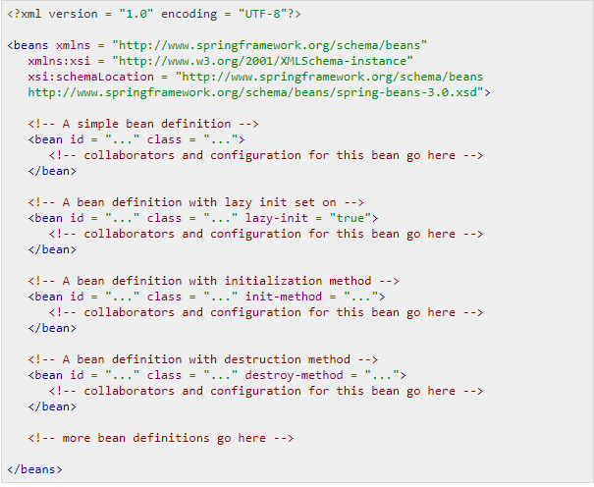

**XML Namespace(xmlns) is** a mechanism to avoid name conflicts by differentiating elements or attributes within an XML document that may have identical names, but different definitions.

**Xml:xsi:** Once you have the XML Schema Instance namespace available:**xmlns**:**xsi**="http://www.w3.org/2001/XMLSchema-instance" you can use the schemaLocation attribute. This attribute has two values, separated by a space. The first value is the namespace to use.

**xsi:schemaLocation** The xsi:schemaLocation attribute locates schemas for elements and attributes that are in a specified namespace

### SPRING BEAN CONFIGURATION FILE

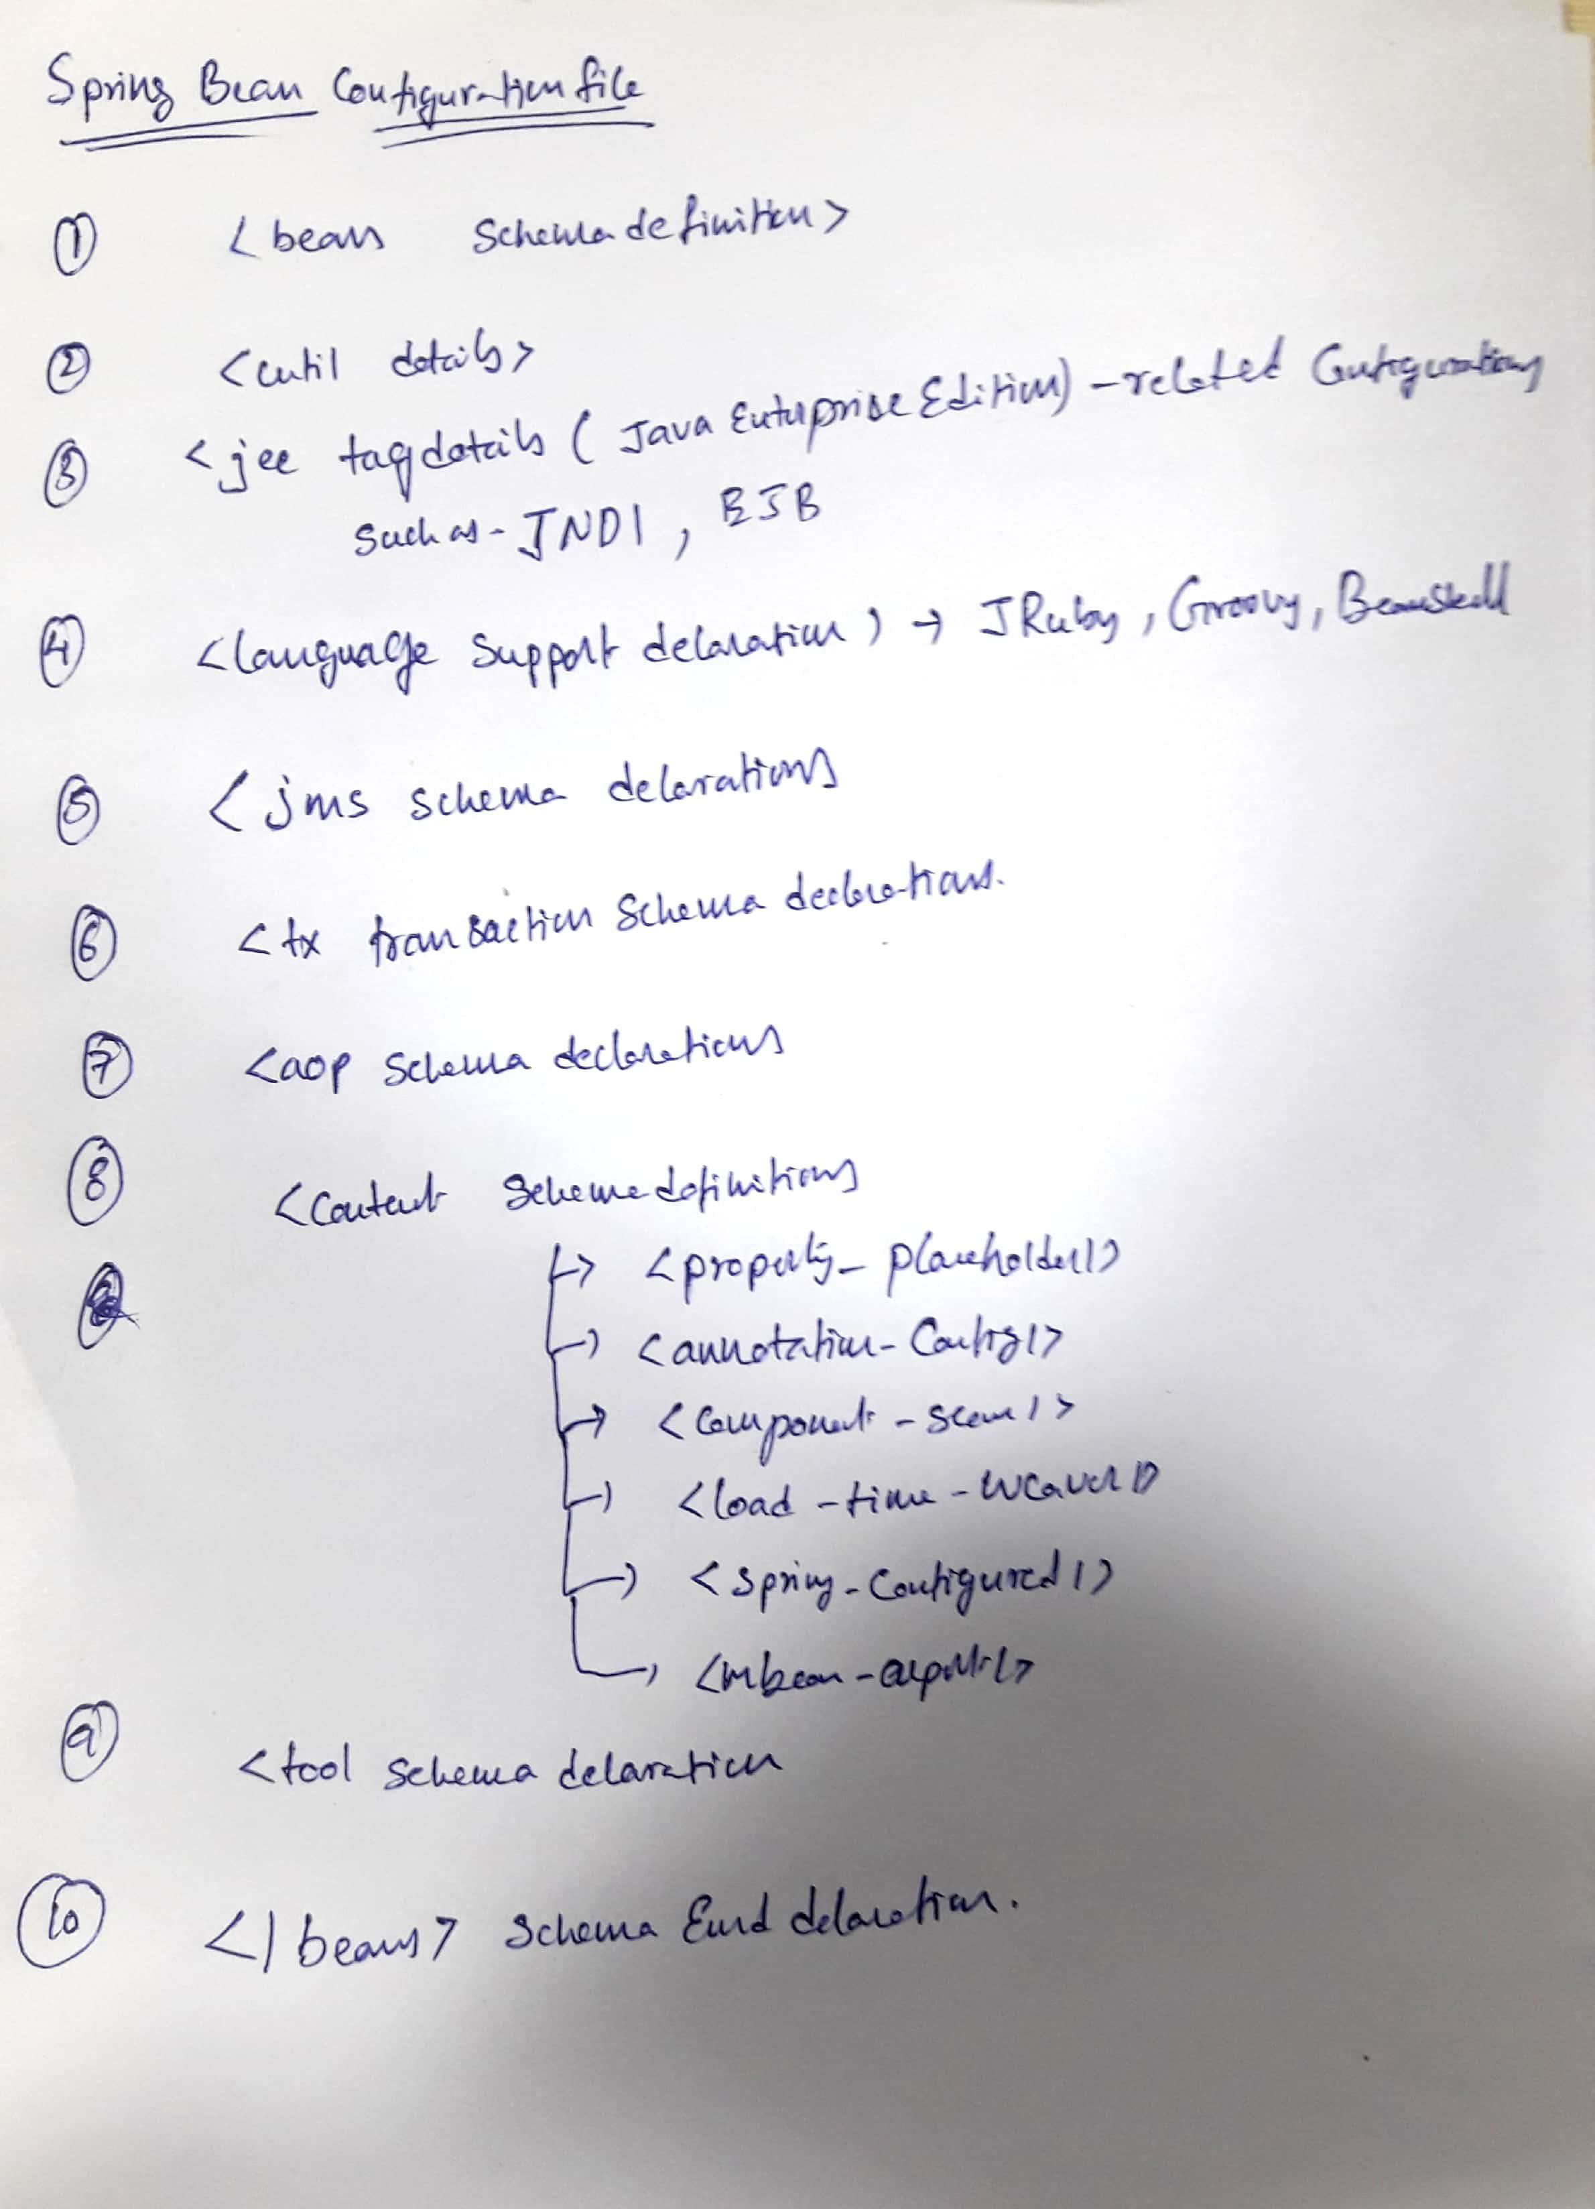

.

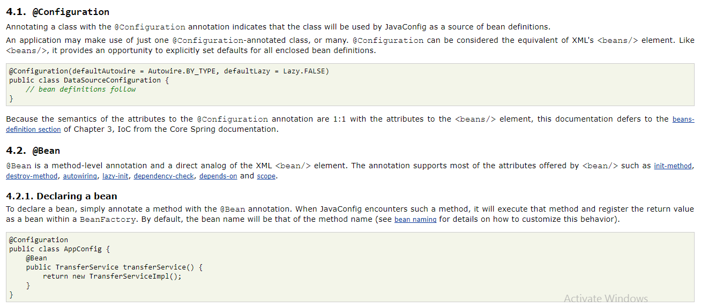

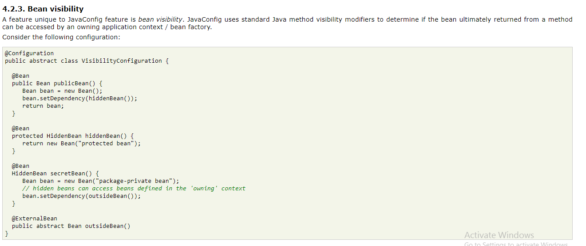

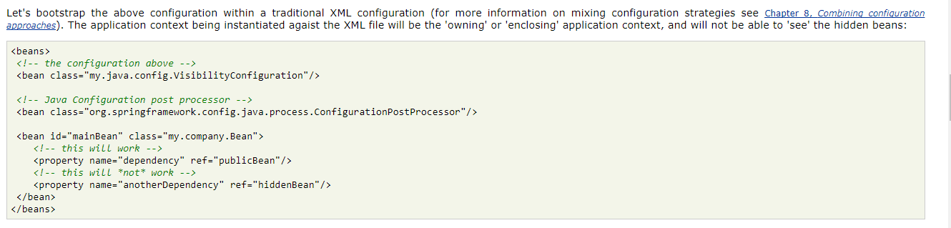

|  |  |
| --- | --- |
| **Sr.No.** | **Properties & Description** |
| 1 | **class**  This attribute is mandatory and specifies the bean class to be used to create the bean. |
| 2 | **name**  This attribute specifies the bean identifier uniquely. In XMLbased configuration metadata, you use the id and/or name attributes to specify the bean identifier(s). |
| 3 | **scope**  This attribute specifies the scope of the objects created from a particular bean definition and it will be discussed in bean scopes chapter. |
| 4 | **constructor-arg**  This is used to inject the dependencies and will be discussed in subsequent chapters. |
| 5 | **properties**  This is used to inject the dependencies and will be discussed in subsequent chapters. |
| 6 | **autowiring mode**  This is used to inject the dependencies and will be discussed in subsequent chapters. |
| 7 | **lazy-initialization mode**  A lazy-initialized bean tells the IoC container to create a bean instance when it is first requested, rather than at the startup. |
| 8 | **initialization method**  A callback to be called just after all necessary properties on the bean have been set by the container. It will be discussed in bean life cycle chapter. |
| 9 | **destruction method**  A callback to be used when the container containing the bean is destroyed. It will be discussed in bean life cycle chapter. |

# 12)Spring application has two types of context configuration files for [Spring MVC](https://javabeat.net/spring-mvc-example/) module:

1. **ApplicationContext (default name for this file is applicationContext.xml)**
2. **WebApplicationContext (default name for this file is xxx-servlet.xml where xxx is the DispatcherServlet name in web.xml)**

## ApplicationContext

* applicationContext.xml is the root context configuration for every web application.
* Spring loads applicationContext.xml file and creates the ApplicationContext for the whole application.
* There will be only one application context per web application.
* If you are not explicitly declaring the context configuration file name in web.xml using the contextConfigLocation param, Spring will search for the applicationContext.xml under WEB-INF folder and throw [FileNotFoundException](https://javabeat.net/filenotfoundexception-java/) if it could not find this file.

## WebApplicationContext

* Apart from **ApplicationContext**, there can be multiple **WebApplicationContext** in a single web application.
* In simple words, each DispatcherServlet associated with single WebApplicationContext.
* xxx-servlet.xml file is specific to the [DispatcherServlet](https://javabeat.net/spring-mvc-dispatcherservlet-example/) and a web application can have more than one DispatcherServlet configured to handle the requests.
* In such scenarios, each DispatcherServlet would have a separate xxx-servlet.xml configured. But, applicationContext.xml will be common for all the [servlet](https://javabeat.net/servlets-tutorials/)configuration files.
* Spring will by default load file named “xxx-servlet.xml” from your webapps WEB-INF folder where xxx is the servlet name in web.xml.
* If you want to change the name of that file name or change the location, add initi-param with contextConfigLocation as param name.

## ContextLoaderListener

* Performs the actual initialization work for the root application context.
* Reads a “contextConfigLocation” context-param and passes its value to the context instance, parsing it into potentially multiple file paths which can be separated by any number of commas and spaces, e.g. “WEB-INF/applicationContext1.xml, WEB-INF/applicationContext2.xml”.
* ContextLoaderListener is optional. Just to make a point here: you can boot up a Spring application without ever configuring ContextLoaderListener, just a basic minimum web.xml with DispatcherServlet.

Sample web.xml file with configurations:

<?xml version="1.0" encoding="UTF-8"?>

<web-app xmlns:xsi="http://www.w3.org/2001/XMLSchema-instance" xmlns="http://java.sun.com/xml/ns/javaee" xsi:schemaLocation="http://java.sun.com/xml/ns/javaee http://java.sun.com/xml/ns/javaee/web-app\_3\_0.xsd" id="WebApp\_ID" version="3.0">

<display-name>Spring MVC</display-name>

<!-- This is the root application context for whole web application. -->

<context-param>

<param-name>contextConfigLocation</param-name>

<param-value>/WEB-INF/rootApplicationContext.xml</param-value>

</context-param>

<listener>

<listener-class>

org.springframework.web.context.ContextLoaderListener

</listener-class>

</listener>

<servlet>

<servlet-name>webmvc1</servlet-name>

<servlet-class>

org.springframework.web.servlet.DispatcherServlet

</servlet-class>

<!-- We require this configuration when we want to change the default name / location of the servlet specific configuration files -->

<init-param>

<param-name>contextConfigLocation</param-name>

<param-value>/WEB-INF/mvc1-servlet.xml</param-value>

</init-param>

<load-on-startup>1</load-on-startup>

</servlet>

<servlet>

<servlet-name>webmvc2</servlet-name>

<servlet-class>

org.springframework.web.servlet.DispatcherServlet

</servlet-class>

<!-- We require this configuration when we want to change the default name / location of the servlet specific configuration files -->

<init-param>

<param-name>contextConfigLocation</param-name>

<param-value>/WEB-INF/mvc2-servlet.xml</param-value>

</init-param>

<load-on-startup>1</load-on-startup>

</servlet>

<servlet-mapping>

<servlet-name>webmvc1</servlet-name>

<url-pattern>/webmvc1</url-pattern>

</servlet-mapping>

<servlet-mapping>

<servlet-name>webmvc2</servlet-name>

<url-pattern>/webmvc2</url-pattern>

</servlet-mapping>

</web-app>

# 13)Spring - Bean Scopes

In the spring bean configurations, bean attribute called 'scope' defines what kind of object has to created and returned. There are 5 types of bean scopes available, they are:

**1) singleton:**Returns a single bean instance per Spring IoC container.

**2) prototype:**Returns a new bean instance each time when requested.

**3) request:**Returns a single instance for every HTTP request call.

**4) session:**Returns a single instance for every HTTP session.

**5) global session:**global session scope is equal as session scope on portlet-based web applications.

## Are Singleton beans thread safe in Spring Framework?

Spring framework does not do anything under the hood concerning the multi-threaded behavior of a [**singleton**](https://howtodoinjava.com/design-patterns/singleton-design-pattern-in-java/) bean. It is the developer’s responsibility to deal with concurrency issue and [**thread safety**](https://howtodoinjava.com/core-java/multi-threading/what-is-thread-safety/) of the singleton bean.

While practically, most spring beans have no mutable state (e.g. Service and DAO clases), and as such are trivially thread safe. But if your bean has mutable state (e.g. View Model Objects), so you need to ensure thread safety. The most easy and obvious solution for this problem is to change bean scope of mutable beans from “**singleton**” to “**prototype**“.

Here is an example for specifying bean scope configuration:

|  |  |  |
| --- | --- | --- |
| [?](http://www.java2novice.com/spring/bean-scope-types/)   |  |  | | --- | --- | | 1  2  3  4  5  6  7  8  9  10  11  12  13  14  15  16 | <beans xmlns="<http://www.springframework.org/schema/beans>"      xmlns:xsi="<http://www.w3.org/2001/XMLSchema-instance>"      xsi:schemaLocation="http://www.springframework.org/schema/beans      http://www.springframework.org/schema/beans/spring-beans-3.0.xsd">        <!-- Since scope is not defined, it assigns default value 'singleton'.       It creates only one instance per spring IoC. -->      <bean id="articleBean" class="com.java2novice.bean.Article" />        <!-- Since scope is prototype, it creates and returns ColorBean for every      call-->      <bean id="clrBean" class="com.java2novice.bean.ColorBean" scope="prototype"/>        <bean id="ticketBean" class="com.java2novice.bean.TicketManager" scope="singleton"/>    </beans> | |

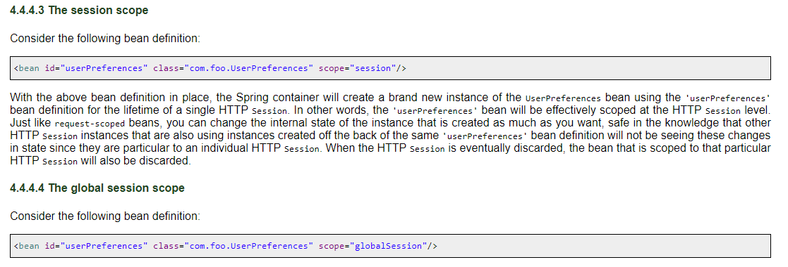

scope by using the **@Scope** annotation:

singleton

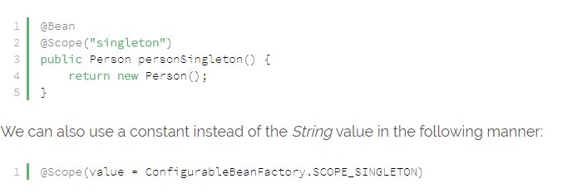

**Prototype Scope**

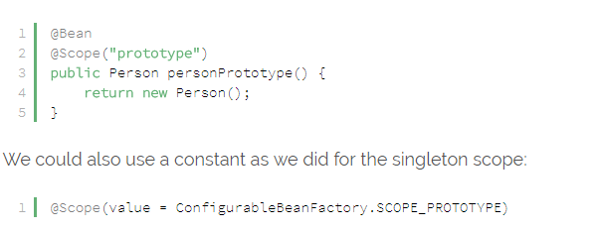

**Request Scope**

@Bean

@Scope(value = WebApplicationContext.SCOPE\_REQUEST, proxyMode = ScopedProxyMode.TARGET\_CLASS)

public HelloMessageGenerator requestMessage() {

    return new HelloMessageGenerator();

}

**Session Scope**

@Bean

@Scope(value = WebApplicationContext.SCOPE\_SESSION, proxyMode = ScopedProxyMode.TARGET\_CLASS)

public HelloMessageGenerator sessionMessage() {

    return new HelloMessageGenerator();

}

**GlobalSession Scope**

@Bean

@Scope(value = WebApplicationContext.SCOPE\_GLOBAL\_SESSION, proxyMode = ScopedProxyMode.TARGET\_CLASS)

public HelloMessageGenerator globalSessionMessage() {

    return new HelloMessageGenerator();

}

# ****14) Spring DI –Dependency Injection****

Dependency Injection (DI) design pattern is used to define the object dependencies between each other.

* Setter injection
* Construction injection
* Interface injection

But in spring we have only setter, constructor injections but **not** interface injection,  In spring 2.x we have interface injection

## WHAT IS THE Dependency lookup:

* + If resource of the application spending time to search and get dependent values from other resources of application  then it is called dependency lookup
  + **Example :**
    - The way servlet / ejb component gets jdbc data source object form registry through jndi lookup operation is called dependency lookup
  + In dependency lookup resource perform **“pull”** operation on other resource or on underlying s/w to get the dependent values
  + **Disadvantage**: resource has to spend time to search and get dependent values
  + **Advantage**: resource can get only required dependent values

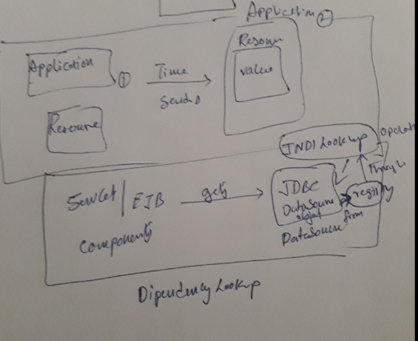

**Note**: in struts application form bean class is mediator for actionservlet to send multiple values of form pages to actionservlet class in the form of single object

## Dependency injection:

* + if underlying s/w (or) framework server (or) special resource of application assign dependent values to resource, the moment resource is ready then it is called dependency injection or inversion of controller (IOC)
  + **Example :**
    - The way student gets his course material the moment to register for course is called dependency injection
    - If jdbc data source object is assigned to servlet object by servlet container the moment servlet object is created is called dependency injection
  + In dependency injection underlying s/w or container/ framework server or special resource perform **“push”** operation on the resource of application to assign dependent values the moment resource is ready
  + **Advantage**: resource need not spend time to get dependent value and it can use dependent value at the moment resource is ready
  + **Disadvantage**: both necessary and unnecessary values will be injected
  + In struts the way action servlet dynamically assign form data to form bean class properties
  + By creating /locating formbean class object is called dependency injection or ioc

**Note**: the servlet container of web server / application server where struts application is deployed wills created actionservlet class object. This actionservlet create object for form bean and action class of struts application. The common thing the struts application contain is move architecture mvc design pattern

## What are inner beans in Spring?

In Spring framework, whenever a bean is used for only one particular property, it’s advise to declare it as an inner bean. And the inner bean is supported both in setter injection ‘**property**‘ and constructor injection ‘**constructor-arg**‘.

For example, let’s say we one Customer class having reference of Person class. In our application, we will be creating only one instance of Person class, and use it inside Customer.

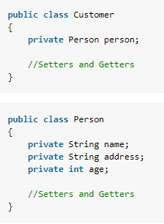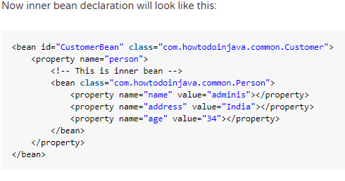

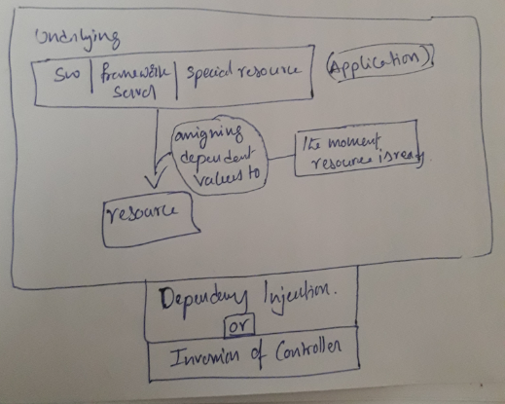

## Dependency Injection by Constructor Example

**Constructor-based dependency Injection**: A bean is instantiated with other beans via constructor.

In this type of injection spring container uses constructor of the bean class for assigning the dependencies.

In spring config xml, we need to inform to the spring IOC container about constructor injection by using <constructor -arg />

The **<constructor-arg>**subelement of **<bean>** is used for constructor injection. Here we are going to inject

1. primitive and String-based values
2. Dependent object (contained object)
3. Collection values etc.

In spring bean class, if both constructor and setter injection applied for same property then constructor injection value will be overridden by setter injection, because constructor injection will happen at the object creation time, and setter after objection right…, so setter will overrides

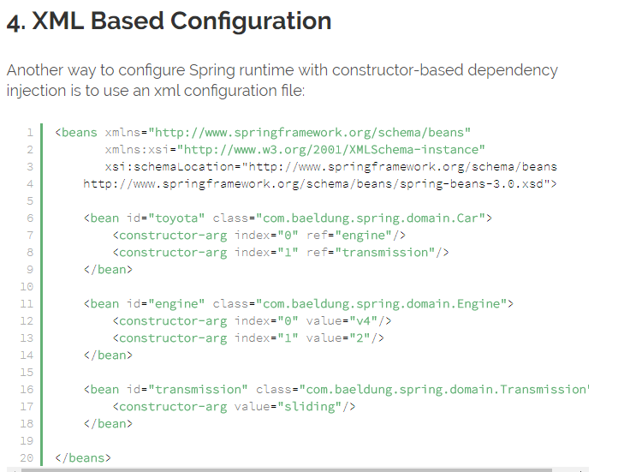

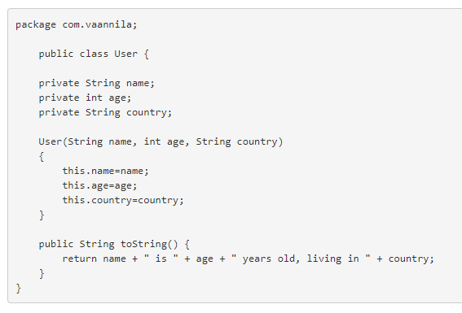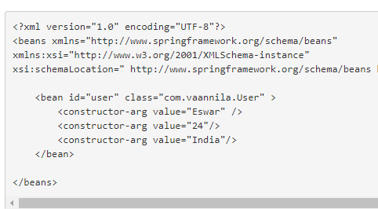

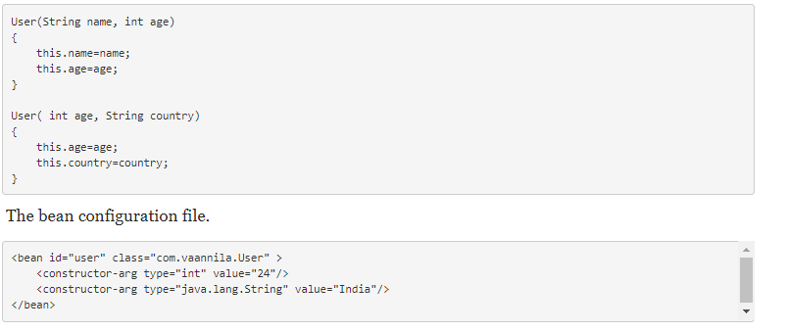

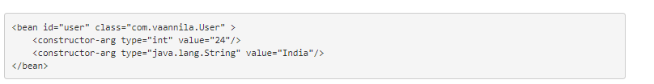

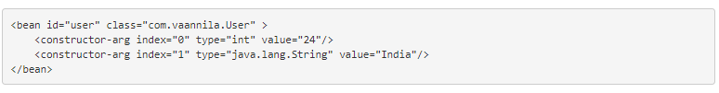

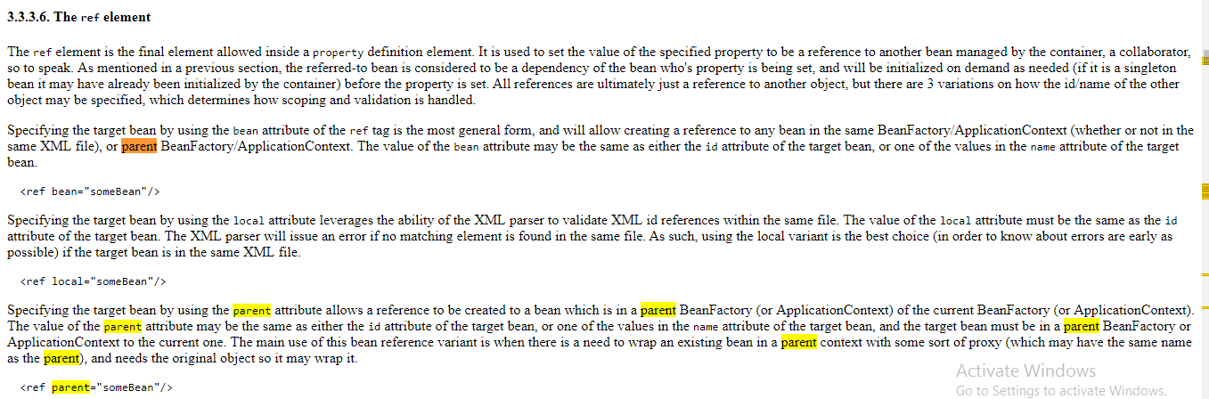

Collections definitions: List,Set,Map

### List or Set

### Constructor Injection with String Collection Example

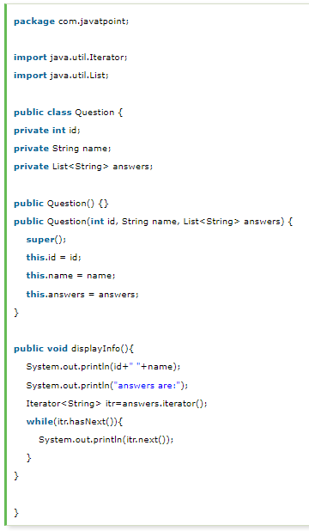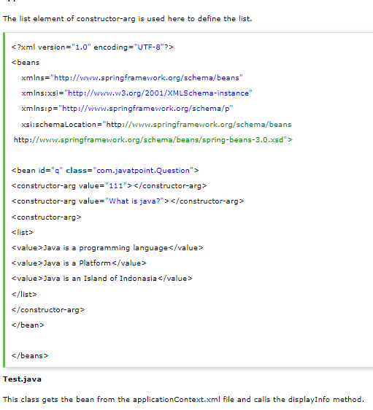

### Constructor Injection with Non-String Collection (having Dependent Object) Example

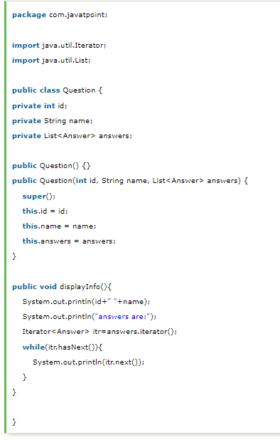 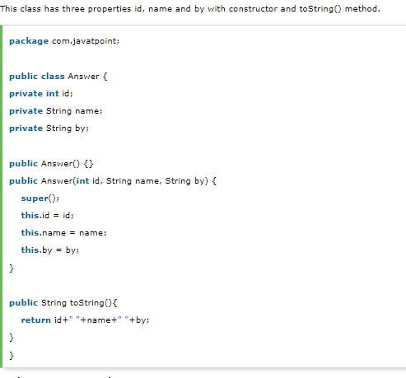

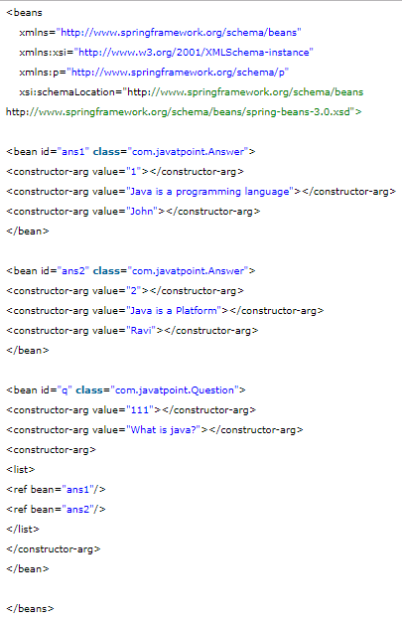

### Map

#### Constructor Injection with Map Example

In this example, we are using **map** as the answer that have answer with posted username. Here, we are using key and value pair both as a string.

Like previous examples, it is the example of forum where **one question can have multiple answers**.

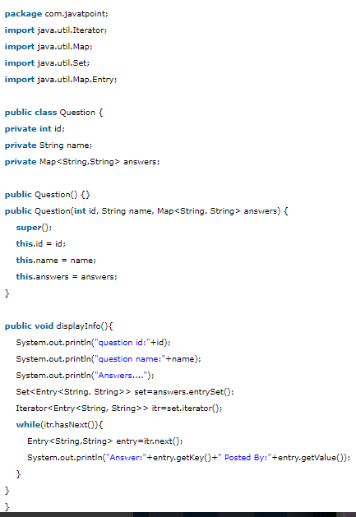 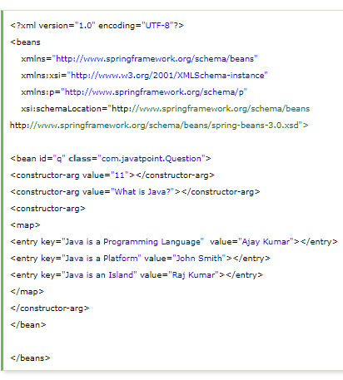

#### Constructor Injection with Non-String Map (having dependent Object) Example

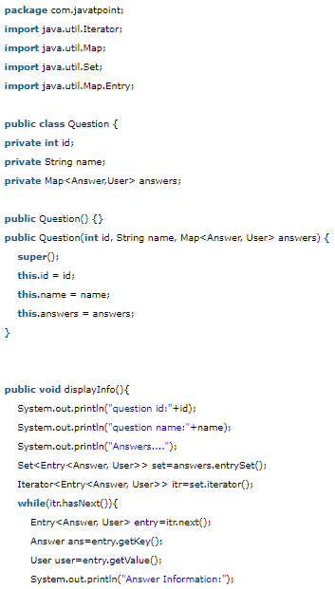 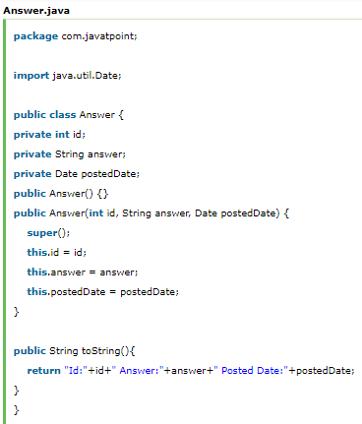

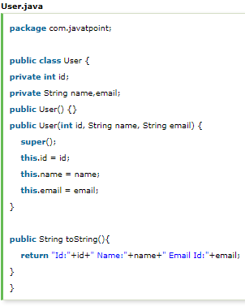 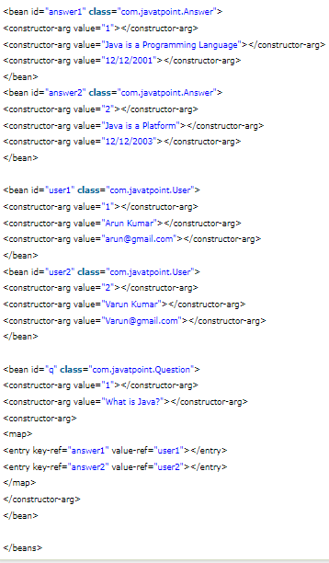

## Inheriting Bean in Spring

1. [Inheriting Bean in Spring](https://www.javatpoint.com/spring-tutorial-inheriting-bean-in-spring)

By using the **parent** attribute of **bean**, we can specify the inheritance relation between the beans. In such case, parent bean values will be inherited to the current bean.

Let's see the simple example to inherit the bean.

**Employee.java**

This class contains three properties, three constructor and show() method to display the values.

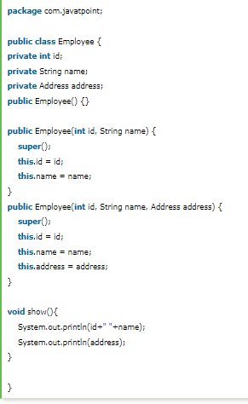 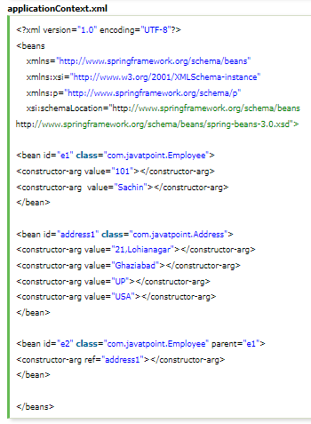

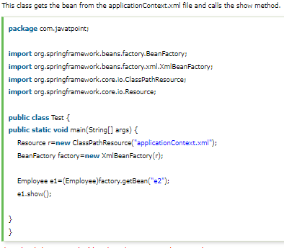

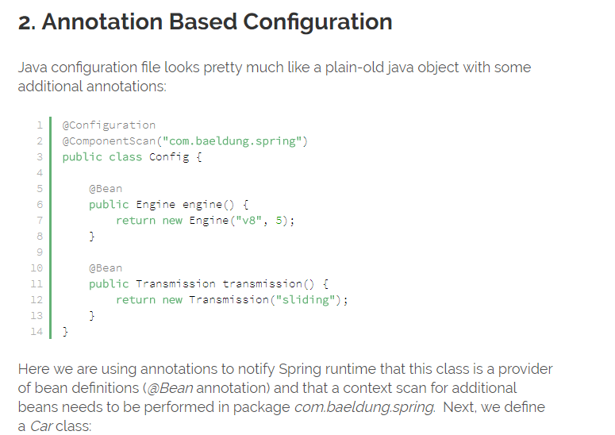

|  |  |
| --- | --- |
| 1  2  3  4  5  6  7  8  9 | @Component  public class Car {        @Autowired      public Car(Engine engine, Transmission transmission) {          this.engine = engine;          this.transmission = transmission;      }  } |

Spring will encounter our *Car*class while doing a package scan and will initialize its instance by calling the *@Autowired*annotated constructor.

Instances of *Engine and Transmission*will be obtained by calling *@Bean*annotated methods of the *Config*class.  Finally, we need to bootstrap an *ApplicationContext*using our POJO configuration:

|  |  |
| --- | --- |
| 1  2 | ApplicationContext context = new AnnotationConfigApplicationContext(Config.class);  Car car = context.getBean(Car.class); |

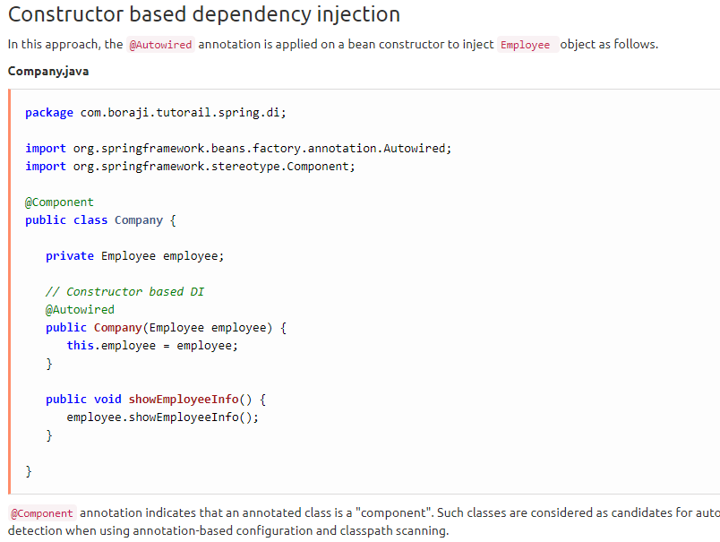

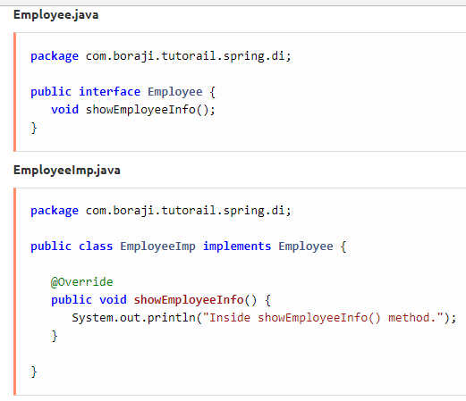

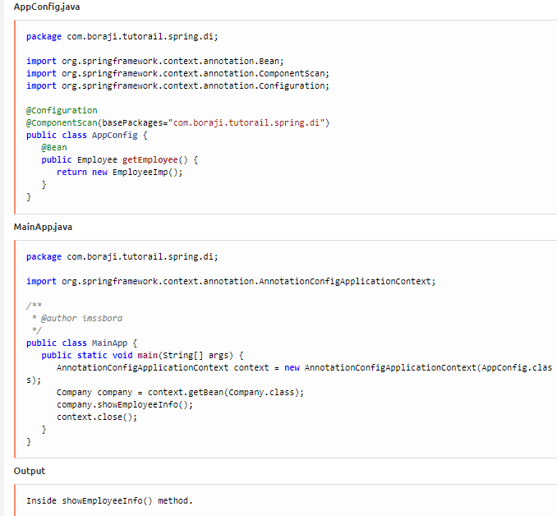

## Setter-based dependency Injection

We can inject the dependency by setter method also. The **<property>** subelement of **<bean>** is used for setter injection. Here we are going to inject

1. primitive and String-based values
2. Dependent object (contained object)
3. Collection values etc.

**Injecting primitive and string-based values by setter method**

**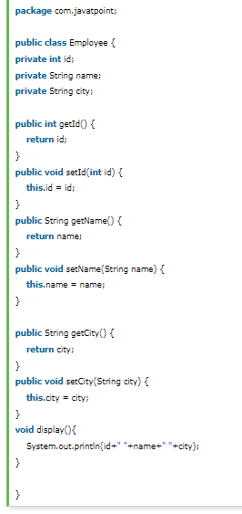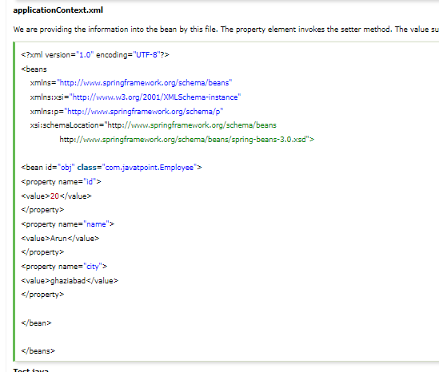**

**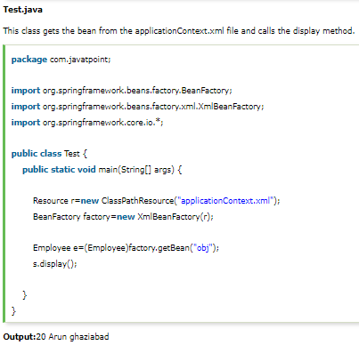**

### Setter Injection with Dependent Object Example

we can inject the dependency of another bean using setters. In such case, we use **property** element. Here, our scenario is **Employee HAS-A Address**. The Address class object will be termed as the dependent object. Let's see the Address class first:

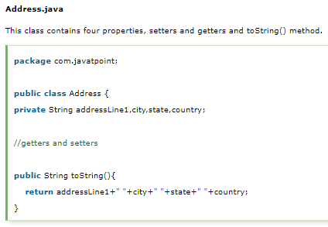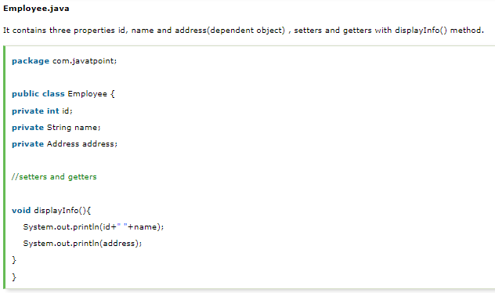

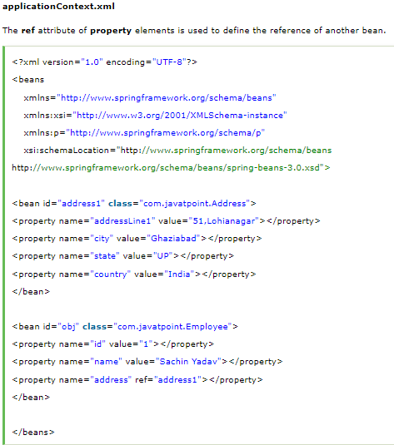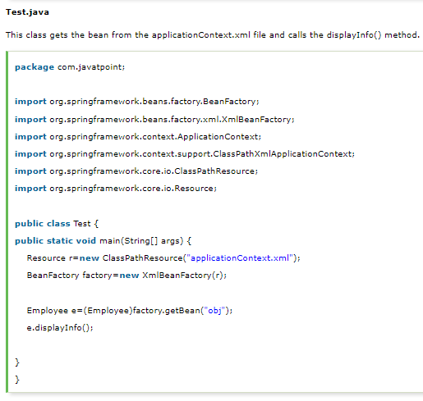

### Setter Injection with Collection Example

It can be:

1. **list**
2. **set**
3. **map**

Each collection can have string based and non-string based values.

Java Collection types such as List, Set, Map, and Properties

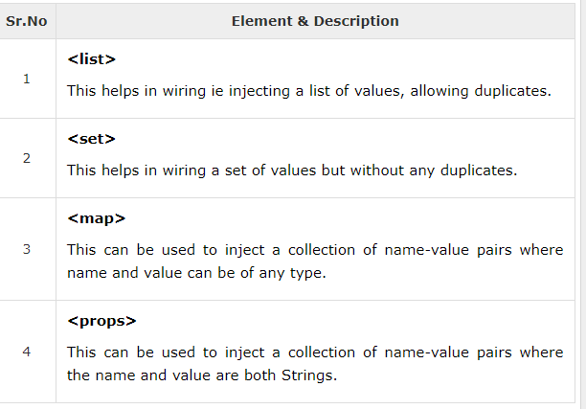

Here is the content of **JavaCollection.java** file −

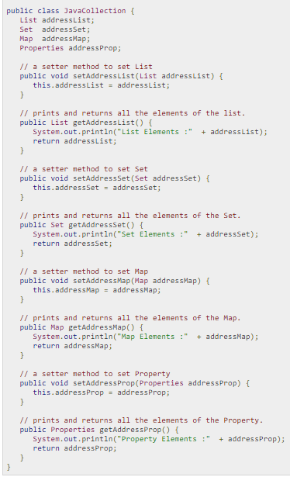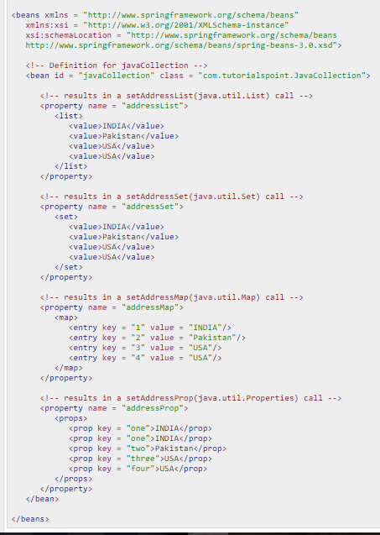

## Injecting Bean References

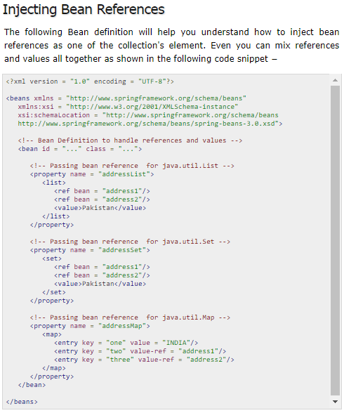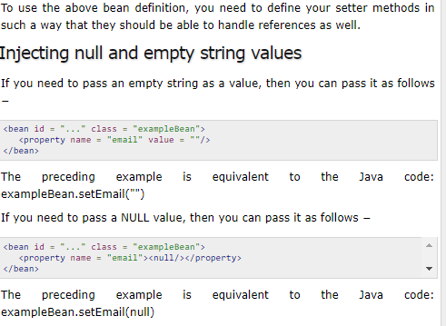

## Difference between constructor and setter injection IN SPRING

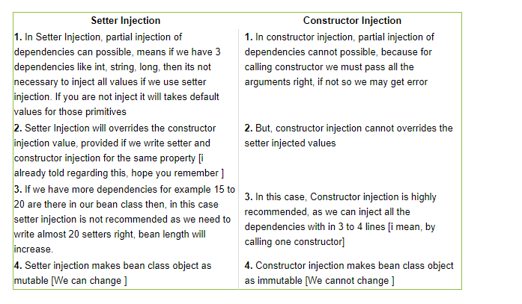

1. **Partial dependency**: can be injected using setter injection but it is not possible by constructor. Suppose there are 3 properties in a class, having 3 arg constructor and setters methods. In such case, if you want to pass information for only one property, it is possible by setter method only.
2. **Overriding**: Setter injection overrides the constructor injection. If we use both constructor and setter injection, IOC container will use the setter injection.
3. **Changes**: We can easily change the value by setter injection. It doesn't create a new bean instance always like constructor. So setter injection is flexible than constructor injection.

### Constructor and Setter based Dependency Injection using JavaConfig

1. In JavaConfig, the class is annotated with @Configuration annotation. We define our bean using spring @Beanannotation. Here constructor and setter based dependency injection is simply creating java class using constructor or setter method. Find the configuration class.   
   **AppConfig.java**
2. package com.concretepage;
3. import org.springframework.context.annotation.Bean;
4. import org.springframework.context.annotation.Configuration;
5. import com.concretepage.bean.Address;
6. import com.concretepage.bean.Company;
7. import com.concretepage.bean.Employee;
8. import com.concretepage.bean.Product;
9. @Configuration
10. public class AppConfig {
11. @Bean(name="mycompany")
12. public Company getCompany() {
13. Company comp = new Company();
14. comp.setCompId(100);
15. comp.setCompName("ConcretePage");
16. return comp;
17. }
18. @Bean(name="myaddress")
19. public Address getAddress() {
20. Address add = new Address(200, "Varanasi");
21. return add;
22. }
23. @Bean(name="product")
24. public Product getProduct() {
25. Product product = new Product();
26. product.setAddress(getAddress());
27. product.setCompany(getCompany());
28. return product;
29. }
30. @Bean(name="employee")
31. public Employee getEmployee() {
32. Employee employee = new Employee(getCompany(),getAddress());
33. return employee;
34. }
35. }
36. To test the application, I am using the Main class as follows.   
    **SpringDemo.java**
37. package com.concretepage;
38. import org.springframework.context.annotation.AnnotationConfigApplicationContext;
39. import com.concretepage.bean.Employee;
40. import com.concretepage.bean.Product;
41. public class SpringDemo {
42. public static void main(String[] args) {
43. AnnotationConfigApplicationContext ctx = new AnnotationConfigApplicationContext();
44. ctx.register(AppConfig.class);
45. ctx.refresh();
46. System.out.println("--Result by Setter based Dependency Injection--");
47. Product product = (Product)ctx.getBean("product");
48. product.print();
49. System.out.println("--Result by Constructor based Dependency Injection--");
50. Employee employee = ctx.getBean(Employee.class);
51. employee.print();
52. ctx.close();
53. }
54. }
55. We can call bean by passing class name or by using bean name. Find the code snippet to use bean name.
56. Product product = (Product)ctx.getBean("product");
58. Find the output.
59. --Result by Setter based Dependency Injection--
60. CompId:100, Company name:ConcretePage
61. AddId:200, City:Varanasi
62. --Result by Constructor based Dependency Injection--
63. CompId:100, Company name:ConcretePage
64. AddId:200, City:Varanasi

sSpring Dependency Injection with @Autowire Annotation

1. Spring provides @Autowire annotation that can make field, constructor or setter method autowired using spring dependency injection. In our example we will autowire a field. We can create bean using annotations from the package *org.springframework.stereotype*.   
     
   **@Component**: It indicates that the class is a component and eligible to be autowired.   
   **@Service**: It indicates that a class is service and eligible to be autowired.   
   **@Repository**: It indicates that the class will act as repository and eligible to be autowired.   
     
   For the example we have two classes CalcUtil annotated with @Component and FarmerService annotated with @Service. CalcUtil will be autowired using @Autowire annotation in FarmerService class at field level. Find theCalcUtil class.   
   **CalcUtil.java**
2. package com.concretepage.bean;
3. import org.springframework.stereotype.Component;
4. @Component
5. public class CalcUtil {
6. public int multiply(int num1, int num2) {
7. return num1 \* num2;
8. }
9. }
10. Now find the FarmerService class.   
    **FarmerService.java**
11. package com.concretepage.bean;
12. import org.springframework.beans.factory.annotation.Autowired;
13. import org.springframework.stereotype.Service;
14. @Service
15. public class FarmerService {
16. @Autowired
17. private CalcUtil calcUtil;
18. public int getFieldArea() {
19. return calcUtil.multiply(12, 15);
20. }
21. }
22. In java configuration class, we need to use @ComponentScan(basePackages="com.concretepage.bean"), to scan our beans. Find the JavaConfig file.   
    **AppConfig.java**
23. package com.concretepage;
24. import org.springframework.context.annotation.ComponentScan;
25. import org.springframework.context.annotation.Configuration;
26. @Configuration
27. @ComponentScan(basePackages="com.concretepage.bean")
28. public class AppConfig {
29. }
30. Run the application using the class as follows.   
    **SpringDemo.java**
31. package com.concretepage;
32. import org.springframework.context.annotation.AnnotationConfigApplicationContext;
33. import com.concretepage.bean.FarmerService;
34. public class SpringDemo {
35. public static void main(String[] args) {
36. AnnotationConfigApplicationContext ctx = new AnnotationConfigApplicationContext();
37. ctx.register(AppConfig.class);
38. ctx.refresh();
39. FarmerService farmer = ctx.getBean(FarmerService.class);
40. System.out.println("Field Area:"+ farmer.getFieldArea());
41. ctx.close();
42. }
43. }
44. Find the output.
45. Field Area:180

# 15) Autowiring in Spring[Explain Spring Bean Autowiring?](https://howtodoinjava.com/interview-questions/top-spring-core-interview-questions-with-answers/#bean_autowiring)

In spring framework, dependency injection of bean can be achieved automatically by using @Autowired annotation.

We can use @Autowired annotation on field, setter method or constructor. In this case, the required bean for dependency injection is searched by spring container.

## Autowiring through XML Configurations:

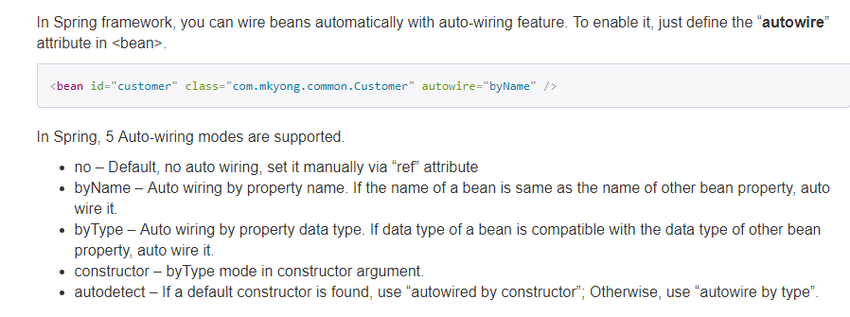

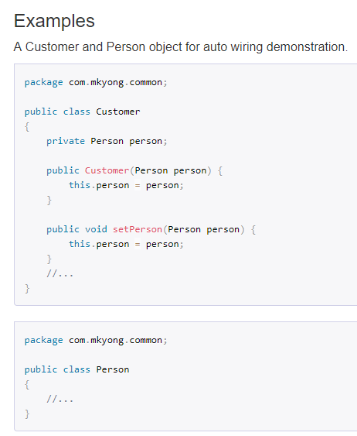

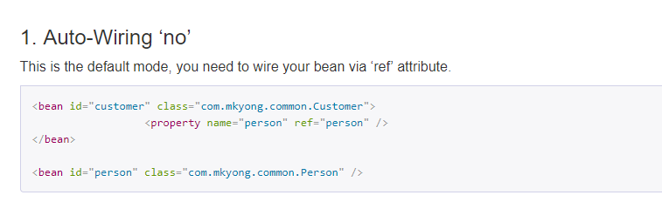

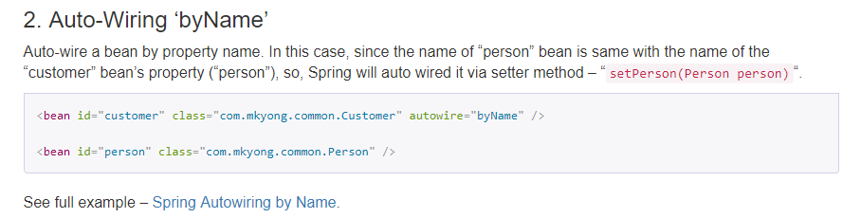

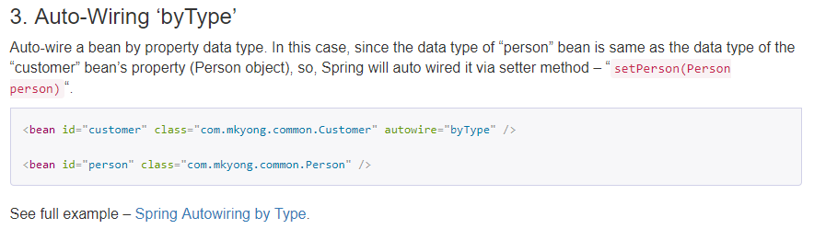

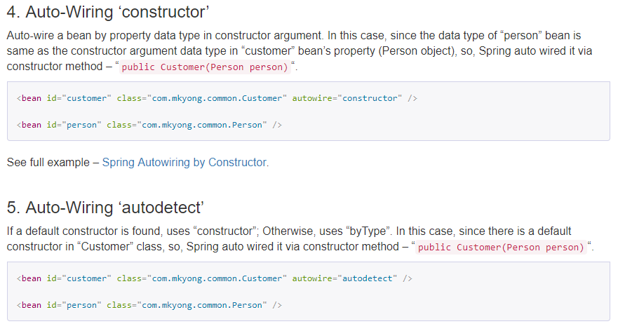

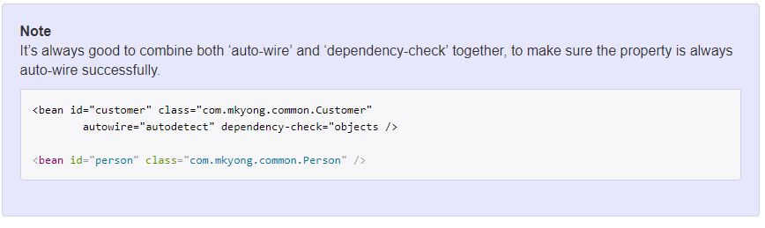

## ****Using autowiring with @Autowired annotations****

To use @Autowired annotation in bean classes, you must first enable the annotation in spring application using below configuration.

|  |
| --- |
| <context:annotation-config /> |

Same can be acheived using ‘AutowiredAnnotationBeanPostProcessor’ bean definition in configuration file.

|  |
| --- |
| <bean class ="org.springframework.beans.factory.annotation.AutowiredAnnotationBeanPostProcessor"/> |

Now, when annotation configuration has been enables, you are free to autowire bean dependencies using @Autowired, the way you like. This is done by three ways:

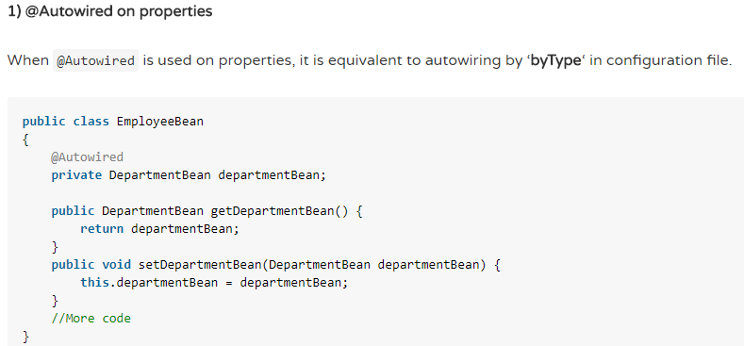

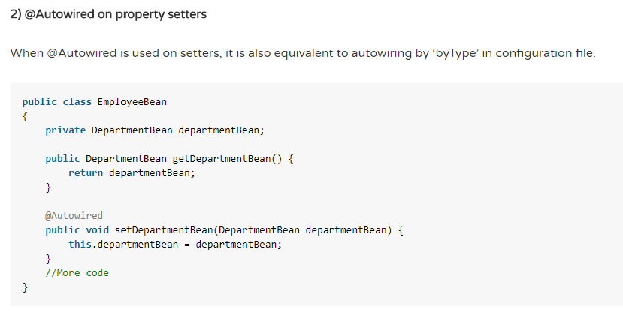

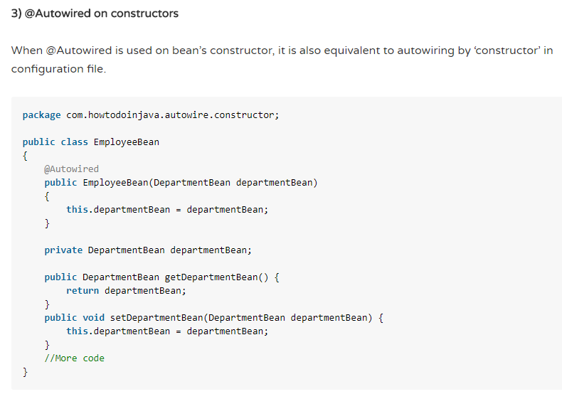

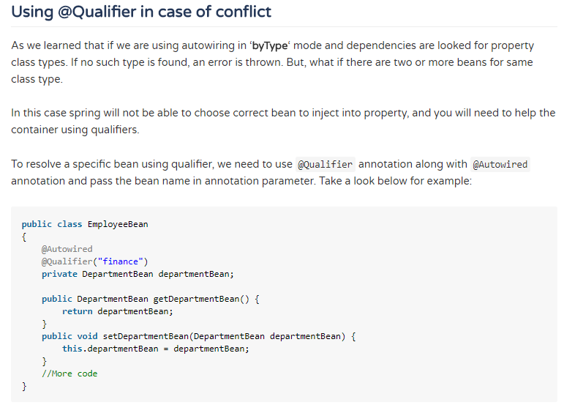

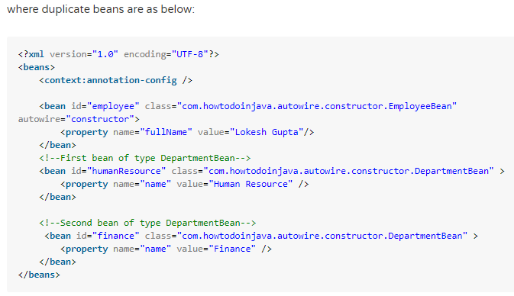

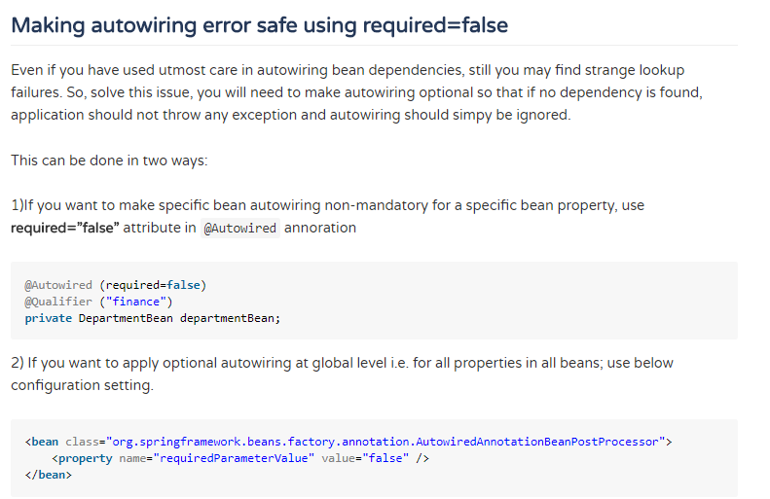

# Spring AOP

## 16) Describe Spring AOP?

[**Spring AOP (Aspect Oriented Programming)**](https://docs.spring.io/spring/docs/current/spring-framework-reference/html/aop.html) It compliments OOPs in the different sense of concern, it also provides modularity.

AOP provides the way to dynamically add the cross-cutting concern before, after or around the actual logic using simple pluggable configurations.

It makes easy to maintain code in present and future as well.

You can add/remove concerns without recompiling complete sourcecode simply by changing configuration files (if you are applying aspects suing XML configuration).

Spring AOP can be used by majorly 2 ways given below. But the widely used approach is Spring AspectJ Annotation Style.

* 1. [**By AspectJ annotation-style**](https://howtodoinjava.com/spring/spring-aop/spring-aop-aspectj-example-tutorial-using-annotation-config/) **2)**[**By Spring XML configuration-style**](https://howtodoinjava.com/spring/spring-aop/spring-aop-aspectj-xml-configuration-example/)

## 17) What are Cross-Cutting Concerns?

• Generic functionality that is needed in many places in your application Examples  
– Logging and Tracing  
– Transaction Management  
– Security  
– Caching  
– Error Handling  
– Performance Monitoring  
– Custom Business Rules

## System Without AOP or Modularization

There are two main problems  
**– Code tangling**  
• A coupling of concerns  
**– Code scattering**  
• The same concern spread across modules

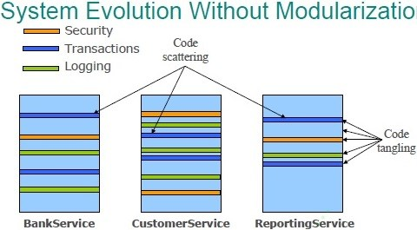

## System With AOP or Modularization

Aspect-Oriented Programming (AOP) enables modularization of cross-cutting concerns  
– To avoid tangling  
– To eliminate scattering

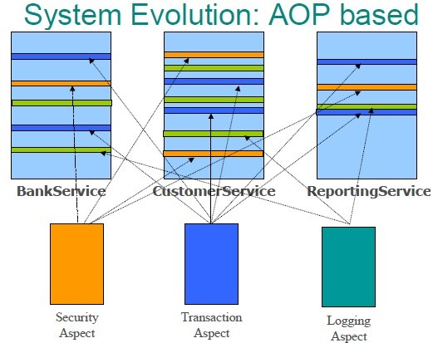

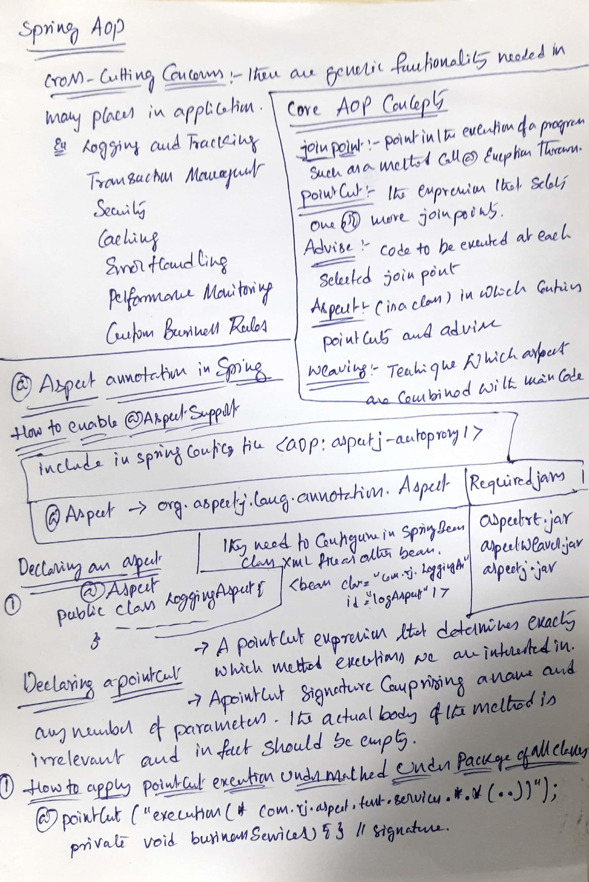

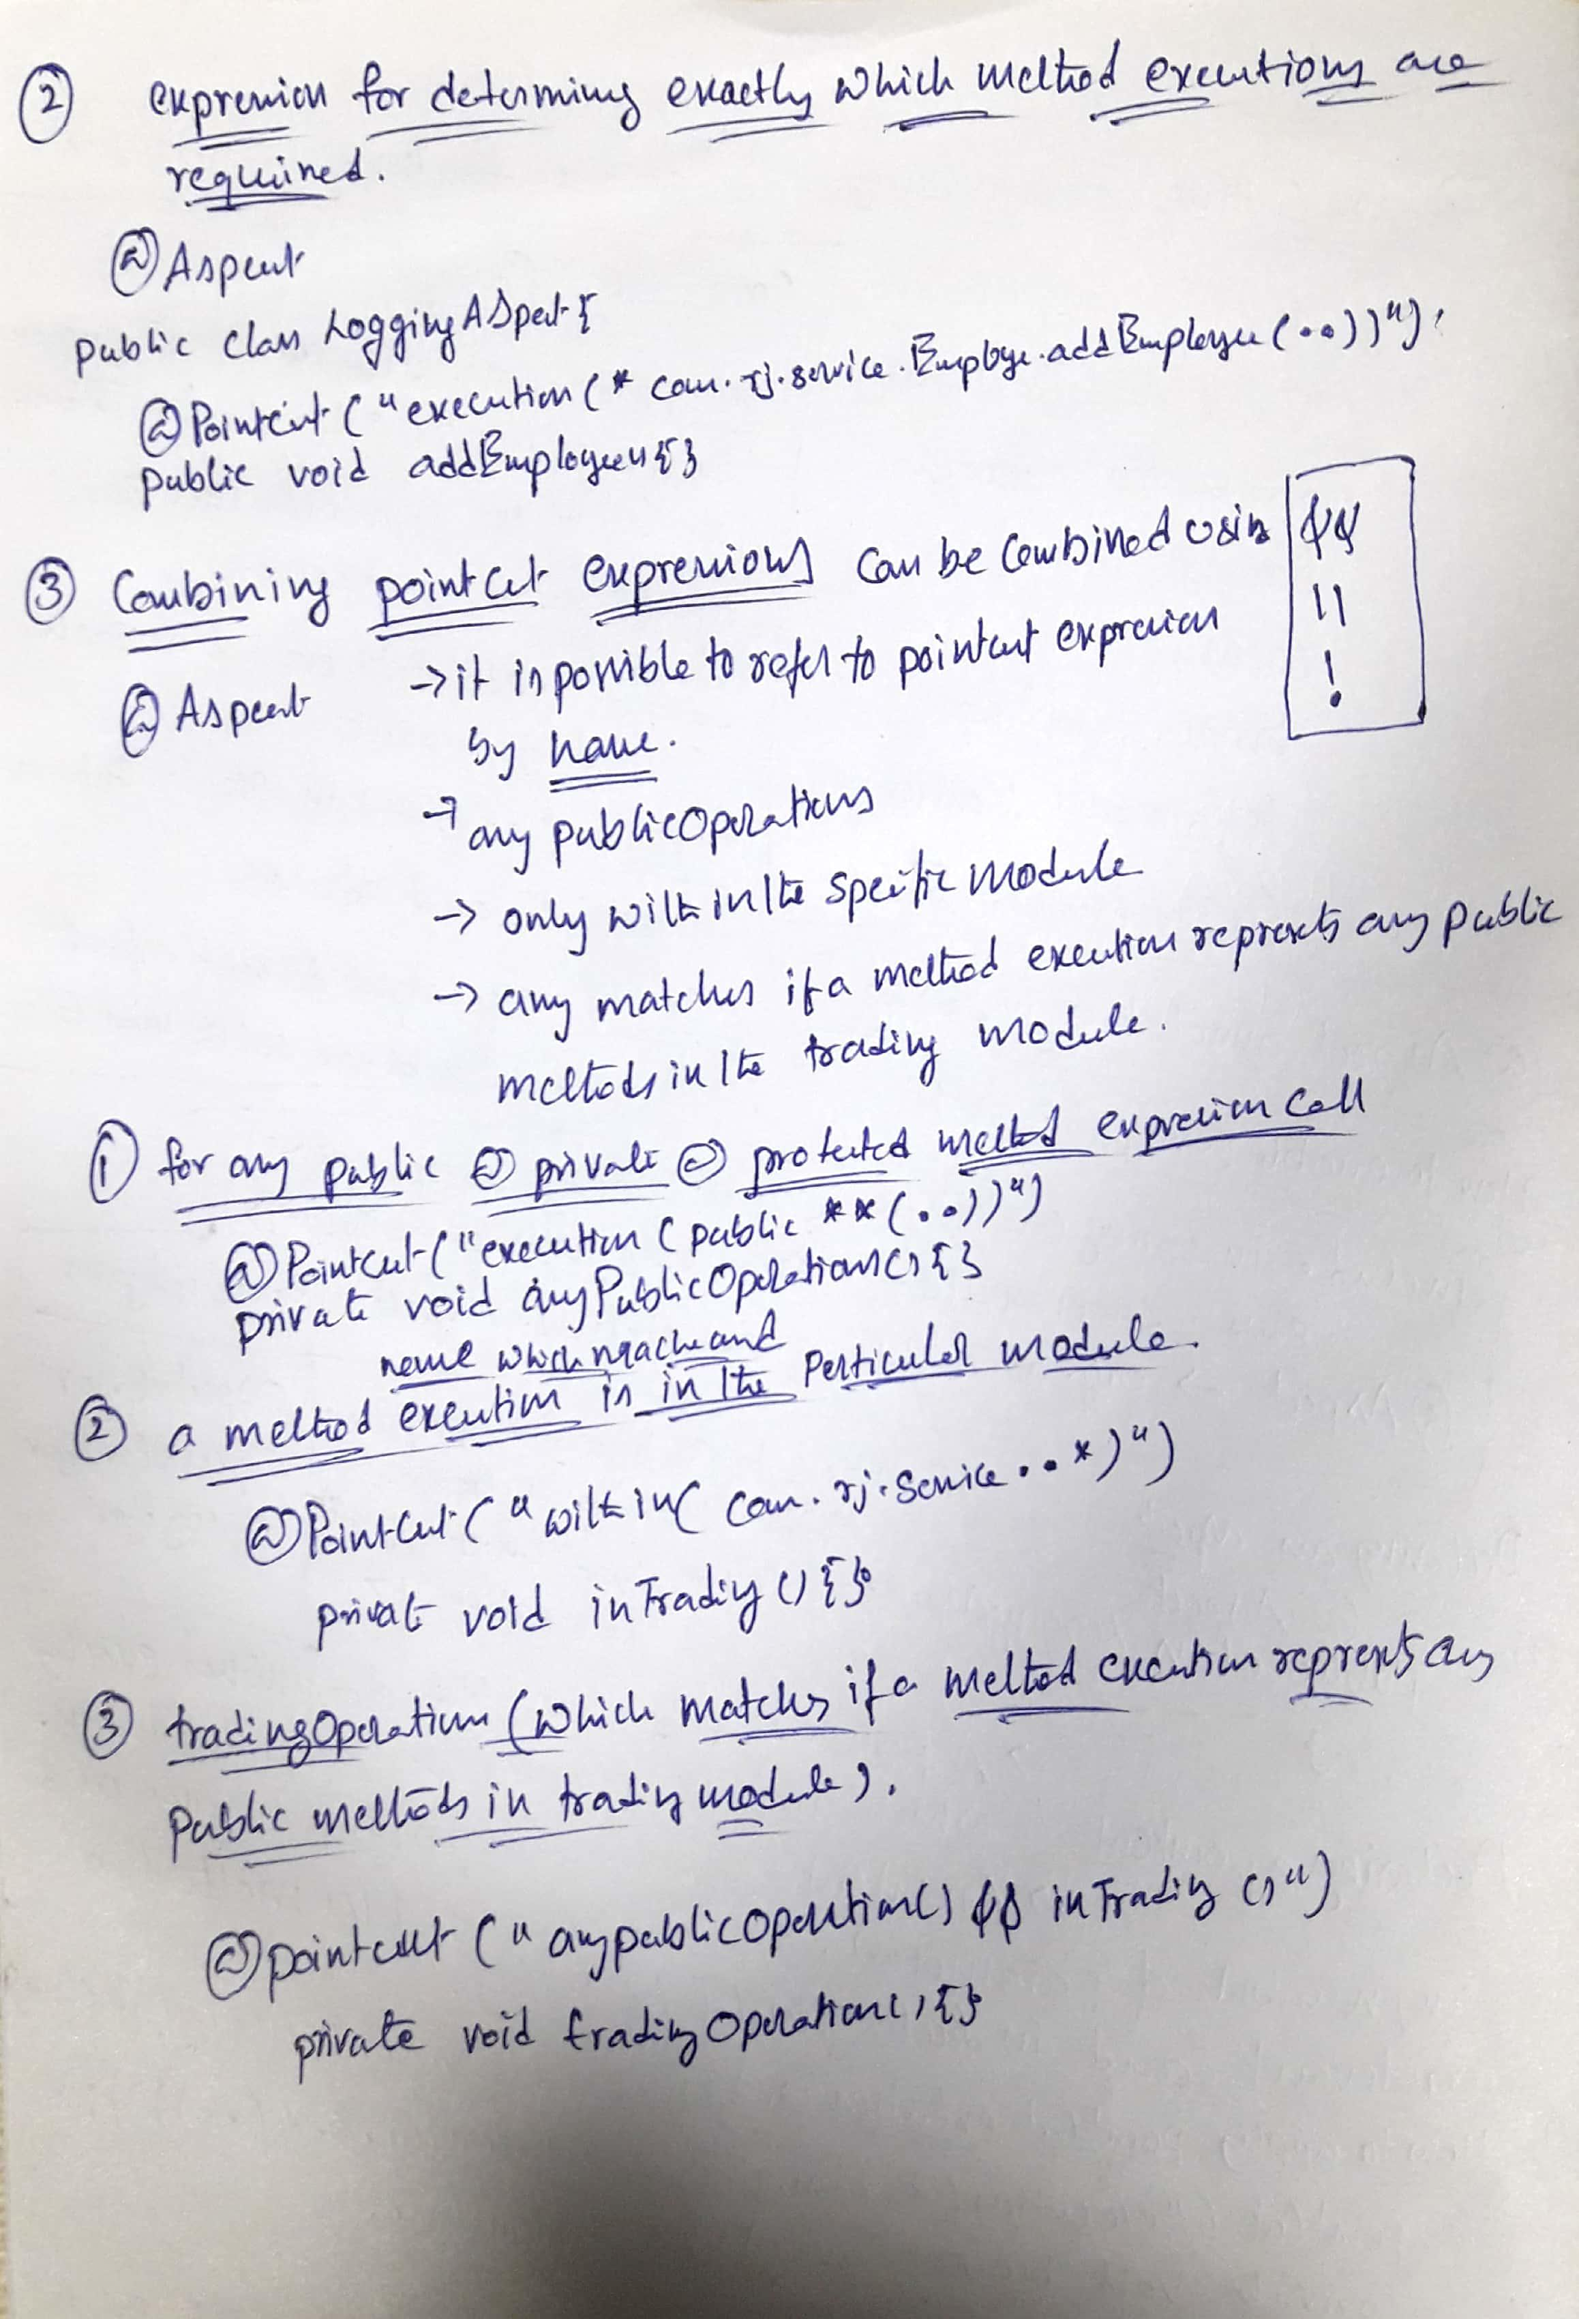

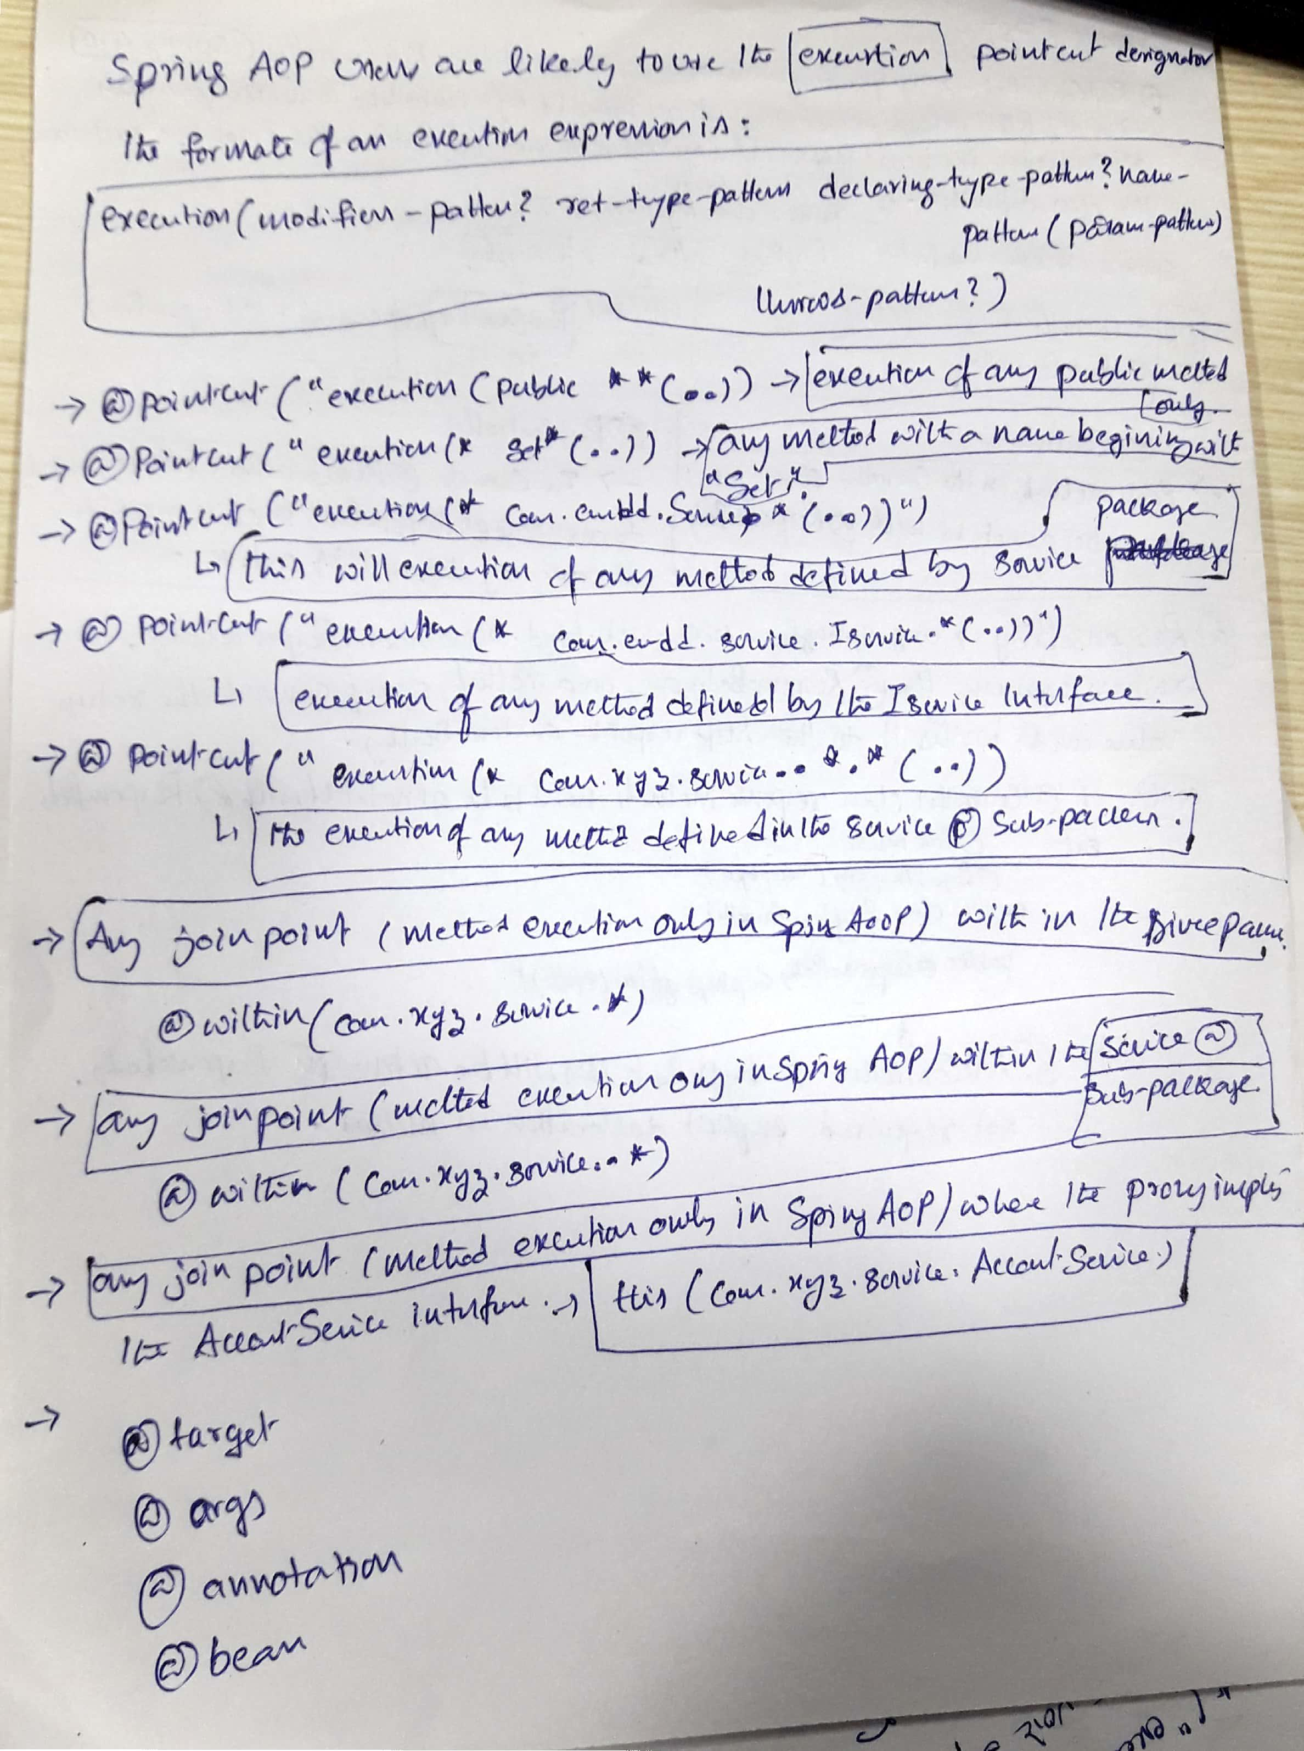

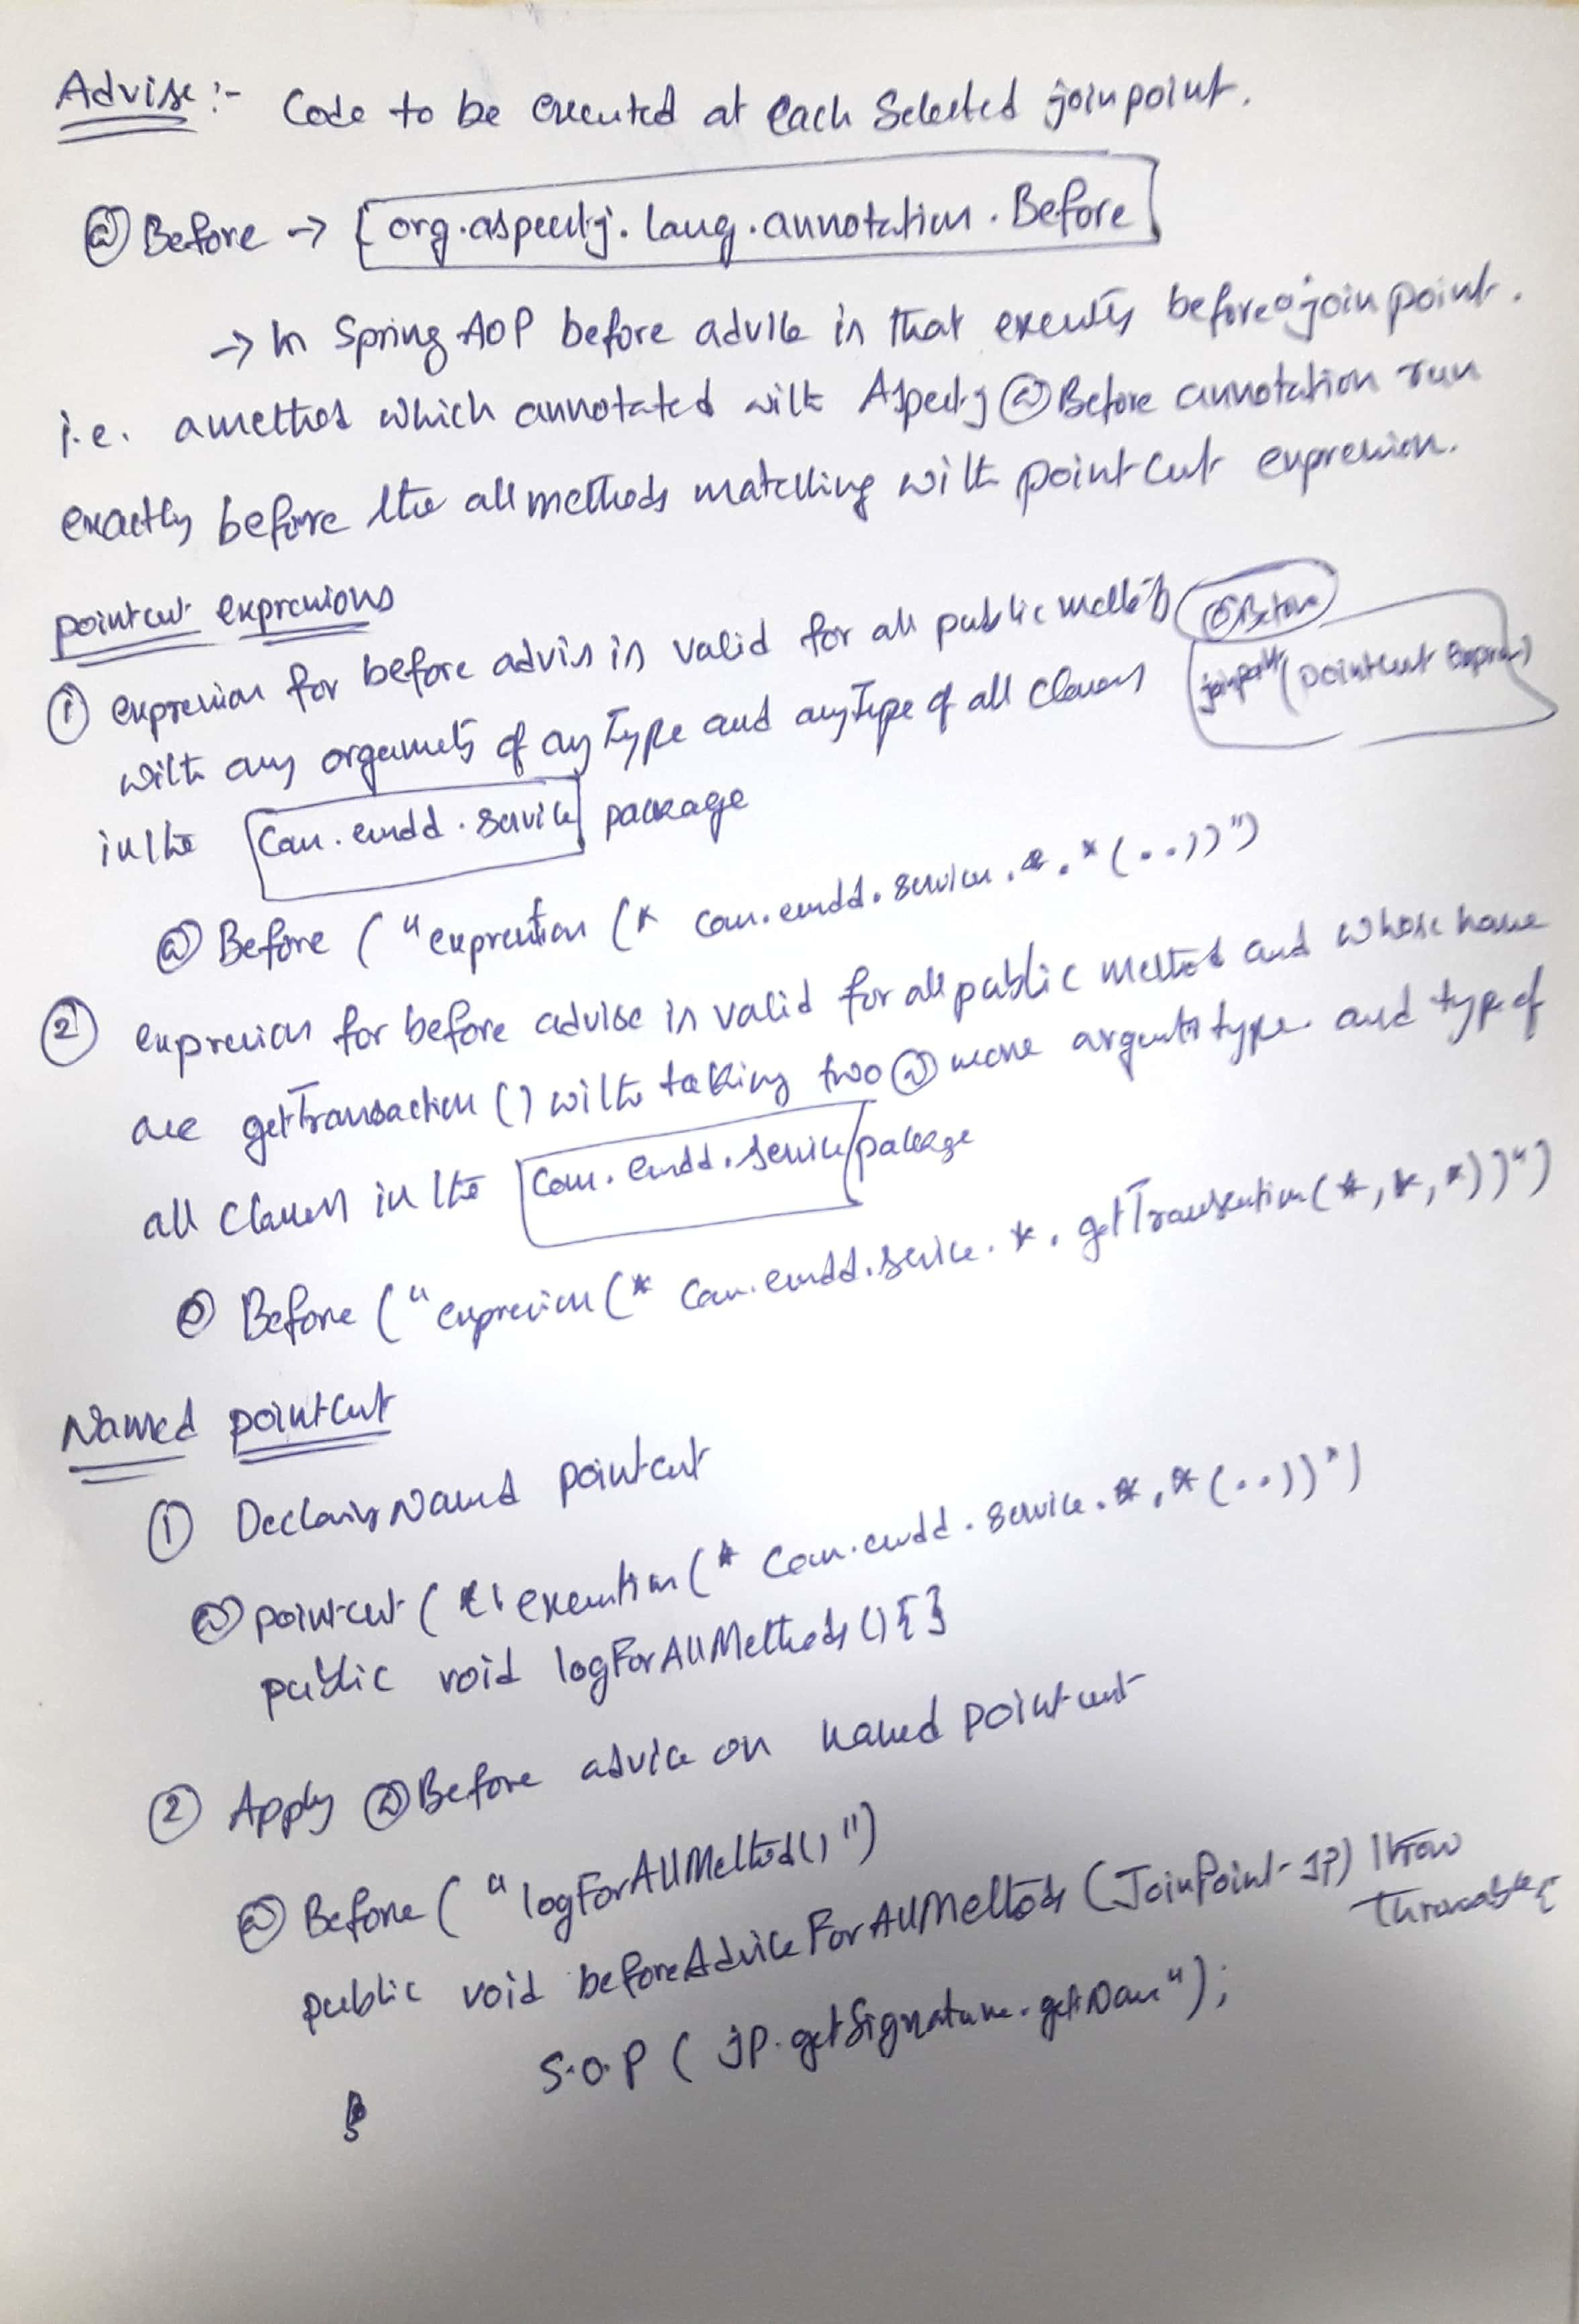

## 18)What is a pointcut, a join point, an advice, an aspect, weaving, Introduction, Target Object, AOP Proxy? Pointcut – An expression that selects one or more Join Points Join Point – A point in the execution of a program such as a method call or exception thrown Advice – Code to be executed at each selected Join Point Aspect – A module that encapsulates pointcuts and advice Weaving – Technique by which aspects are combined with main code Introduction -Spring AOP allows to introduce new interfaces (and a corresponding application) to any object advises. Target Object -An object is assisted by one or more respects. Also known as the object advised. AOP Proxy -AOP proxy is an object used to perform the contract area. This object is created by the AOP framework. In Spring AOP proxy is part of JDK dynamic proxy or proxy CGLIB.

## 19. How does Spring solve (implement) a cross cutting concern?

* Implement your mainline application logic
  + – Focusing on the core problem
* Write aspects to implement your cross-cutting concerns
  + – Spring provides many aspects out-of-the-box
* Weave the aspects into your application
  + – Adding the cross-cutting behaviors to the right places

## 20) Which are the limitations of the two proxy-types? Spring will create either JDK or CGLib proxies

1. **JDK Proxy**
   1. Also called dynamic proxies
   2. API is built into the JDK
   3. Requirements: Java interface(s)
   4. All interfaces proxied
2. **CGLib Proxy**
   1. NOT built into JDK
   2. Included in Spring jars
   3. Used when interface not available
   4. Cannot be applied to final classes or methods

## 21) How many advice types does Spring support. What are they used for?

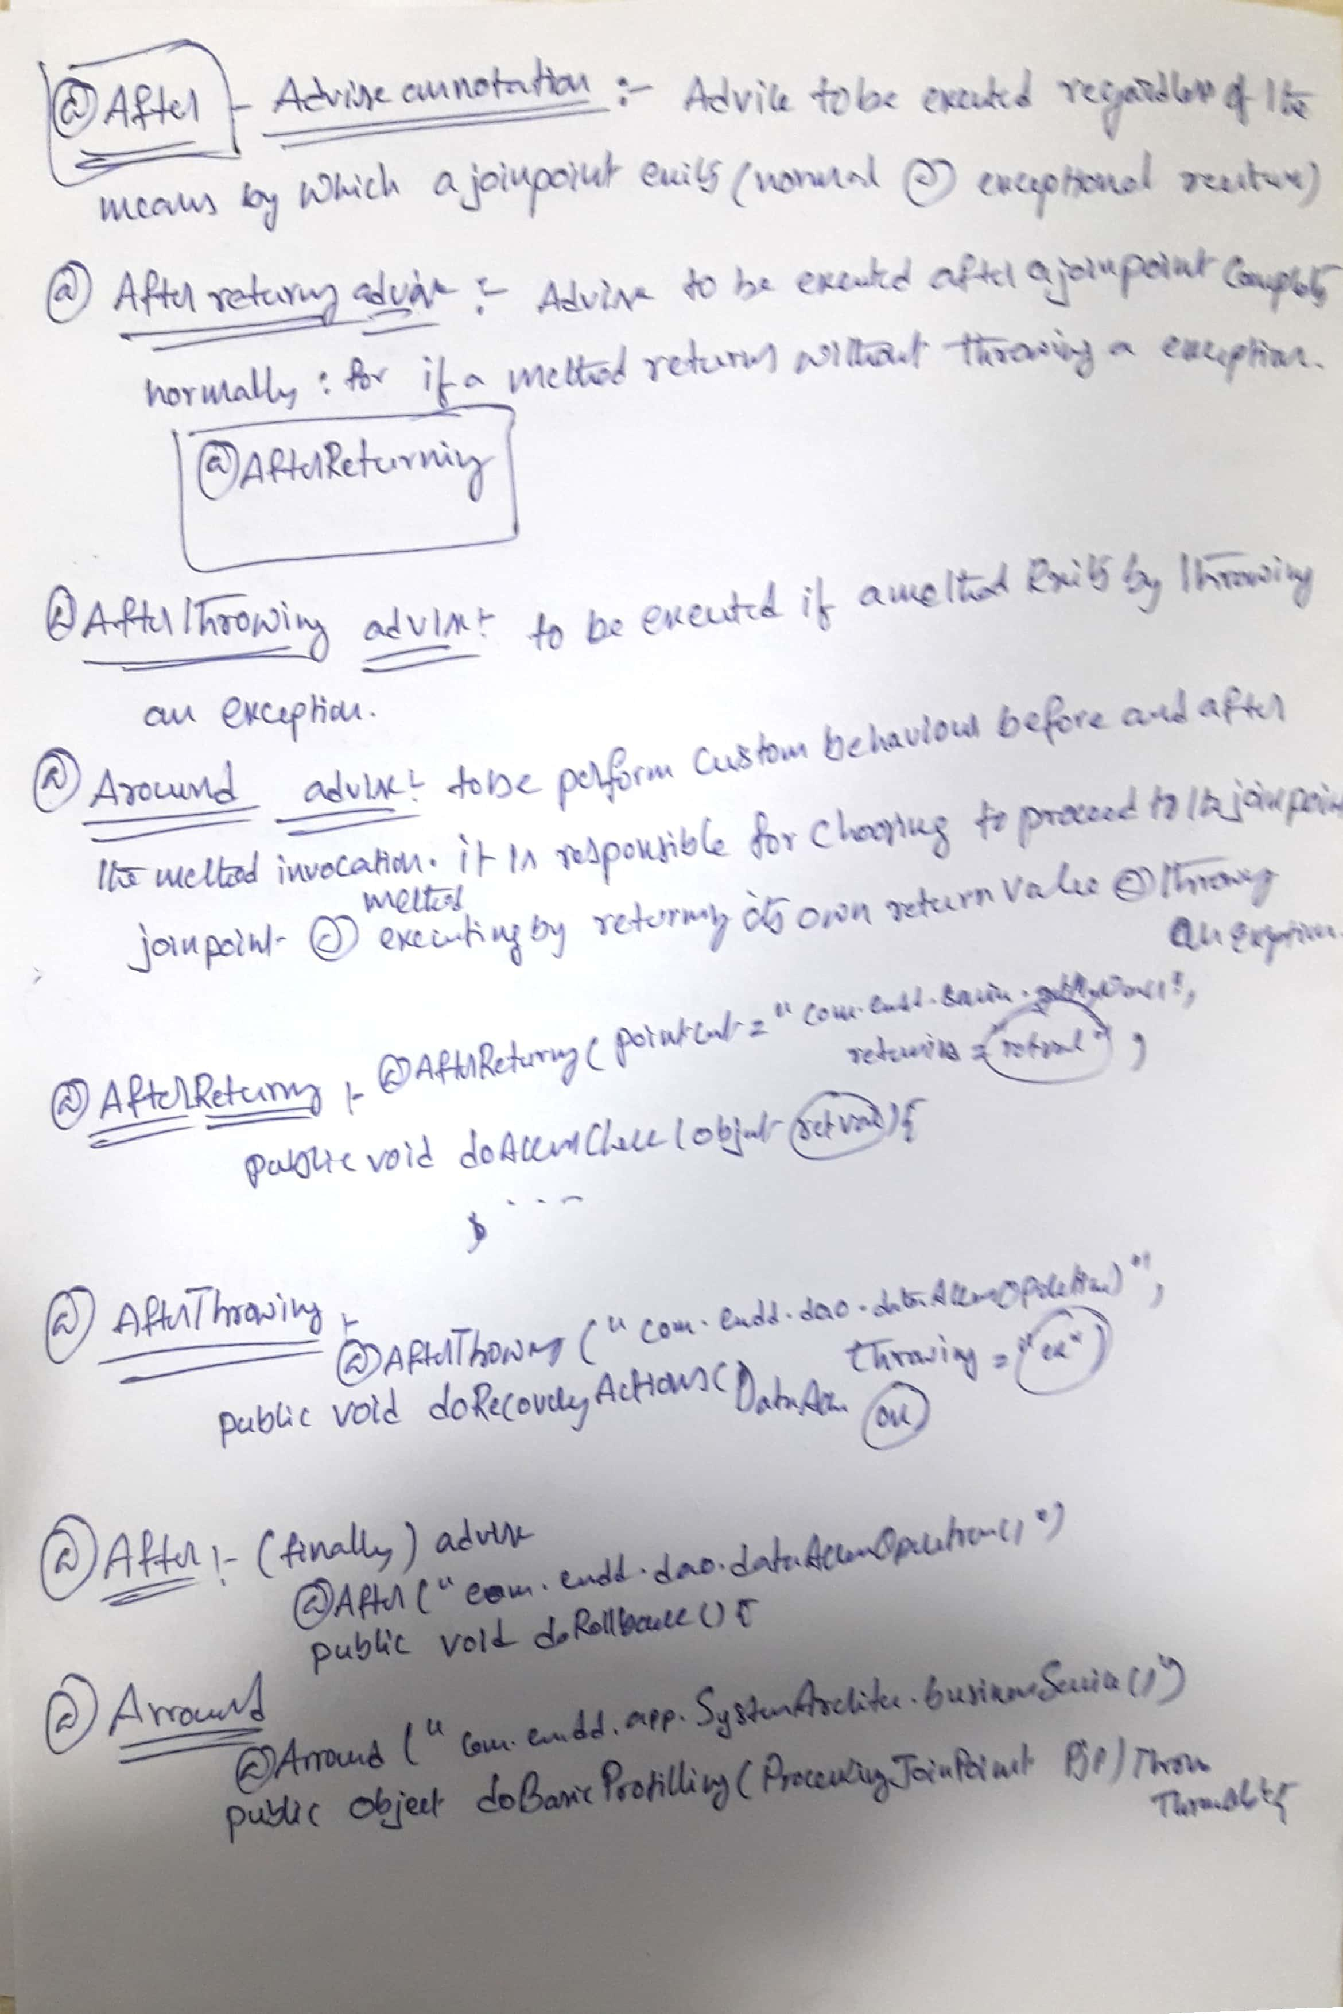

22)What do you have to do to enable the detection of the @Aspect annotation?  
To use @AspectJ aspects in a Spring configuration you need to enable Spring support for configuring Spring AOP based on @AspectJ aspects, and autoproxying beans based on whether or not they are advised by those aspects.  
  
Enabling @AspectJ Support with Java configuration  
To enable @AspectJ support with Java @Configuration add the @EnableAspectJAutoProxy annotation:

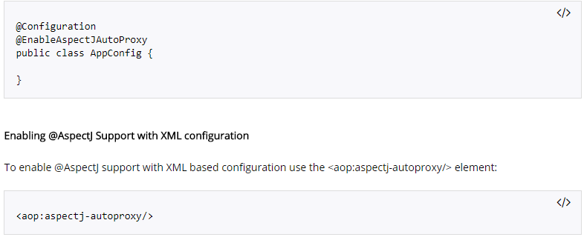

23) What do you understand by Load-time weaving (LTW) in Spring?  
Load-time weaving (LTW) or Run time weaving is a process of weaving AspectJ aspects into the classes of the application when the classes are being loaded in JVM.

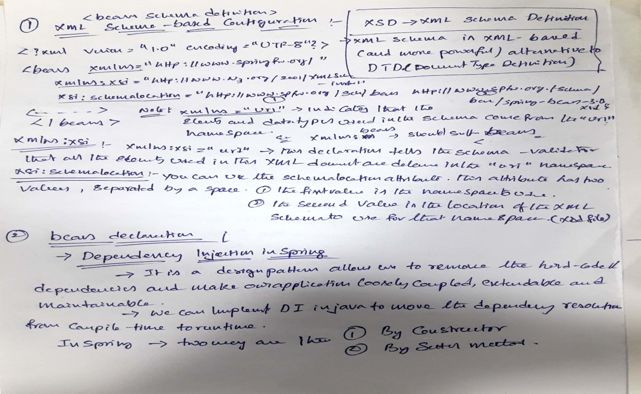

# SPRING LAZY INITIALIZATION

SPRING USEFUL ANNOTATIONS

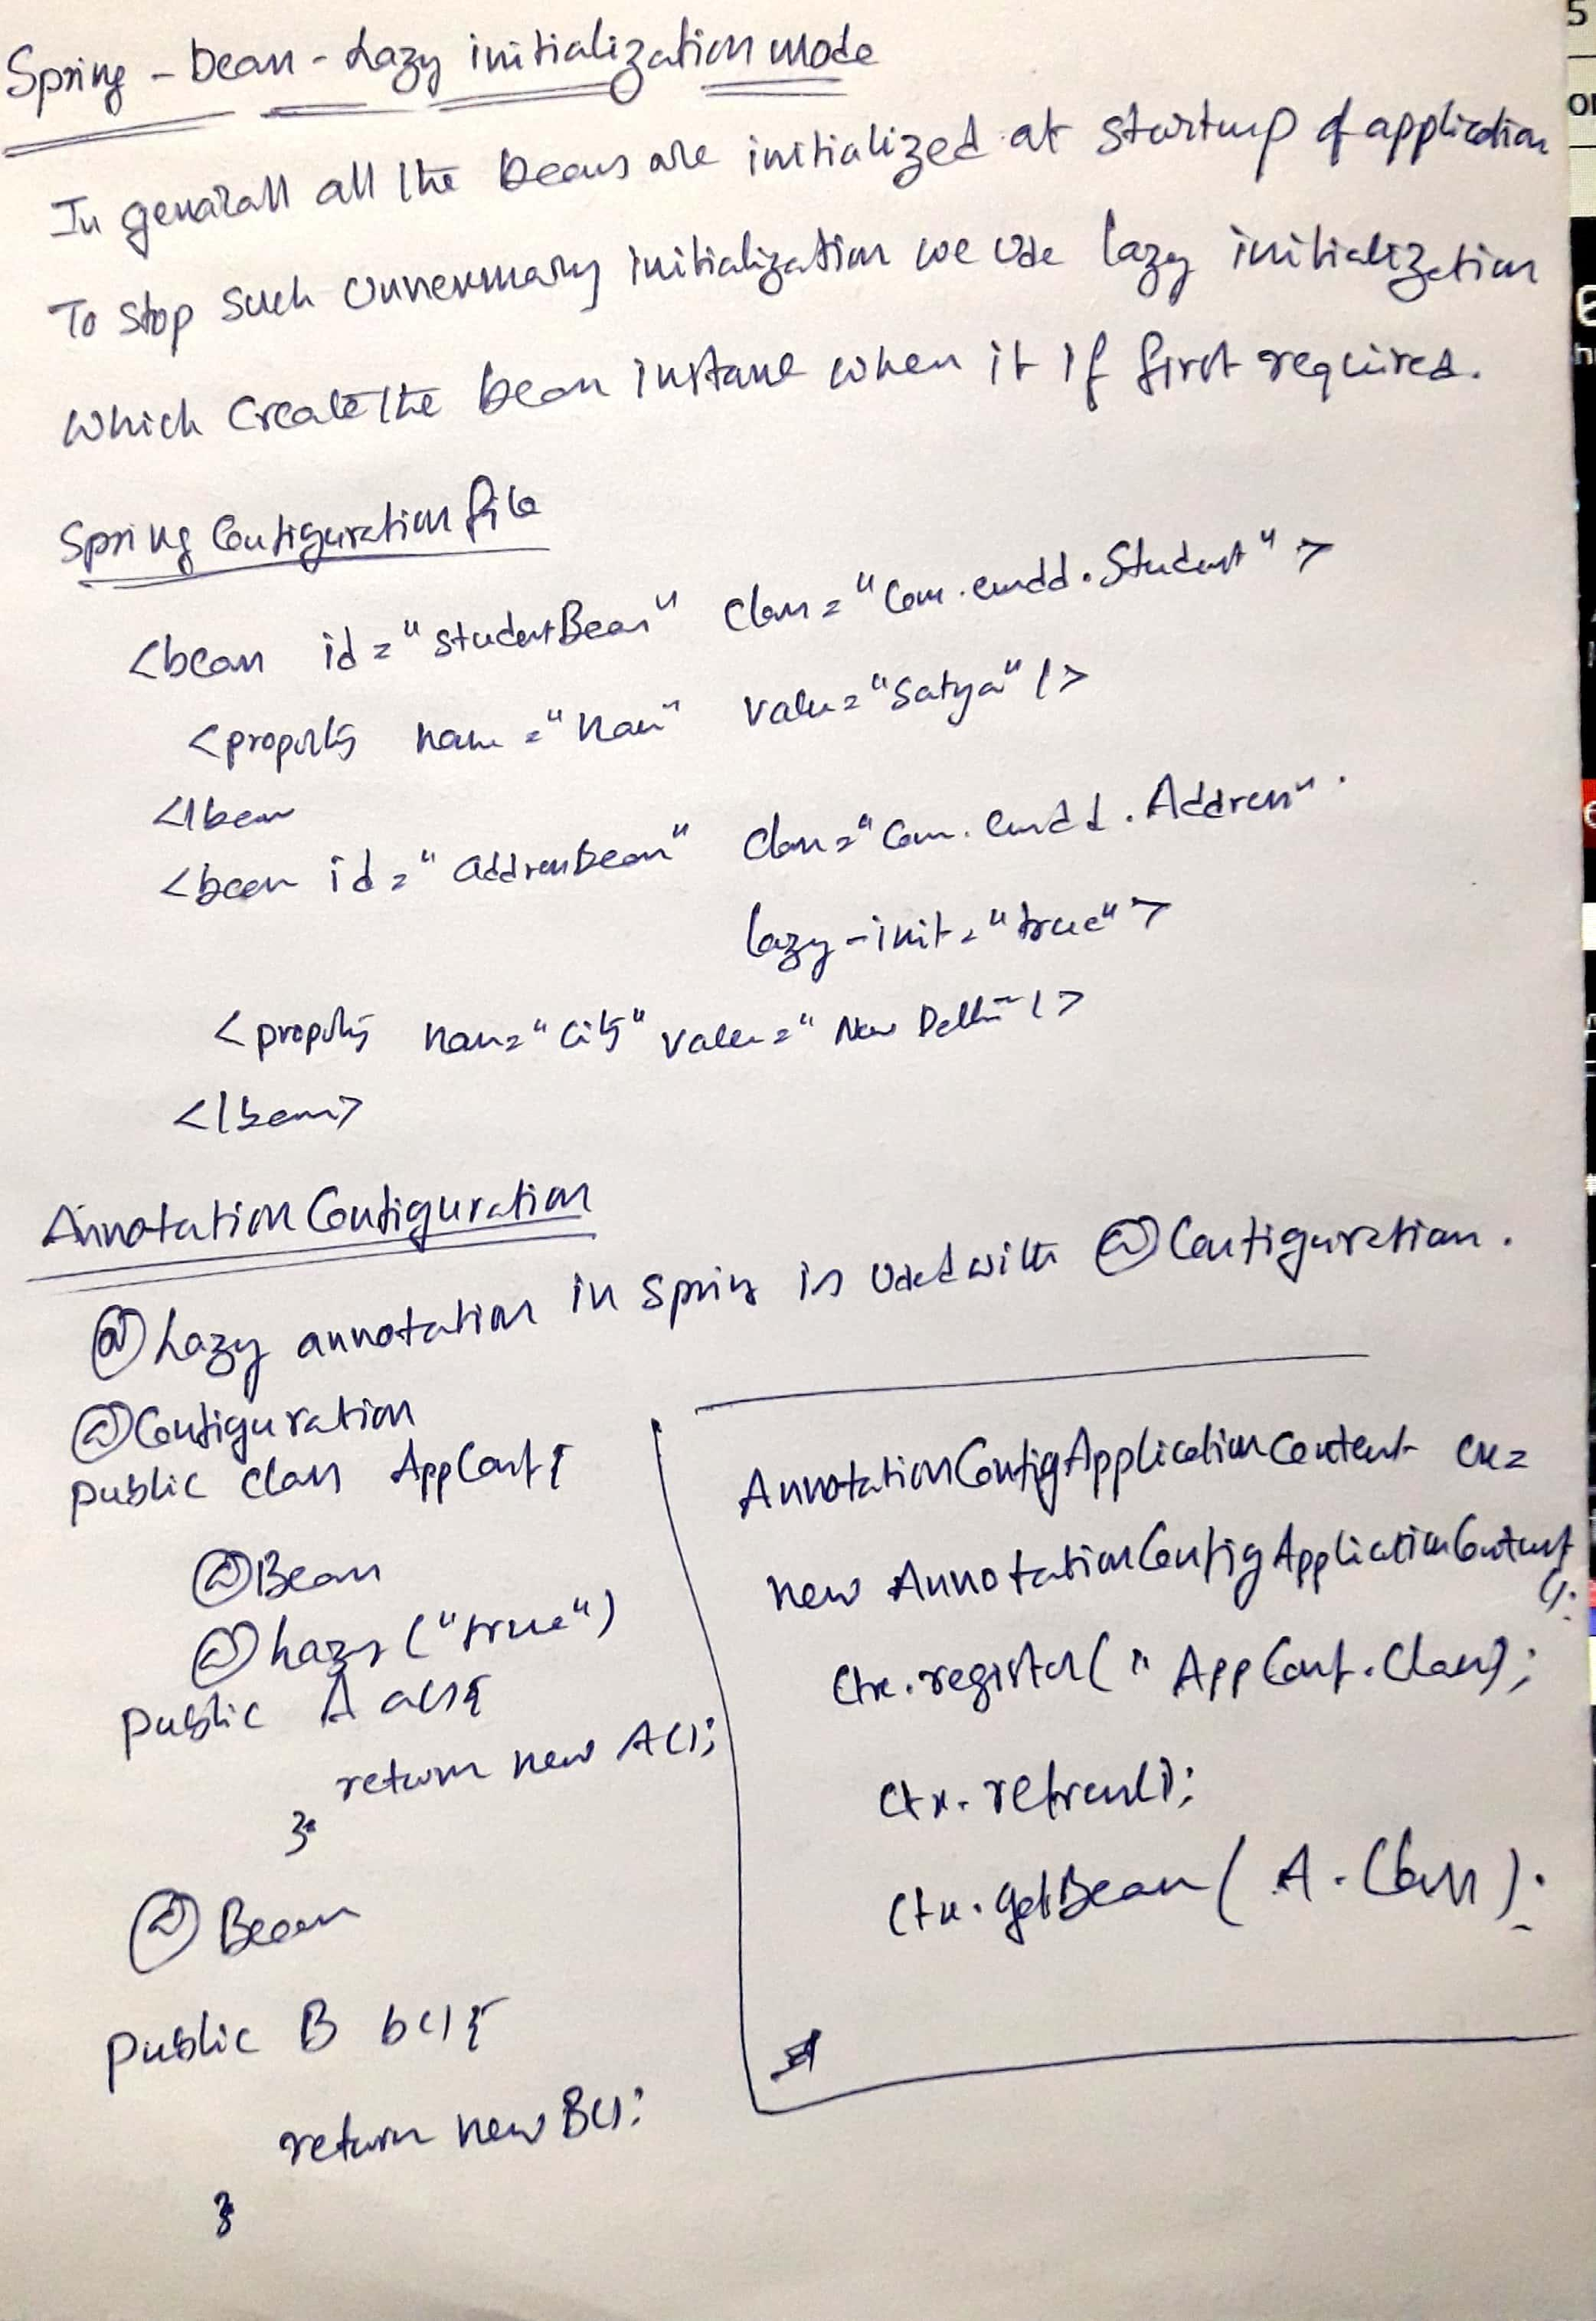

SPRING USEFUL ANNOTAIONS

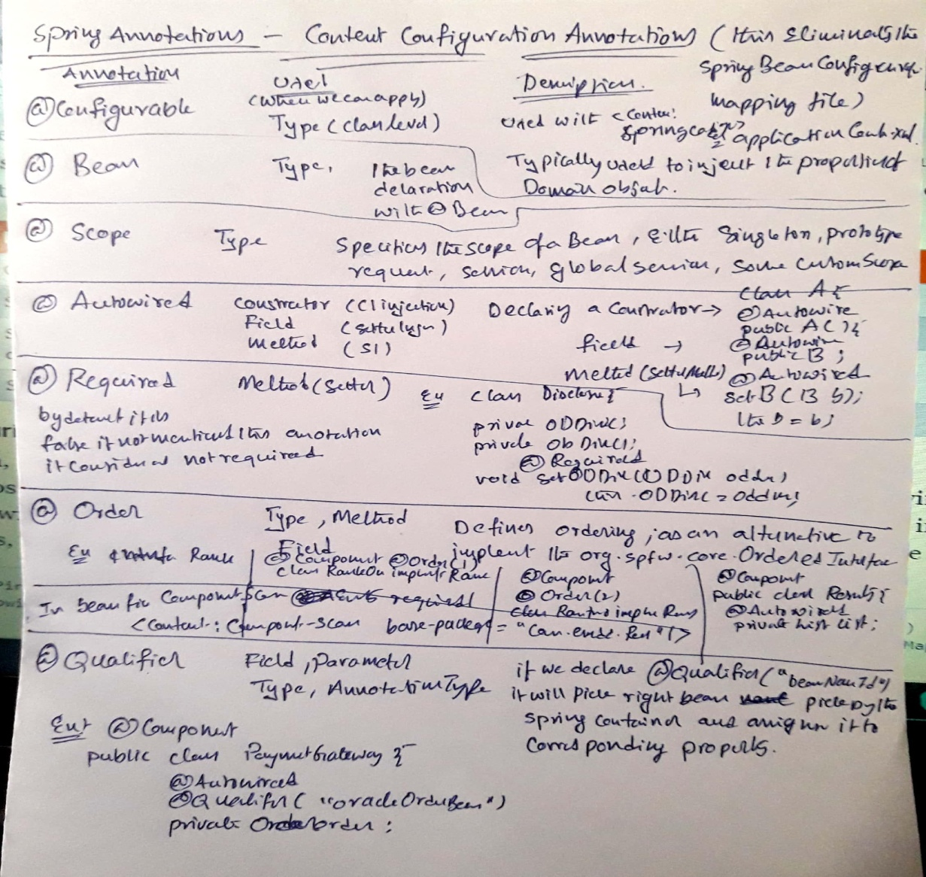

# Spring Steriotype annotations - @Component,@controller,@Repository,@Services

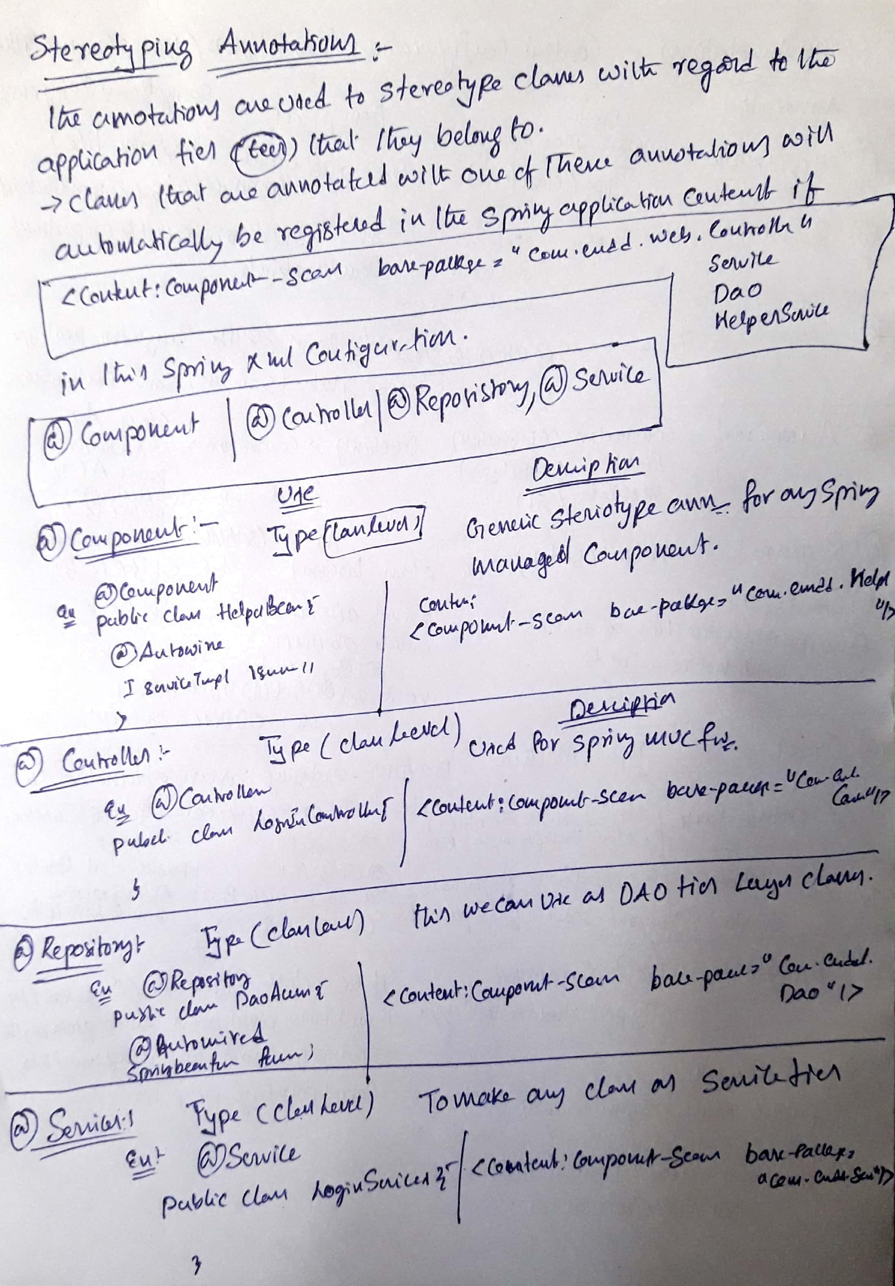

# Spring Transaction management

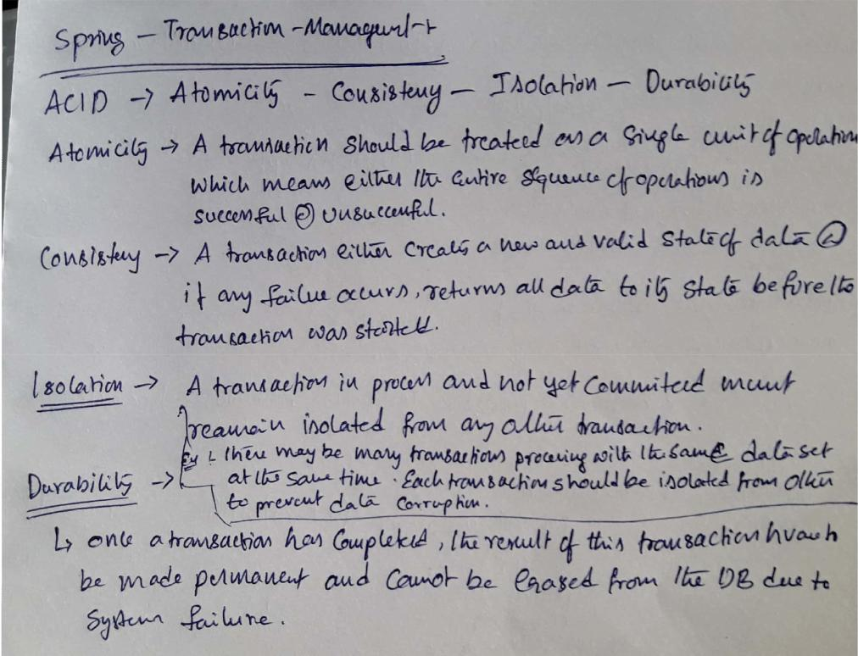

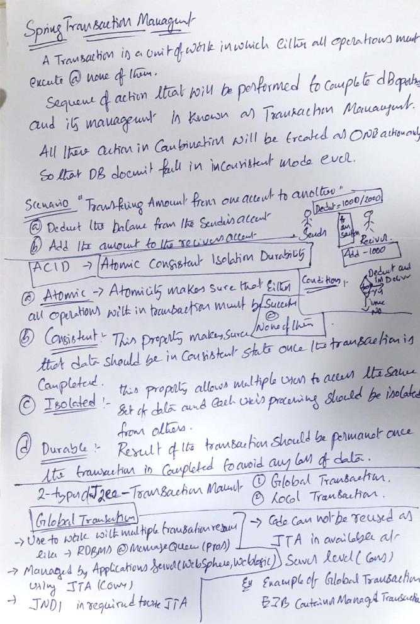

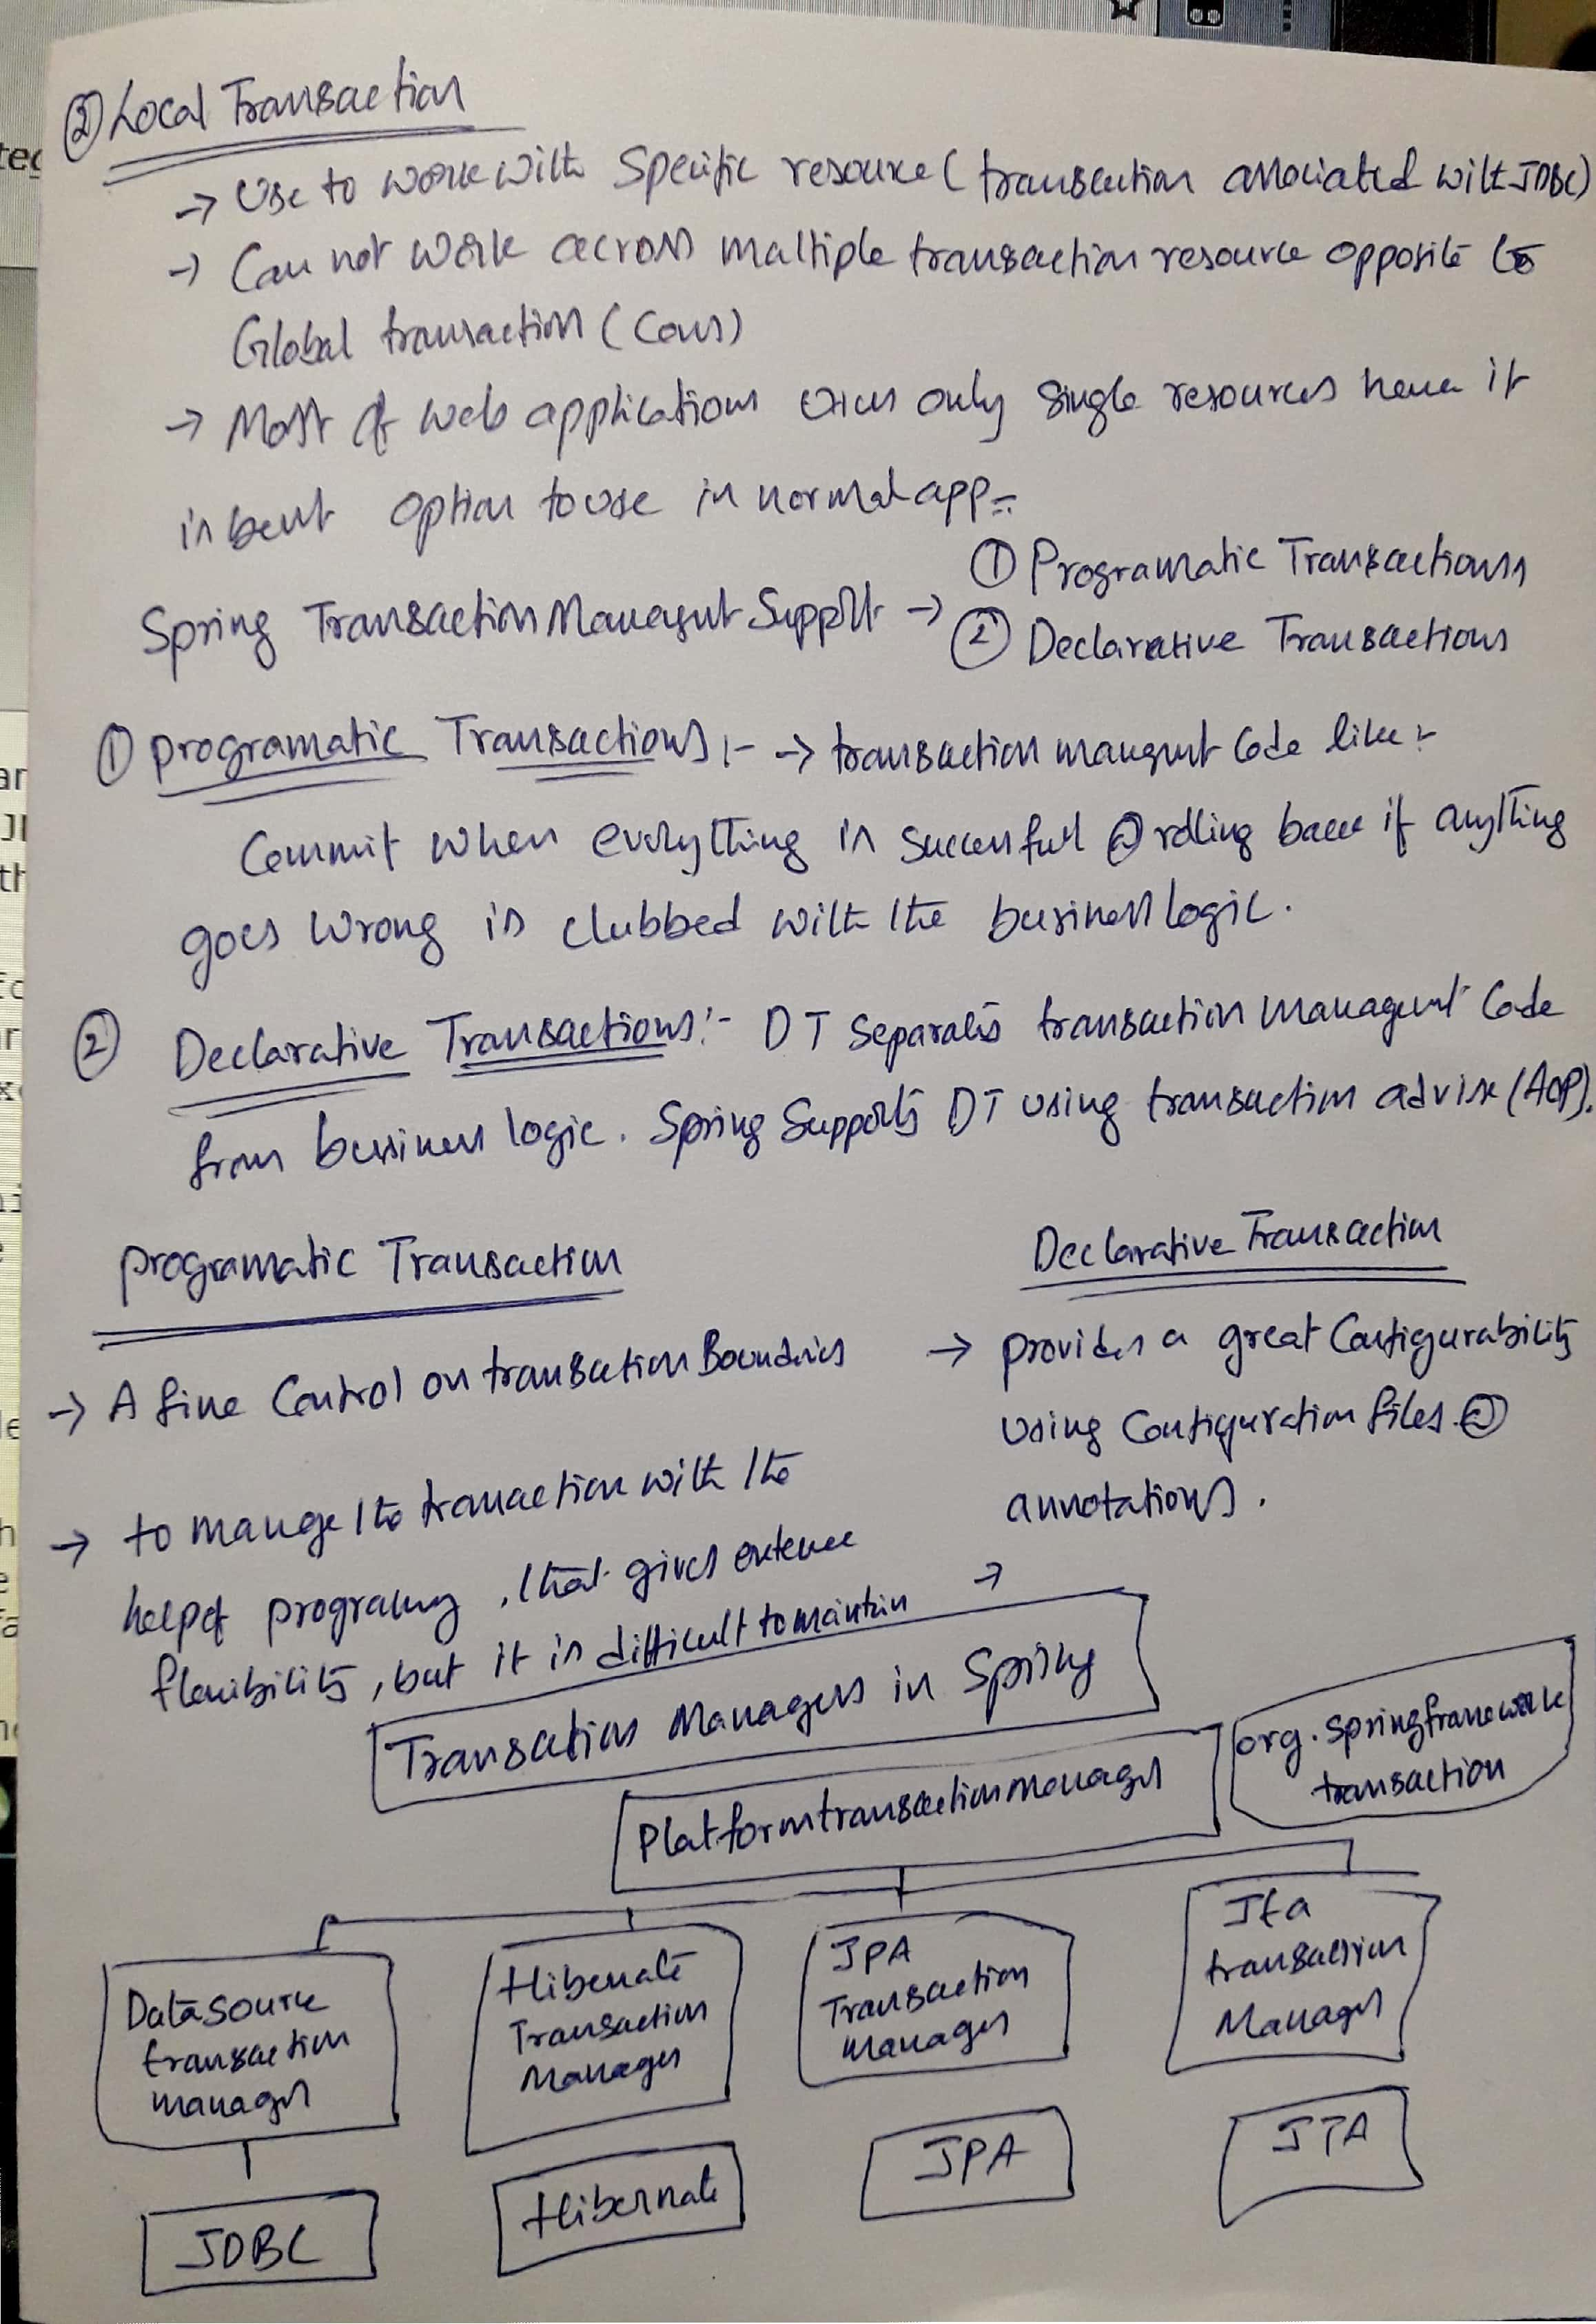

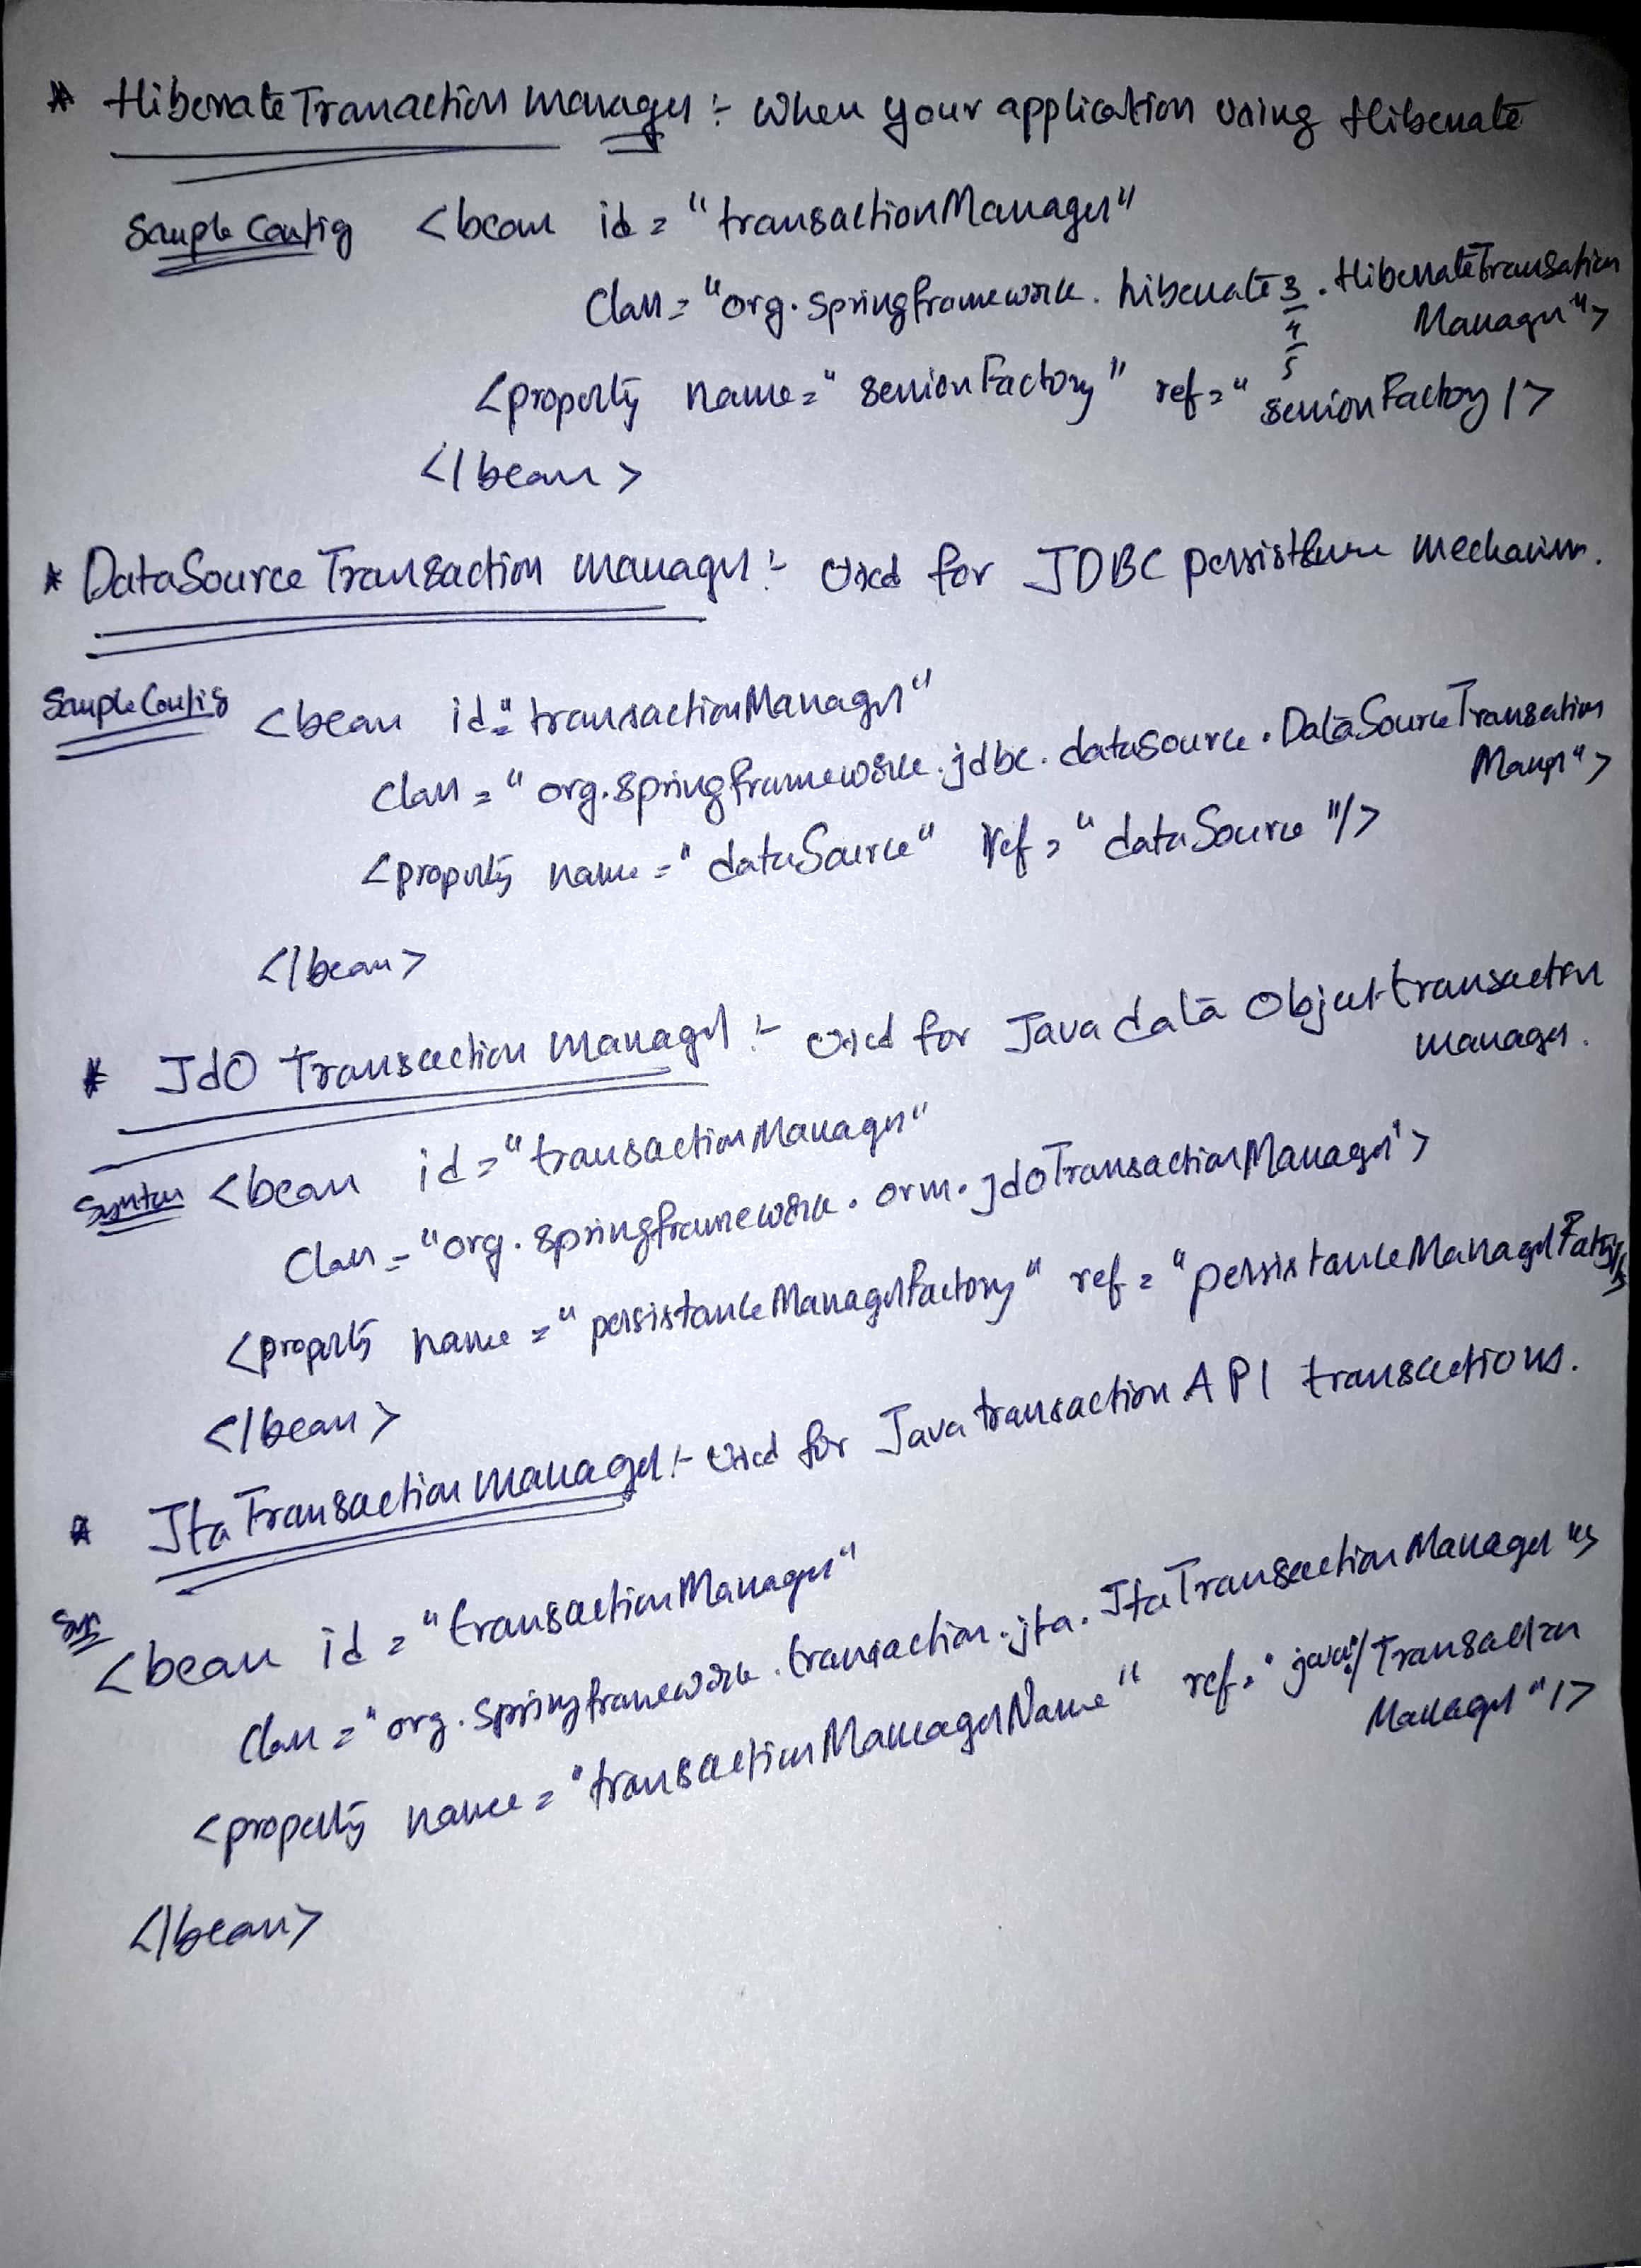



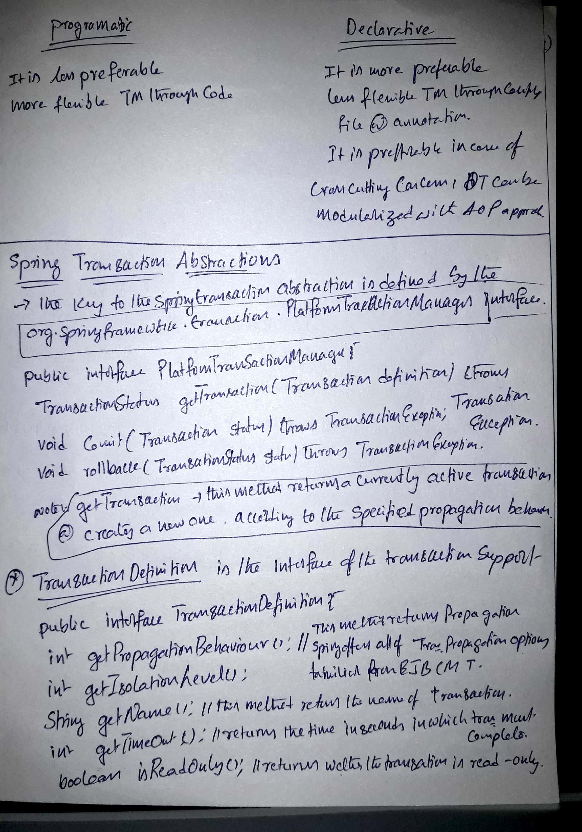

### Transaction Progation Types

Transaction Isolation Levels annotation based

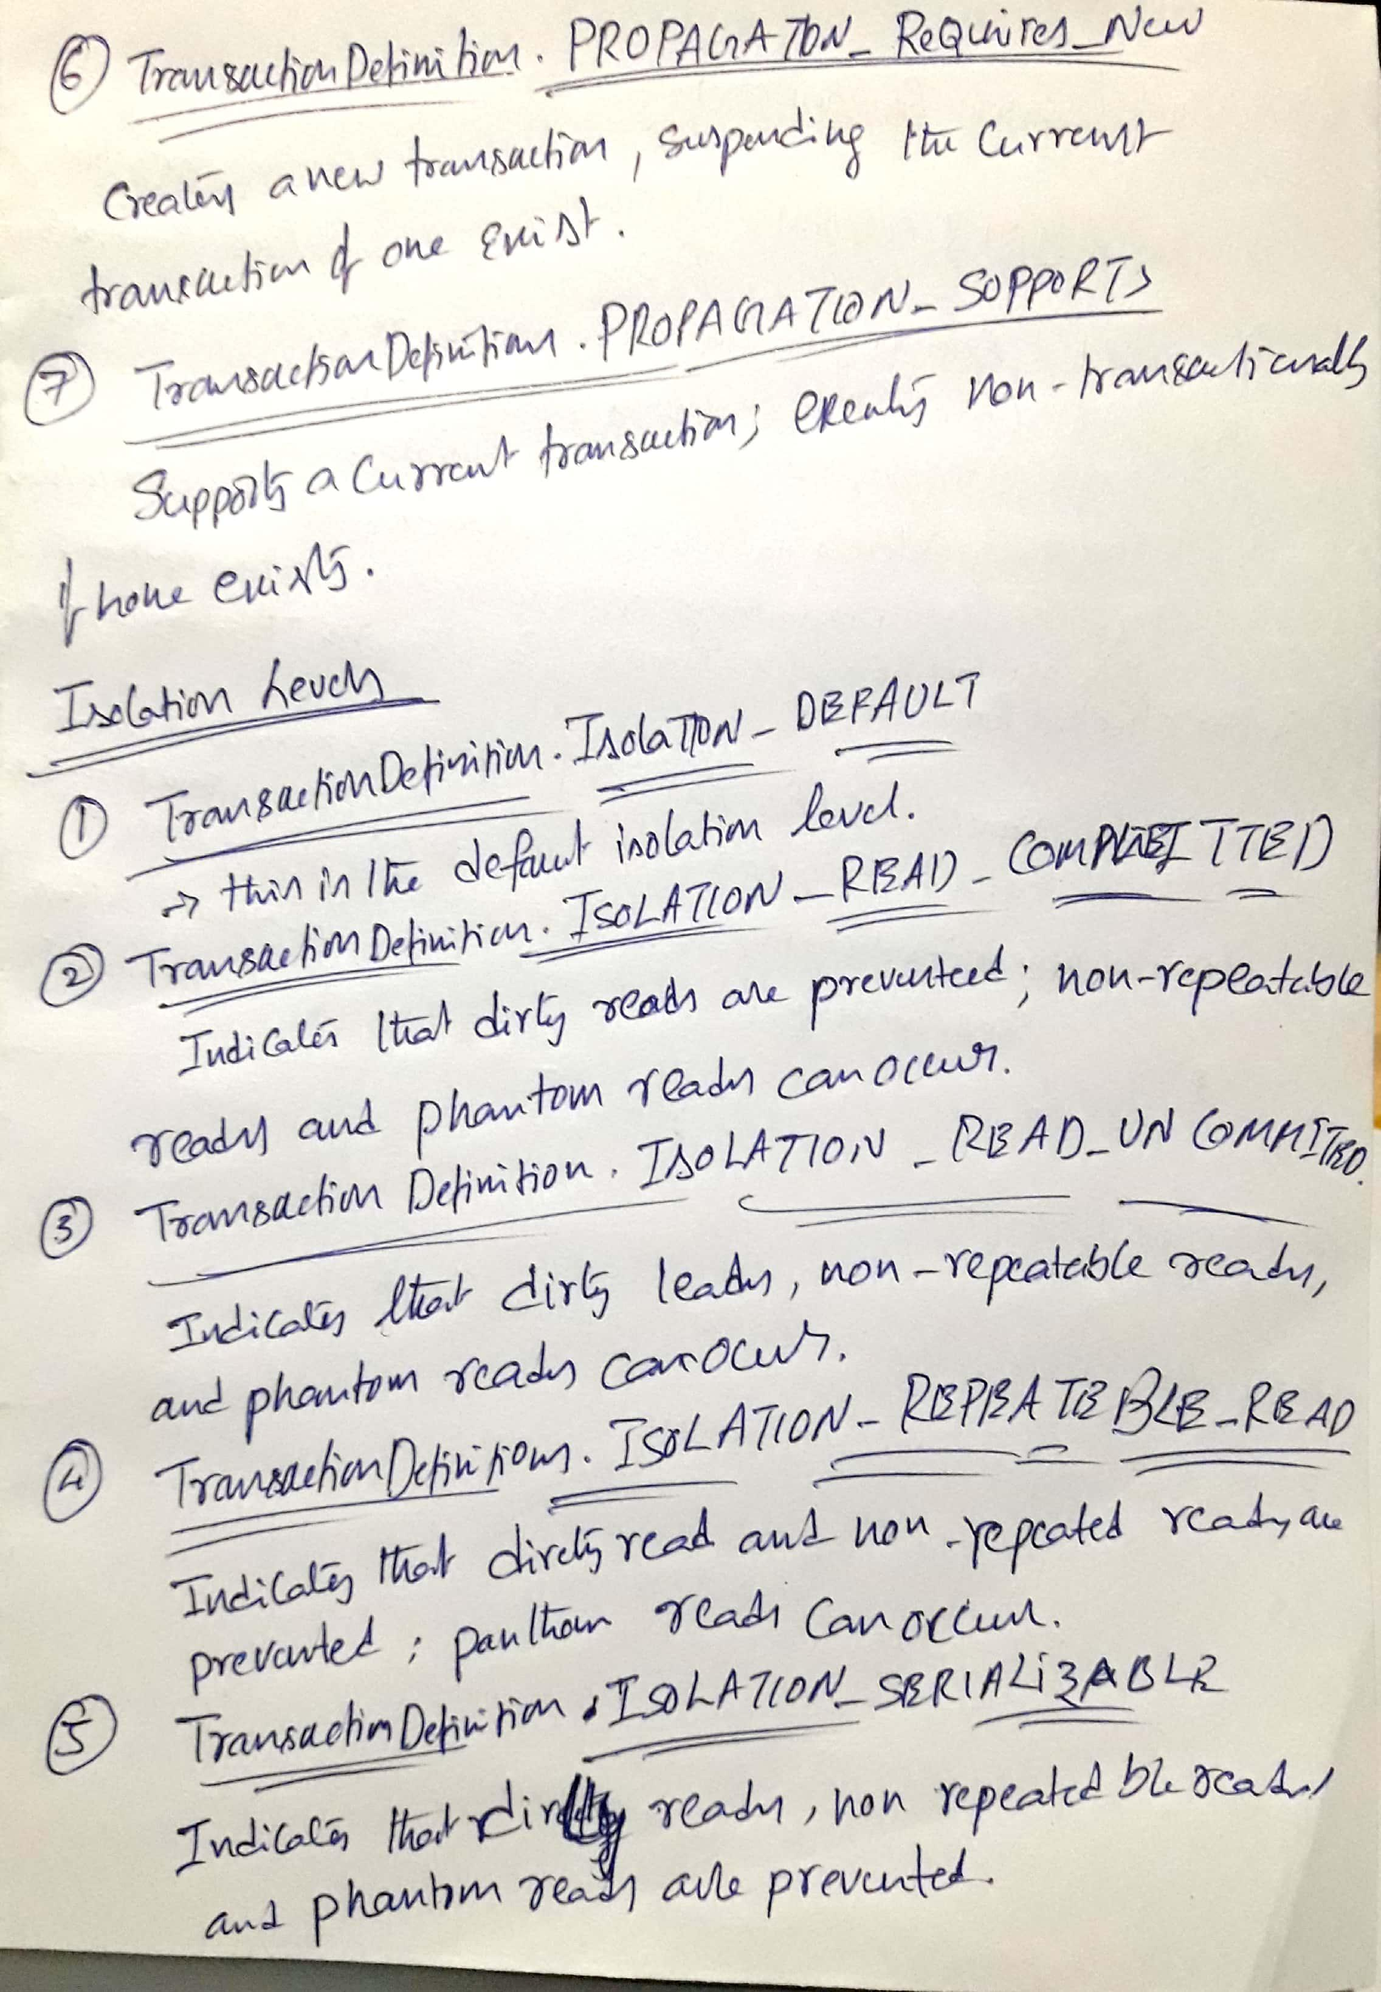

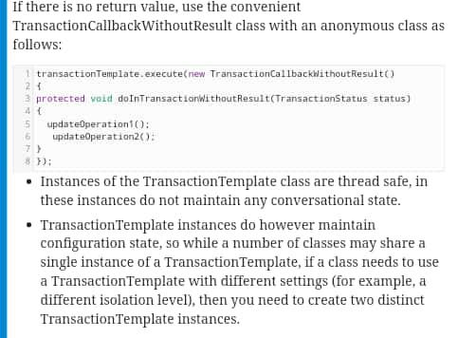

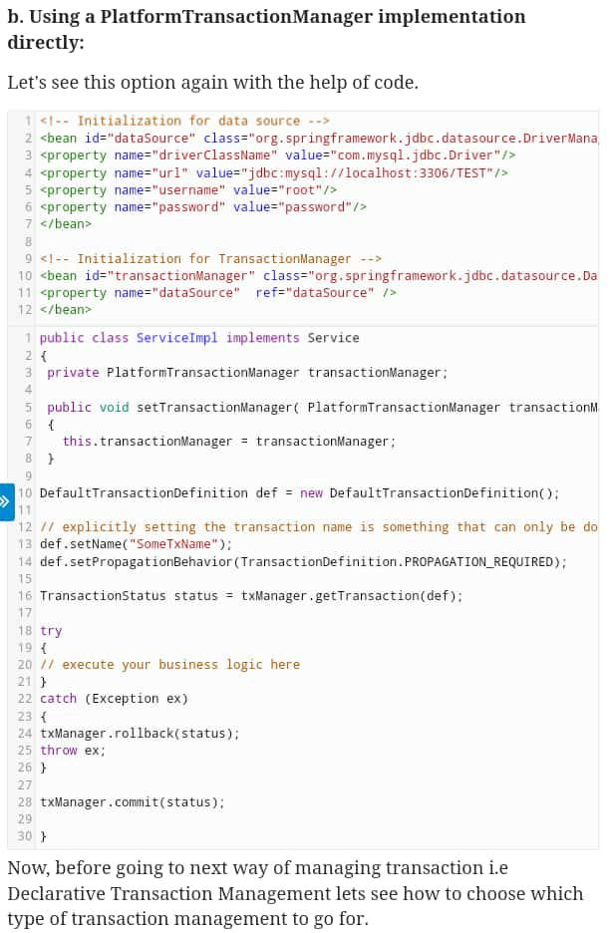

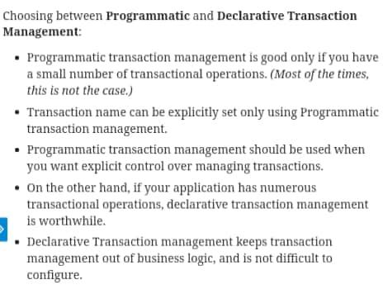

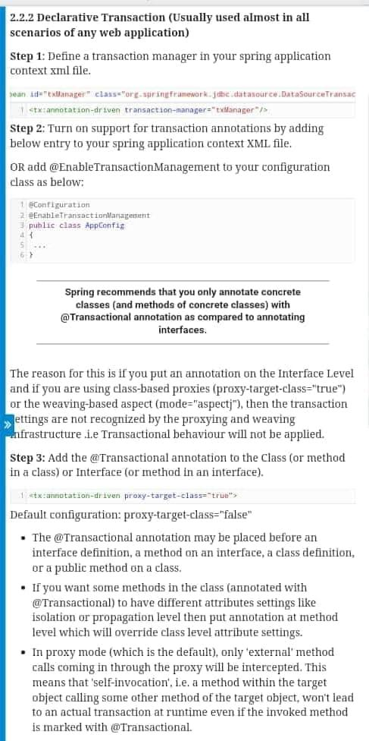

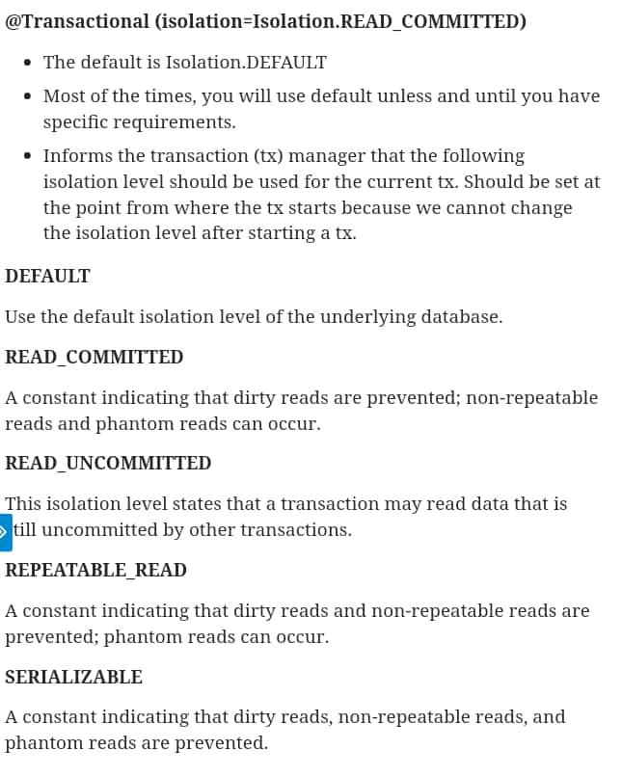

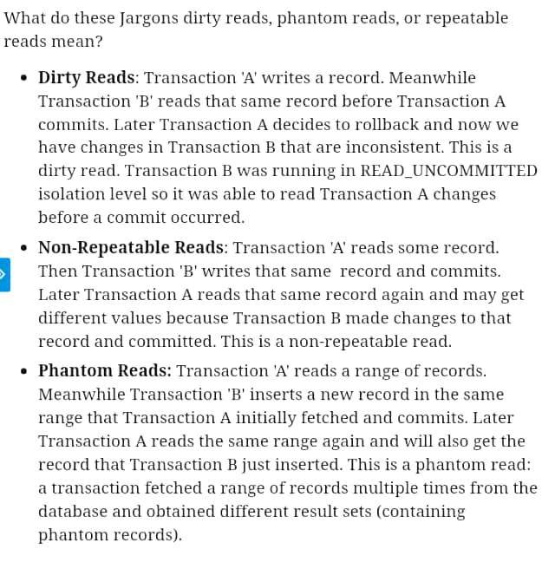

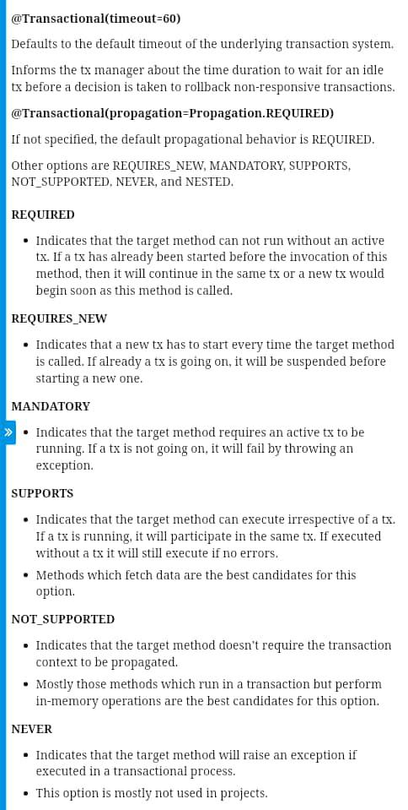

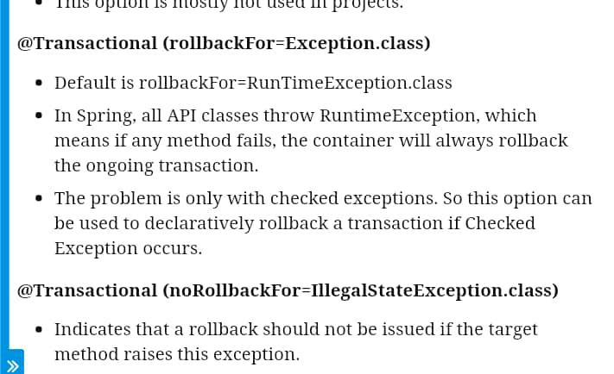

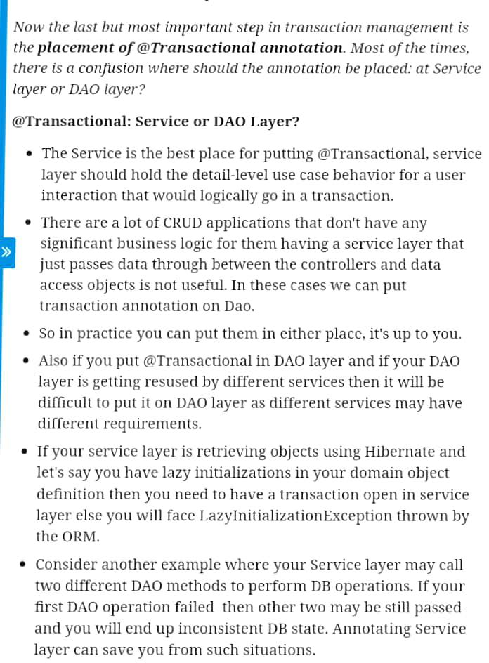

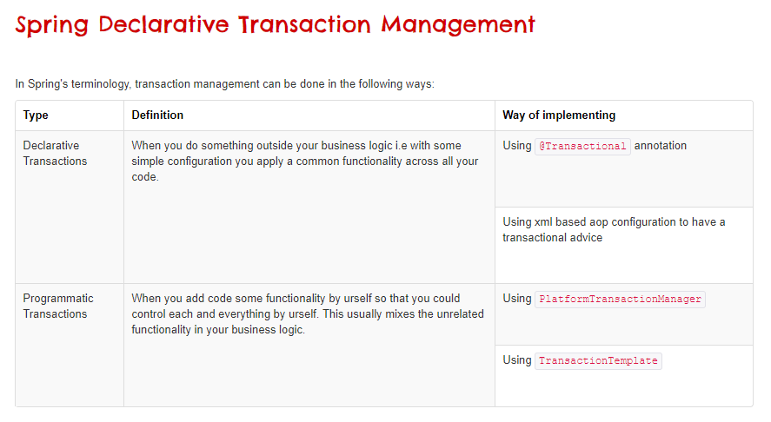

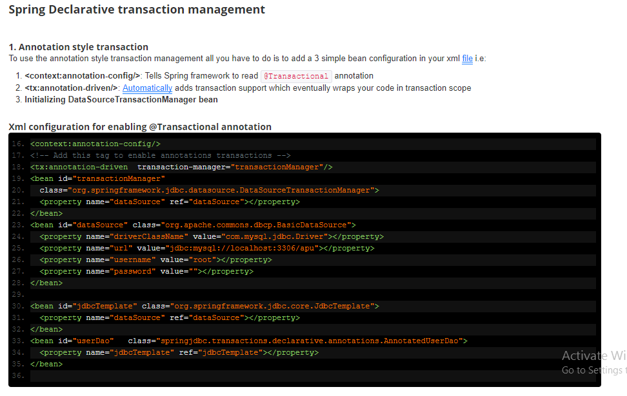

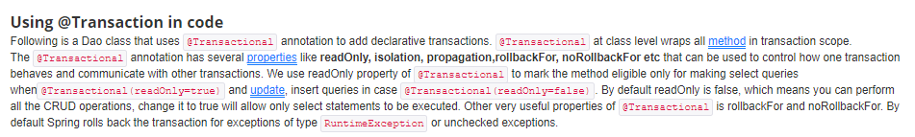

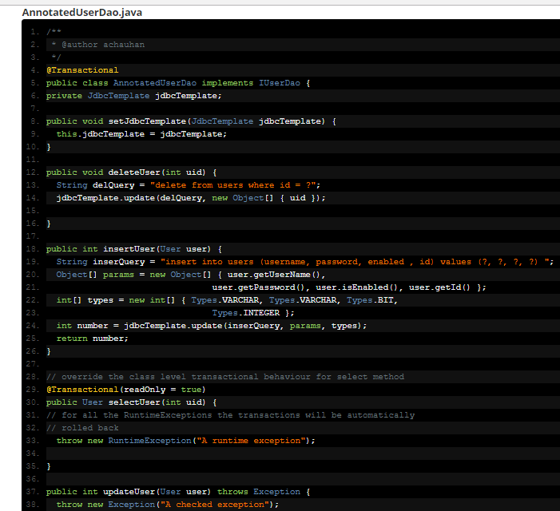

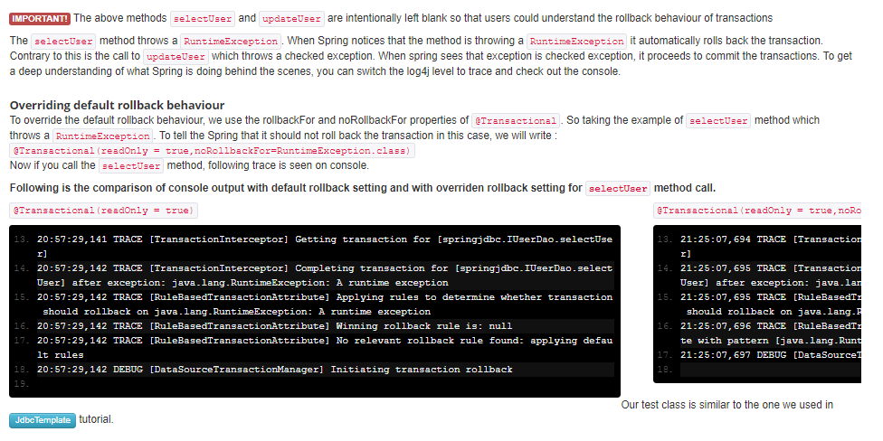

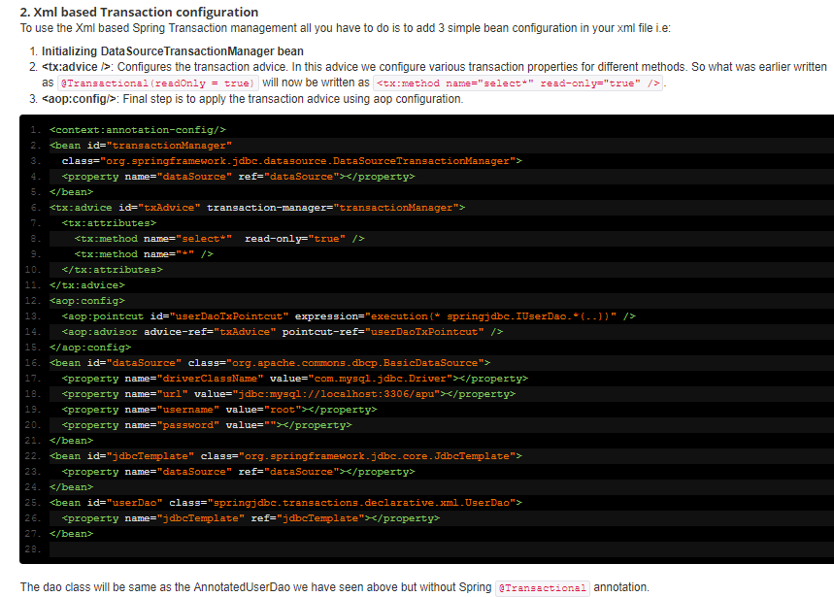

# 25) Spring MVC Form Validation Tutorial (With Annotations)

* 1. [**Spring MVC application**](http://www.javainterviewpoint.com/spring-rest-hello-world-example/) using the Bean Validation ( **JSR 303 Bean Validation**).
  2. **Spring MVC application using the using Validator interface**

## [Spring MVC application](http://www.javainterviewpoint.com/spring-rest-hello-world-example/) using the Bean Validation ( **JSR 303 Bean Validation**).

In our bean, we have used JSR303 validations annotations like **@NotEmpty, @NotNull, @Size, @Email**.

* @NotEmpty–> Ensures that the field cannot be left blank.
* @NotNull–> Ensures that the field can be blank.
* @Size –>Defines the acceptable length of the string with min and max attributes.
* @Email –> Ensures that the entered text is a valid email address.

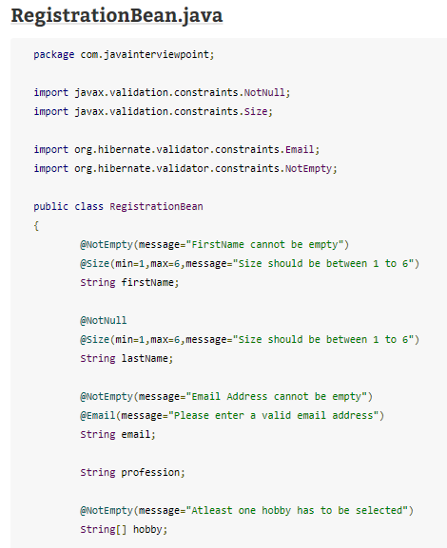

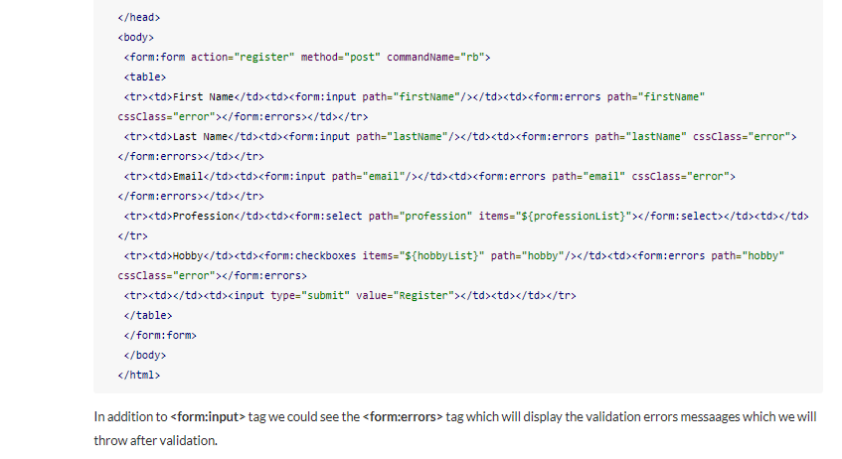

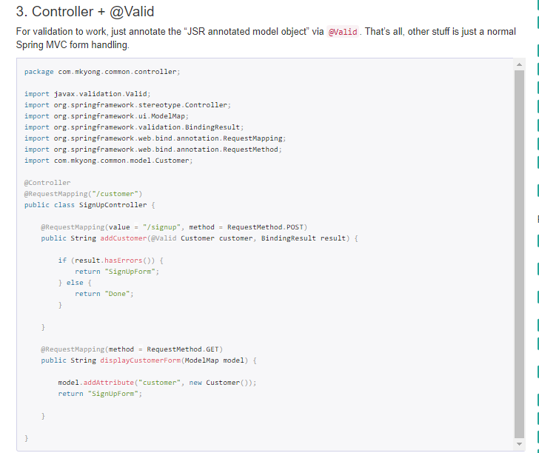

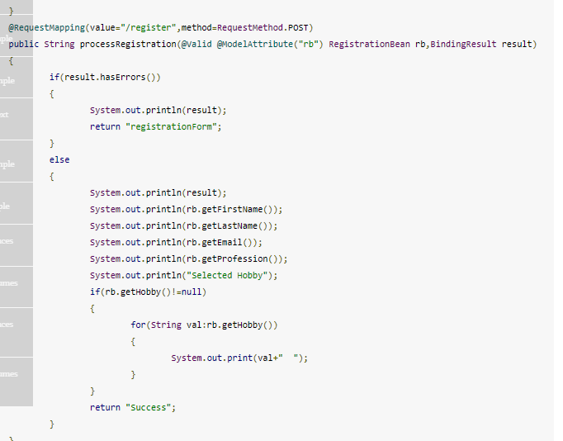

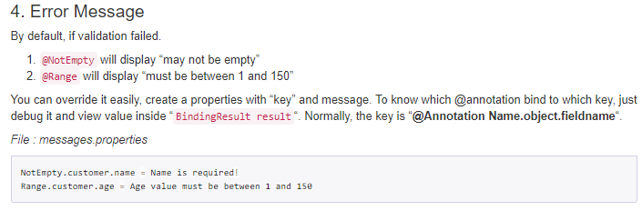

**mvc:annotation-driven**

Enable “mvc:annotation-driven” to make Spring MVC supports JSR303 validator via @Valid, and also bind your properties file.

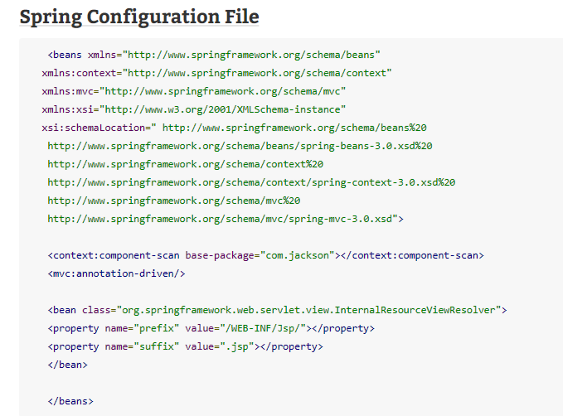

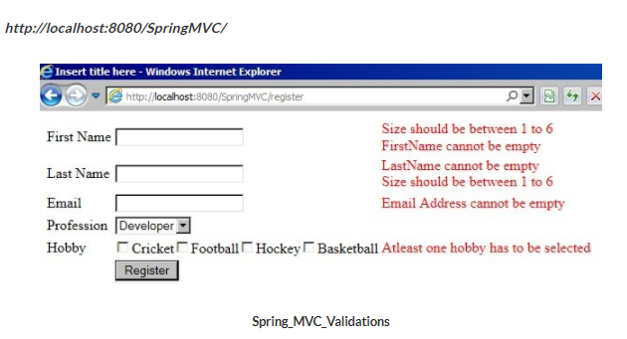

## **Spring MVC application using the using Validator interface**

1)If you enabled the Spring validator via @InitBinder, the bean validation will be ignore(JSR 303 – Bean validation ). 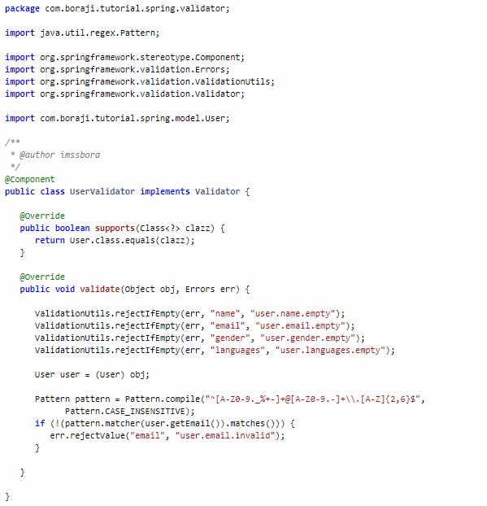

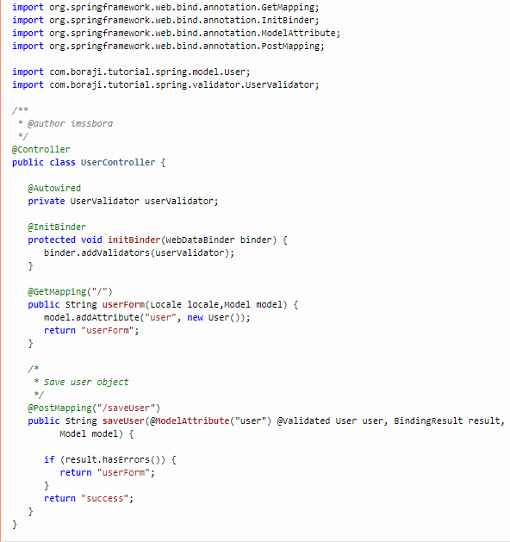

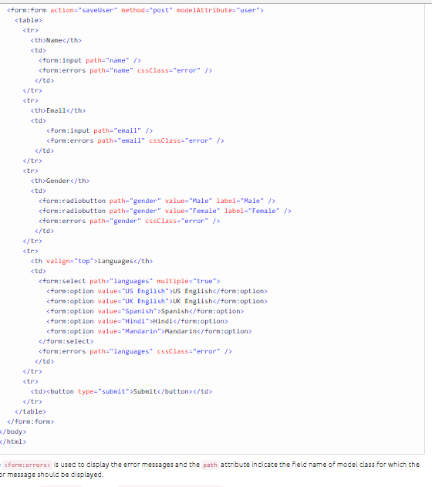

### 2: Bean Validator + Spring Validator

To have both Hibernate and Spring validator. Remove the @InitBinder and fire the Spring validator manually.

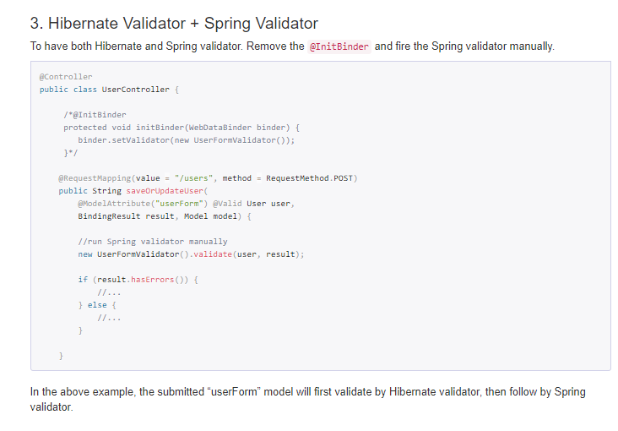

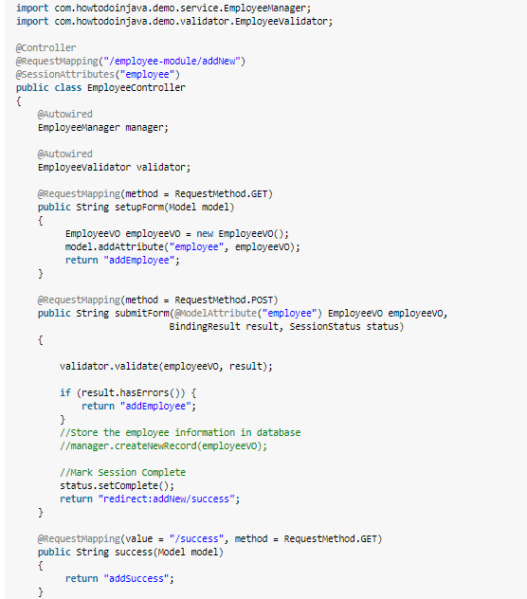

# Spring MVC Custom Exception Handling

* **Using exception handler method**: Spring provides the @ExceptionHandler annotation type which is used to annotate a method to handle exceptions raised by the controller’s methods. This approach applies to only the controller in which the handler method is declared.

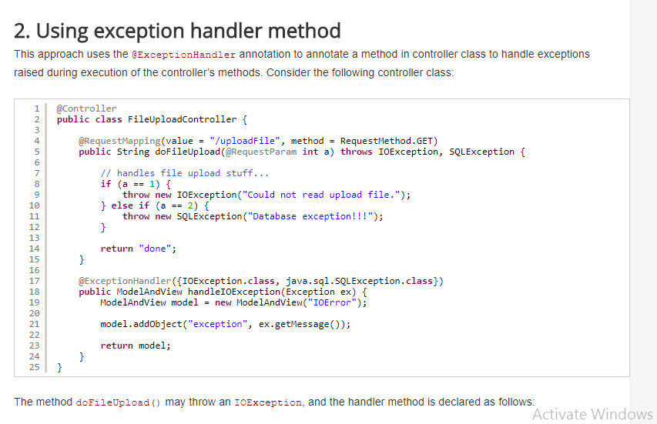

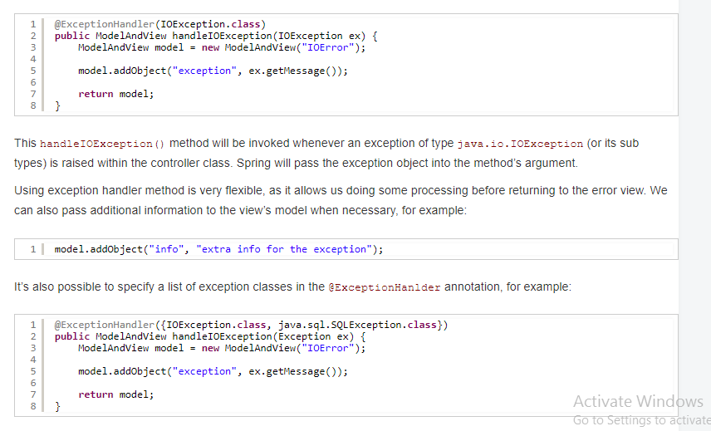

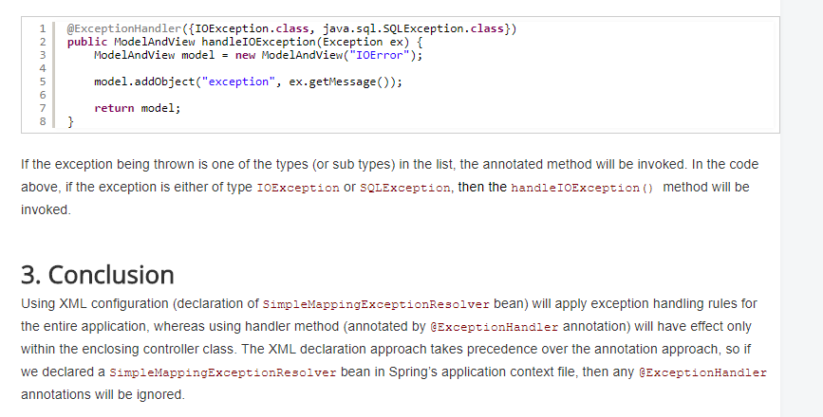

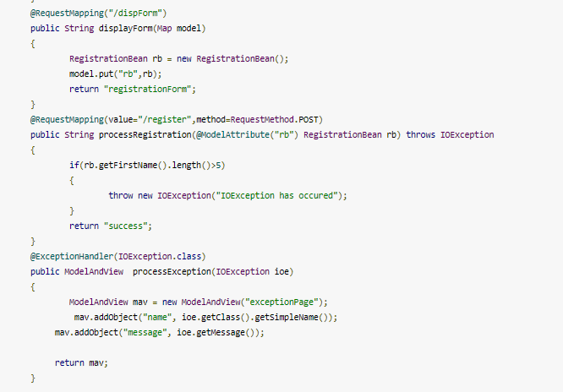

**@ControllerAdvice**and**@ExceptionHandler** annotations works, [**how to handle exception globally**](http://www.javainterviewpoint.com/spring-mvc-exception-handling-controlleradvice-exceptionhandler/). Now let’s see how do we handle a User Defined Exception.

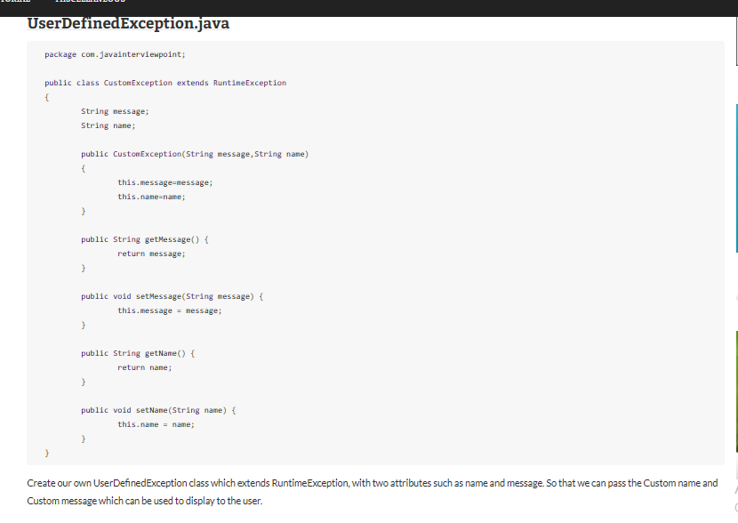

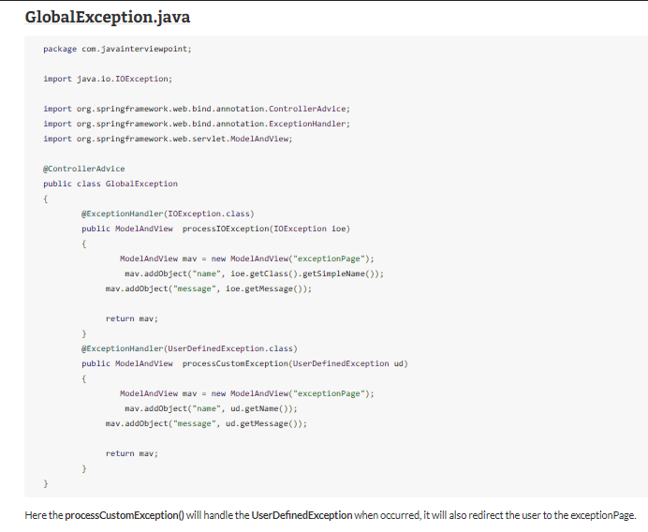

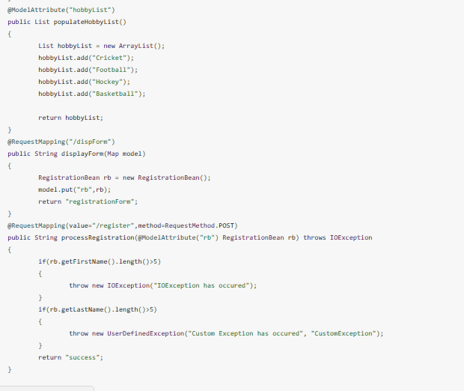

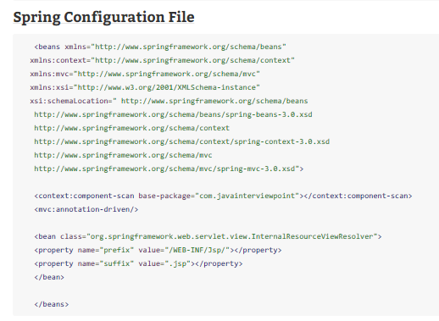

# Global Exception Handling With @ControllerAdvice

@ControllerAdvice is an annotation provided by Spring allowing you to write global code that can be applied to a wide range of controllers — varying from all controllers to a chosen package or even a specific annotation. In this brief tutorial, we will focus on handling exceptions using @ControllerAdviceand @ExceptionHandler (@InitBinder and @ModalAttribute can also be used with @ControllerAdvice).

I will be making use of the VndErrors class in this post and therefore the required dependencies will reflect that. spring-boot-starter-hateoas is included to allow VndErrors to be used, if you do not wish to use this class, spring-boot-start-web will be sufficient and will still provide access to everything else used in this post.

<dependency>

<groupId>org.springframework.boot</groupId>

<artifactId>spring-boot-starter-hateoas</artifactId>

</dependency>

By default, @ControllerAdvice will apply to all classes that use the @Controller annotation (which extends to classes using @RestController). If you wanted this to be more specific, there are a few properties provided that allow this.

To reduce the applicable classes down by package, you simply need to add the name of the package to the annotation. When a package is chosen, it will be enabled for classes inside that package as well as sub-packages. Multiple packages can also be chosen by following the same process, but using an array instead of a singular string (all properties in @ControllerAdvice can be singular or multiple).

@ControllerAdvice("my.chosen.package")

@ControllerAdvice(value = "my.chosen.package")

@ControllerAdvice(basePackages = "my.chosen.package")

Another way to specify a package is via the basePackageClasses property, which will enable @ControllerAdvice to all controllers inside the package that the class (or interface) lives in.

@ControllerAdvice(basePackageClasses = MyClass.class)

To apply to specific classes use assignableTypes.

@ControllerAdvice(assignableTypes = MyController.class)

And finally, what if you want to apply it to controllers with certain annotations? The below snippet would only assist controllers annotated with @RestController (which it covers by default) but will not include @Controller annotated classes.

@ControllerAdvice(annotations = RestController.class)

@ExceptionHandler allows you to define a method that, as the name suggests, handles exceptions. If you weren’t using @ControllerAdvice , the code for handling these exceptions would be in the controllers themselves, which could add quite a bit of duplication and clutter to the class and leading to it not being as “clean”. You could move the @ExceptionHandler methods into a base class that the controller extends to separate the code. This method is not perfect and comes with the issue that every controller where you need this global exception handling will now need to extend the base controller. Therefore, when you create a new controller and forget to extend this base class, you are now no longer handling some exceptions and might get bitten in the butt later on. Using @ControllerAdvicealong with @ExceptionHandler prevents this by providing global (and more specific) error handling so you don’t need to remember to implement them yourself or extend another class every time.

Below is a basic example of a class annotated with @ControllerAdvice.

@ControllerAdvice @RequestMapping(produces = "application/vnd.error+json") public class PersonControllerAdvice {

@ExceptionHandler(PersonNotFoundException.class) public ResponseEntity < VndErrors > notFoundException(final PersonNotFoundException e) {

return error(e, HttpStatus.NOT\_FOUND, e.getId().toString());

}

private ResponseEntity < VndErrors > error(final Exception exception, final HttpStatus httpStatus, final String logRef) {

final String message = Optional.of(exception.getMessage()).orElse(exception.getClass().getSimpleName());

return new ResponseEntity < > (new VndErrors(logRef, message), httpStatus);

}

@ExceptionHandler(IllegalArgumentException.class) public ResponseEntity < VndErrors > assertionException(final IllegalArgumentException e) {

return error(e, HttpStatus.NOT\_FOUND, e.getLocalizedMessage());

}

}

This class provides @ExceptionHandler methods globally to all controllers, as (which you can’t see from this code alone) there are multiple controllers that throw PersonNotFoundException, which need handling. The RequestMapping annotation here is used to set the content type that is returned by the ResponseEntity. These could be added to the methods themselves instead of the different types needed to be returned. Each instance of @ExceptionHandler marks an exception that it is in charge of dealing with. The methods in this example simply catch the exception and take its error message and combine it with an appropriate response code.

Without this code, when PersonNotFoundException is thrown, the following output is produced (along with a stacktrace in your log).

{

"timestamp": "2017-09-12T13:33:40.136+0000",

"status": 500,

"error": "Internal Server Error",

"message": "Person could not be found with id: 1",

"path": "/people/1"

}

With the addition of @ControllerAdvice and @ExceptionHandler, a different response is returned (stacktrace not found anymore).

[

{

"logref": "1",

"message": "Person could not be found with id: 1",

"links": []

}

]

In this response, we have actually controlled what is returned to the client. Although the first one contains more information, some of it is not useful to the client and could technically be incorrect. Yes, an “Internal Server Error” occurred, but really a person did not exist with the passed id and the response could suggest something blew up.

One last thing before I wrap up this post: If you define more than one @ExceptionHandler for the same exception, you need to be on the lookout. When defined in the same class, Spring is kind enough to throw an exception and fail on startup. But when they appear in different classes, say two @ControllerAdvice classes, both with a handler for the PersonNotFoundException, the application would start — but will use the first handler it finds. This could cause unexpected behavior if you are not aware.

In conclusion, we have looked at how to use the @ControllerAdvice and @ExceptionHandler annotations to create global error handling. That allows you to keep your logic in a central place, thus removing possible duplication, and, when applied globally, it removes the need to worry about whether more general exceptions are being handled or not.

The code used in this post can be found on my [GitHub](https://github.com/lankydan/spring-boot-hateoas" \t "_blank).

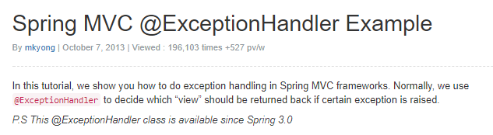

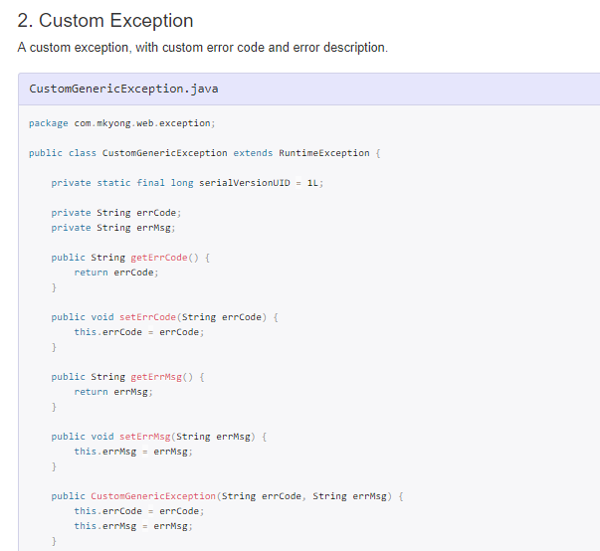

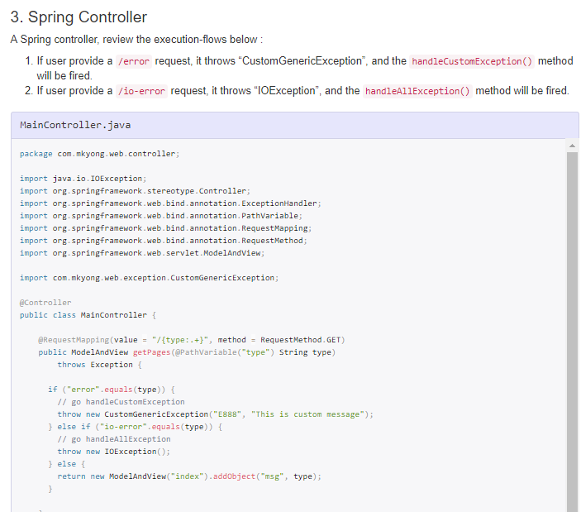

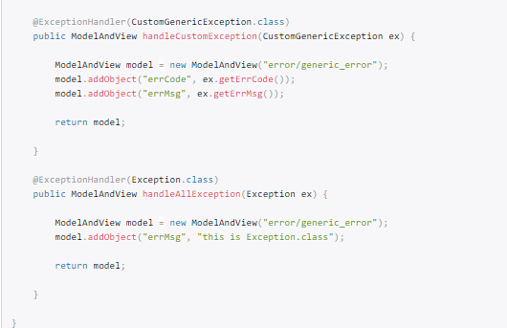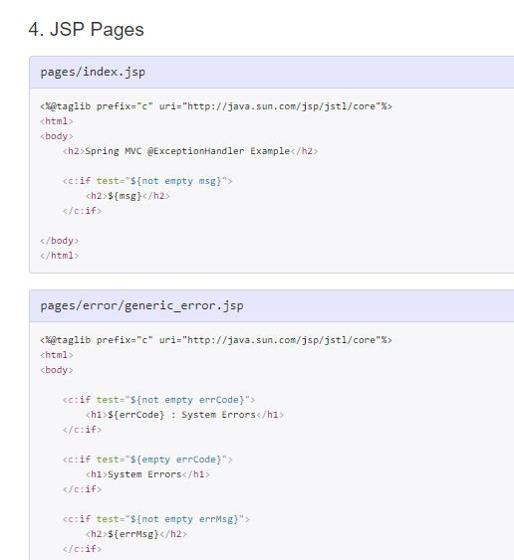

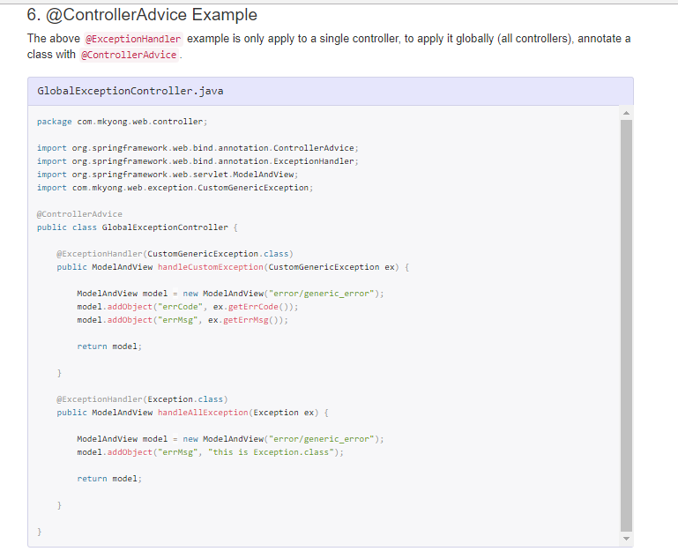

# 27) Spring MVC Tiles Example

Spring provides integration support with apache tiles framework. So we can simply manage the layout of the spring mvc application by the help of spring tiles support. 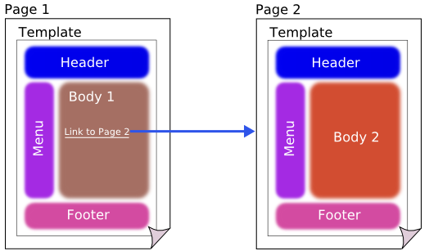

## Advantage of Tiles support in Spring MVC

1. **Reusability**: We can reuse a single component in multiple pages like header and footer components.
2. **Centralized control**: We can control the layout of the page by a single template page only.
3. **Easy to change the layout**: By the help of single template page, we can change the layout of the page anytime. So your website can easily adapt new technologies such as bootstrap, jquery etc.

Required Jar files

To run this example, you need to load:

* **Spring Core jar files**
* **Spring Web jar files**
* **Tiles jar files**

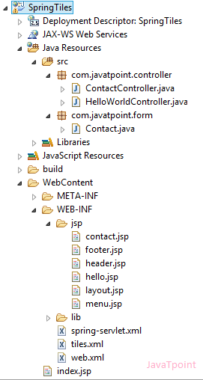 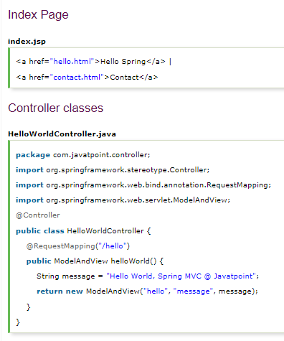

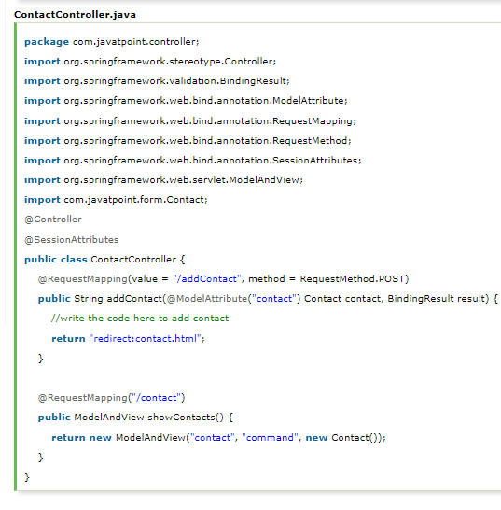 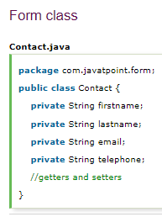

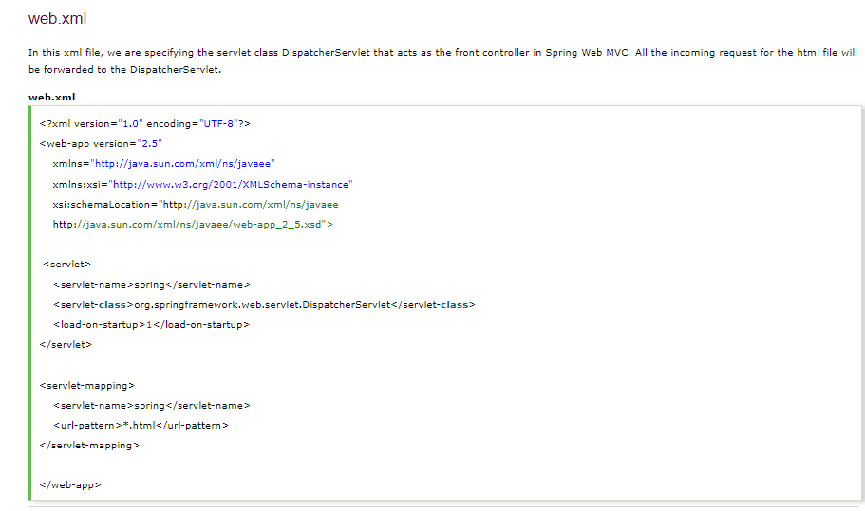

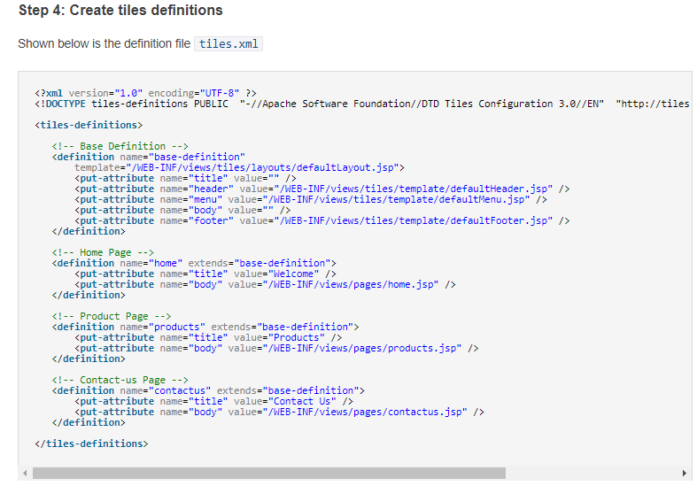

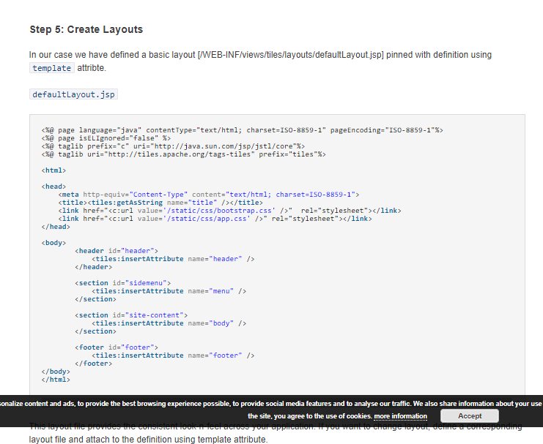 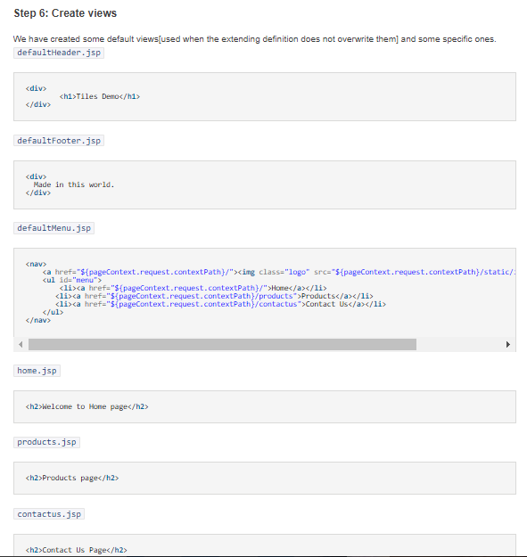

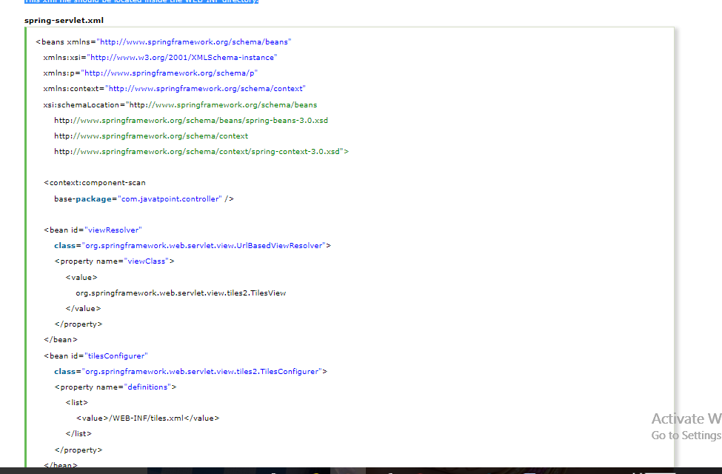

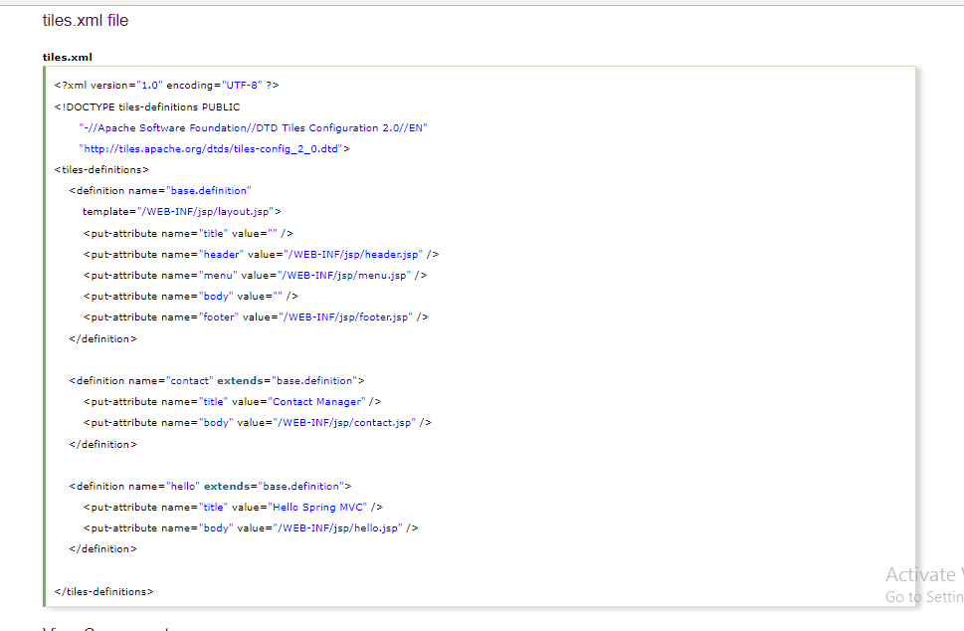

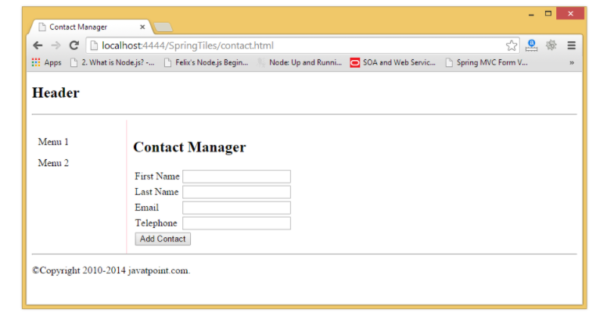

# 28)Spring Interceptors in your MVC Webapp

Spring Interceptor are used to intercept client requests and process them.

Sometimes we want to intercept the HTTP Request and do some processing before handing it over to the controller handler methods.

That’s where Spring MVC Interceptor come handy.

we can create our own Spring interceptor by either implementing org.springframework.web.servlet.HandlerInterceptor interface

or by

overriding abstract class org.springframework.web.servlet.handler.HandlerInterceptorAdapterthat provides the base implementation of HandlerInterceptor interface

Spring MVC allow you to intercept web request through handler interceptors. The handler interceptor have to implement the **HandlerInterceptor** interface, which contains three methods :

1. **preHandle()** – Called before the handler execution, returns a boolean value, “true” : continue the handler execution chain; “false”, stop the execution chain and return it.
2. **postHandle()** – Called after the handler execution, allow manipulate the ModelAndView object before render it to view page.
3. **afterCompletion()** – Called after the complete request has finished. Seldom use, cant find any use case.



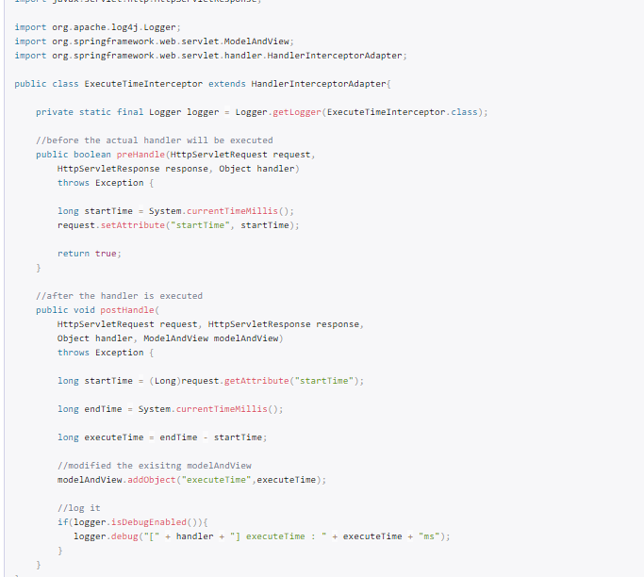

**spring-context.xml**

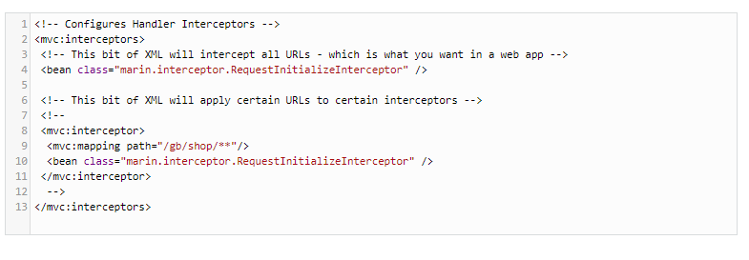

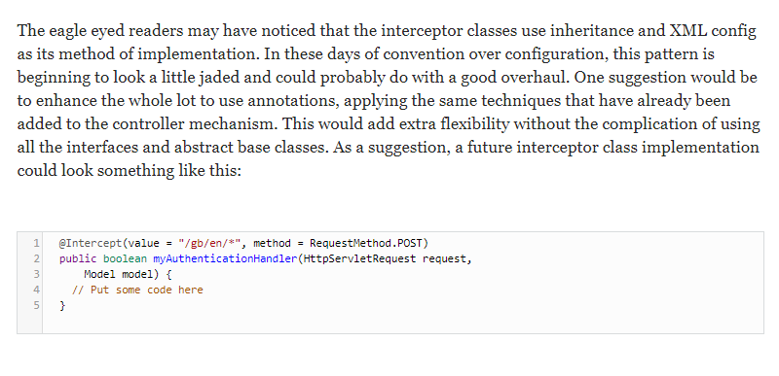

# 30) Spring MVC InternalResourceViewResolver example

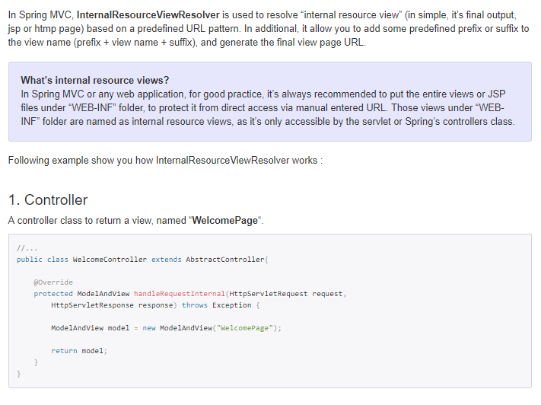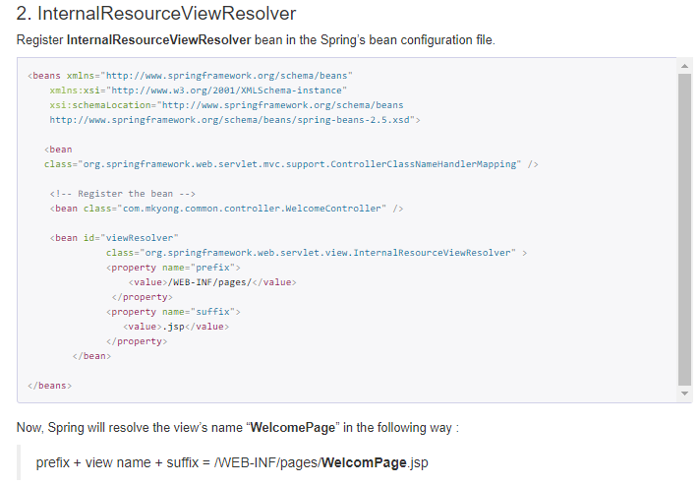

# 31)Spring : How To Load Properties File

🡪[Reading properties files in Spring with PropertyPlaceholderConfigurer bean](http://www.codejava.net/frameworks/spring/reading-properties-files-in-spring-with-propertyplaceholderconfigurer-bean)

🡪Location of the properties files

🡪Loading multiple properties files

🡪Fallback or override with system properties

🡪Ignoring exceptions

🡪Spring @PropertySource example

🡪Load Properties File using @Value Annotation

**Using properties files by MessageSource in Spring:** In previous chapters we will discuss about **[ApplicationContext](https://www.dineshonjava.com/application-context-in-spring/)** and **[BeanFactory](https://www.dineshonjava.com/what-is-bean-factory-in-spring/)**. **[ApplicationContext](https://www.dineshonjava.com/application-context-in-spring/)** has some extra functionalities in Spring Framework which **Internatiolization, Messaging, Properties file** etc..

## 1.Using org.springframework.context.MessageSource:

Its using read message in the class files and display message as the output, below given example show how to use properties files with org.springframework.context.MessageSource.

**myMessage.properties**

greeting=Hello Dinesh!

drawing.circle=Circle is Drawn!

Now to read this properties file in the spring application we have to use the a class name “**org.springframework.context.support.ResourceBundleMessageSource**” this help to pick the properties files into to the application, this define as bean in the spring configuration file(**spring.xml**). As follows

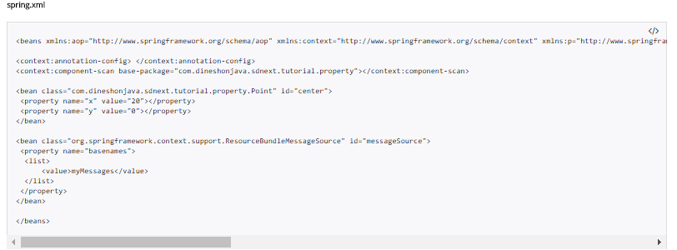

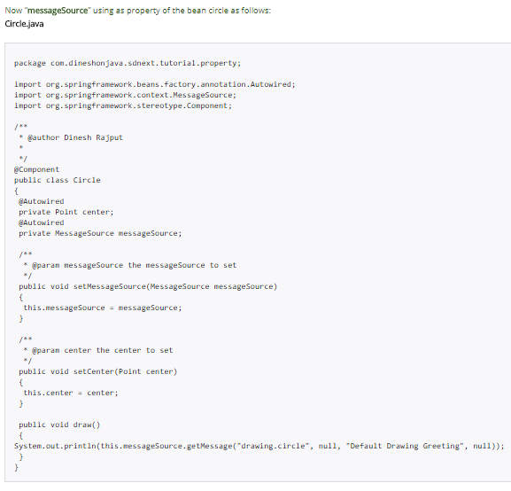

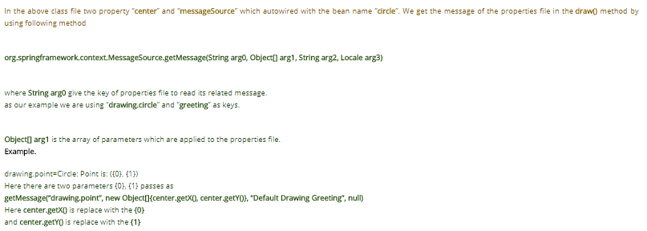

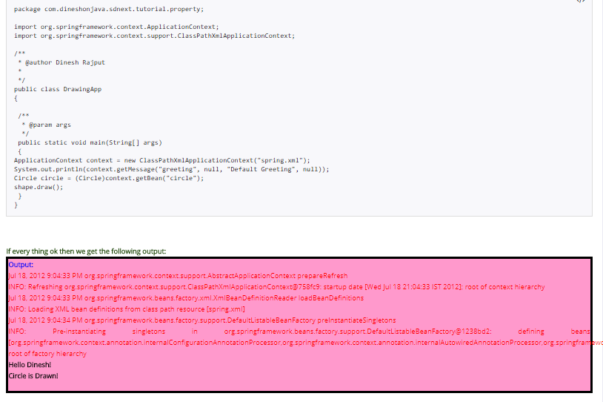

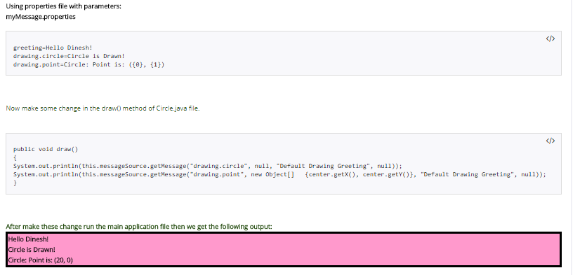

## 2. Using org.springframework.beans.factory.config.PropertyPlaceholderConfigurer:

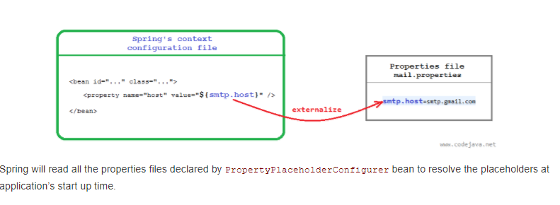

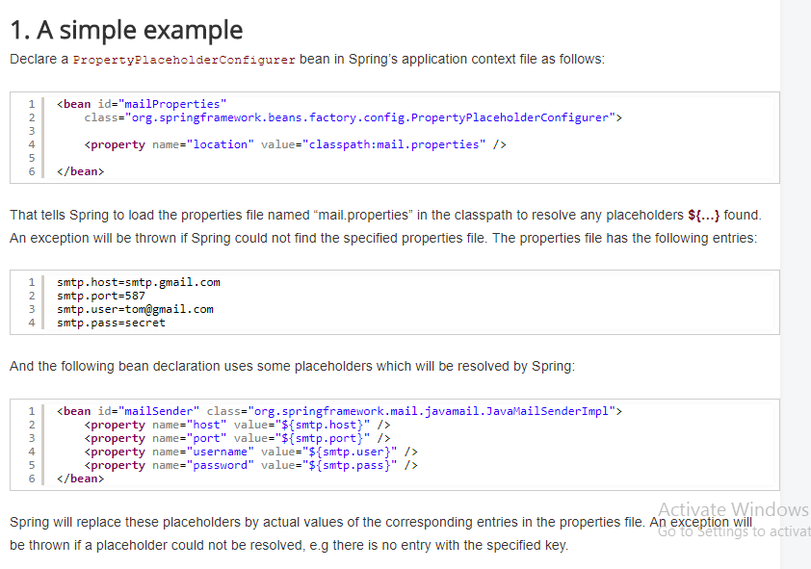

# Location of the properties files

* By default, Spring looks for the properties files in the application’s directory. So if we specify:

**<property name="location" value="WEB-INF/mail.properties" />**

Then it will find the mail.properties file under WEB-INF directory of the application (in case of a Spring MVC application).

* We can use the prefix **classpath:**to tell Spring loads a properties file in the application’s classpath. For example:

**<property name="location" value="classpath:mail.properties" />**

In case of a Spring MVC application, the mail.properties file should be present in the WEB-INF/classesdirectory (or in the source directory (src) in Eclipse IDE).

* Use the prefix **file:///** or **file:** to load a properties file from an absolute path. For example:

**<property name="location" value="file:///D:/Config/mail.properties" />**

**NOTE:**There is no white space between the prefixes **classpath:** and **file:** with the path of properties file.

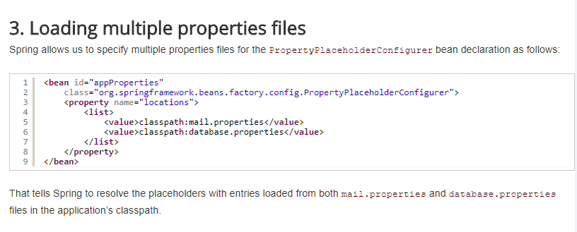

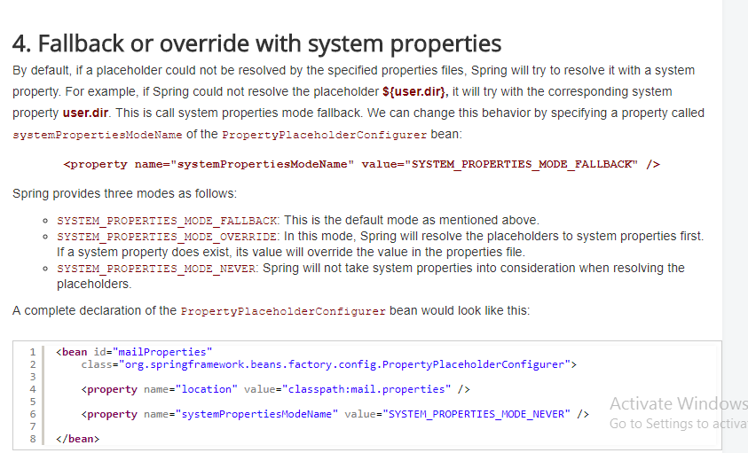

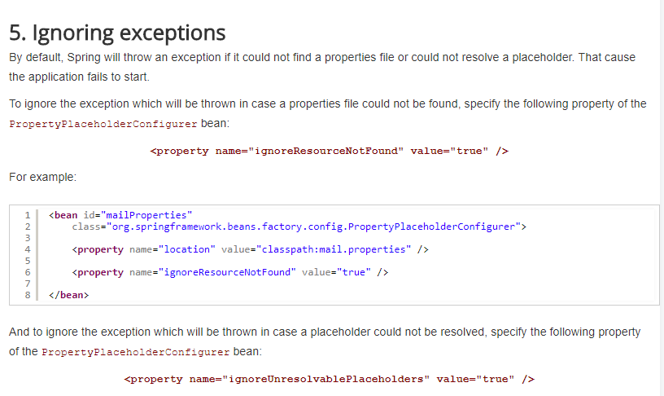

In Spring, you can use @PropertySource annotation to externalize your configuration to a properties file. In this tutorial, we will show you how to use @PropertySource to read a properties file and display the values with @Value and Environment.

P.S @PropertySource has been available since Spring 3.1

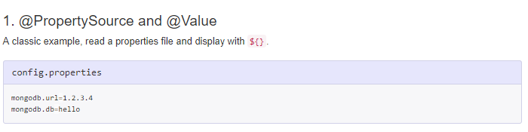

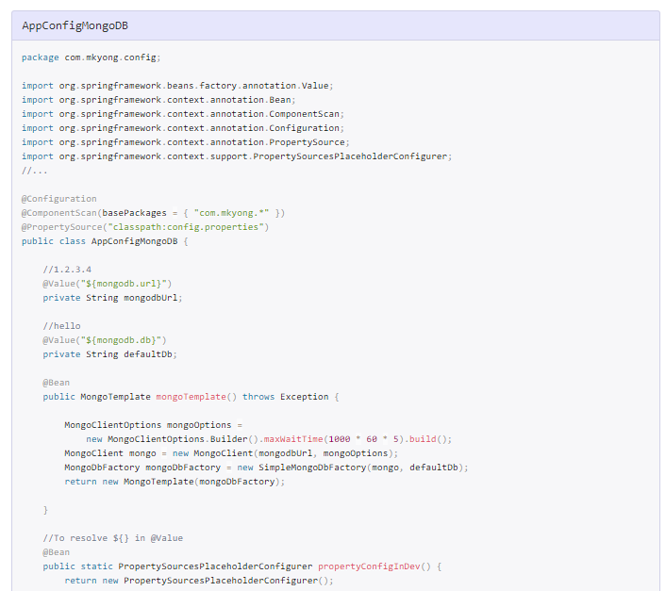

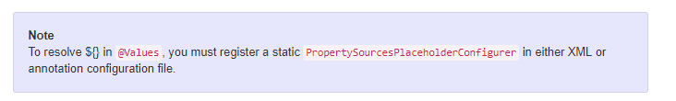

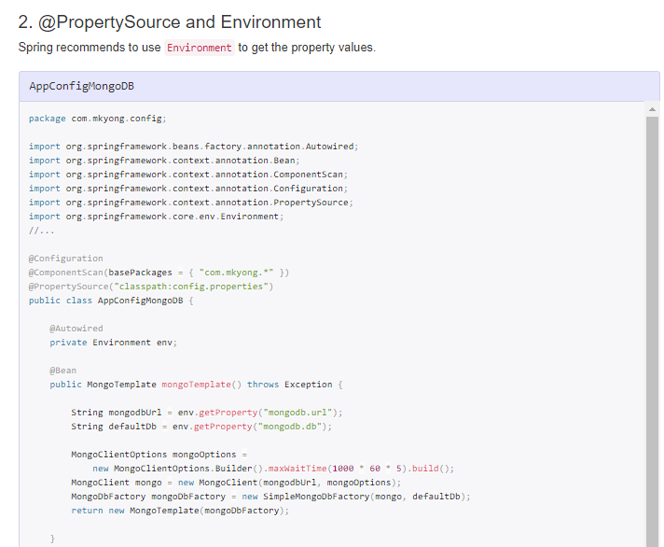

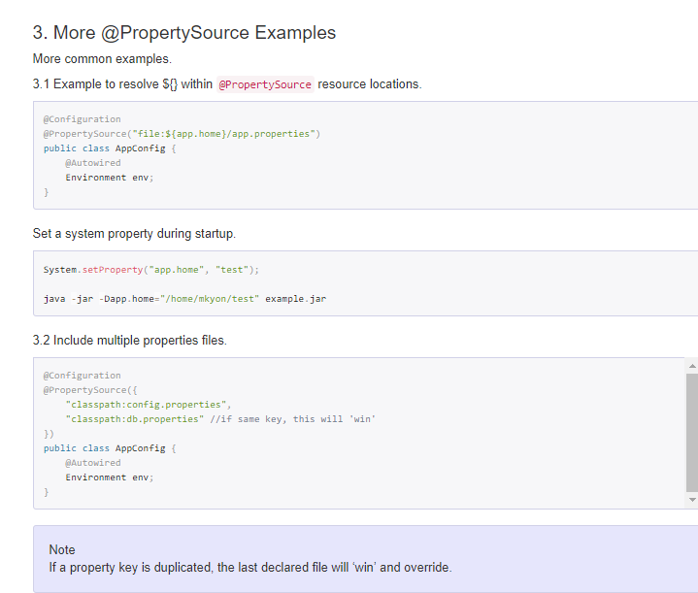

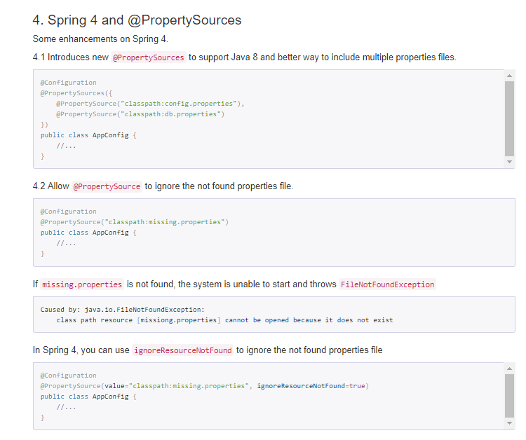

This example shows how to load the properties file values using the @Value annotation. Accessing the property file values in the Spring application involves the following steps:

* Add the property file details to spring bean configuration file. You have to use the “classpath” prefix if you want to load the files from the classpath.
* Create a properties file in the same name that is configured in the XML file and put it under the classpath folders. In most scenarios, source folders will be by default kept under the classpath.
* Use @Value annotation to get the property valye. @Value annotation takes the string parameter which is “key” used in the properties file. This annotation has to be used with variables to inject the value.

## Spring MVC Configurations

**spring4-mvc-dispatcher-servlet.xml**

